How to Schedule Exams in the SAS Portal
The Student Access Testing Center (SATC) is located on the 2nd floor of Brown Library.
Phone: 509-682-6899; Email: SATC@wvc.edu
Important: These directions only apply if you are taking a test in the Student Access Testing Center (SATC). If you are taking a test with your instructor or in another space (e.g., STEM Center), please coordinate directly with them.

Quick Guide (At a Glance)
To schedule your test you will:
- Log in to the SAS Portal
- Select the Alternative Testing module
- Select your class
- Provide your exam date and time
- Click “Add Exam Request”
Before you start you will need:
- Your WVC student email username and password.
- To request testing accommodations for your class.
- The date and time the class is taking the exam (or your best guess).

Step 1: Log In to the SAS Portal
Go to wvc.edu/studentaccess and scroll down to the Current Students section.
Click SAS Portal Login. Log in using your WVC Student Email credentials.
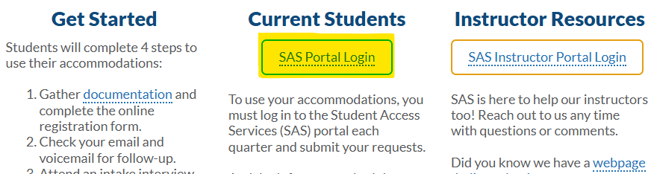
You can also go directly to: https://denali.accessiblelearning.com/WVC
Note: If this is your first time logging in to the portal this quarter, you will need to:
- Review and digitally sign any accommodation agreements.
- Request testing accommodations for your class(es). See the “How to Use the SAS Portal” guide or contact SAS staff if you need assistance with this step.

Step 2: Select the Alternative Testing Module
In the menu on the left, click “Alternative Testing” under the Accommodations section. 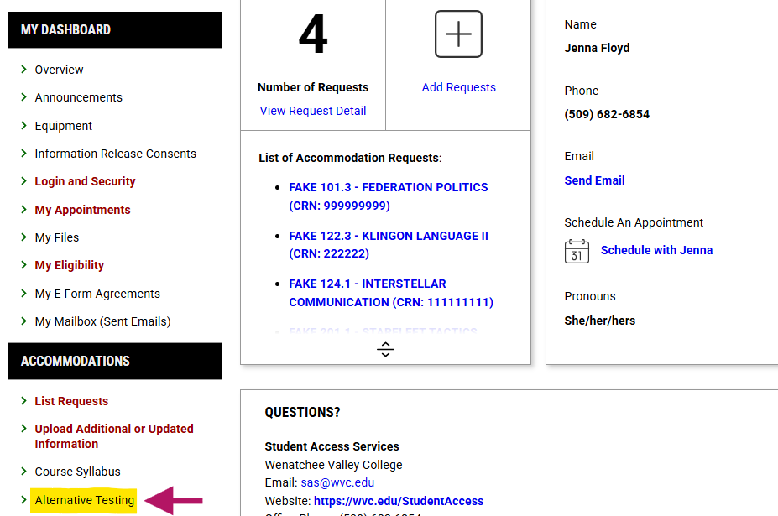

What You’ll See
There are two main areas on this page:
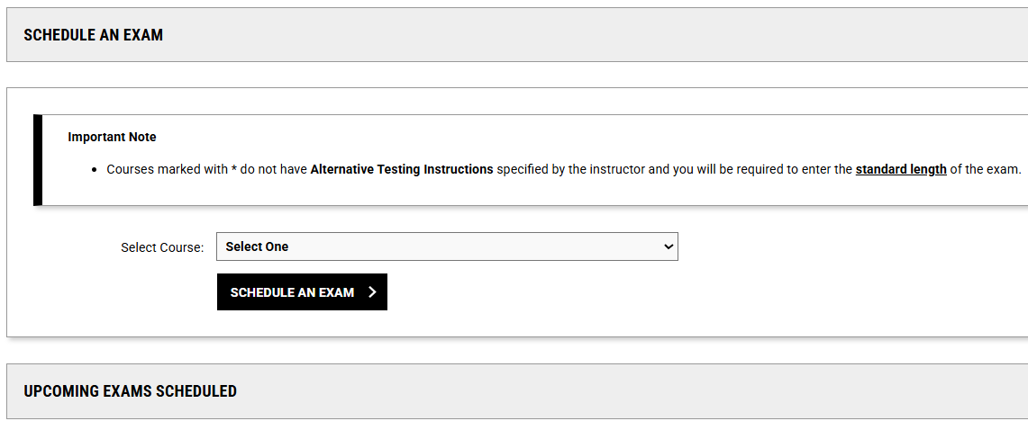

Schedule an Exam:
- Choose a class to begin scheduling a test.

Upcoming Exams Scheduled
- Shows exams you’ve already scheduled this quarter.

Step 3: Start Scheduling an Exam
Use the Select Course drop-down menu to choose the class with the upcoming exam.
Note: If you do not see your class listed, you may need to return to the SAS Portal home screen and request testing accommodations for that course.
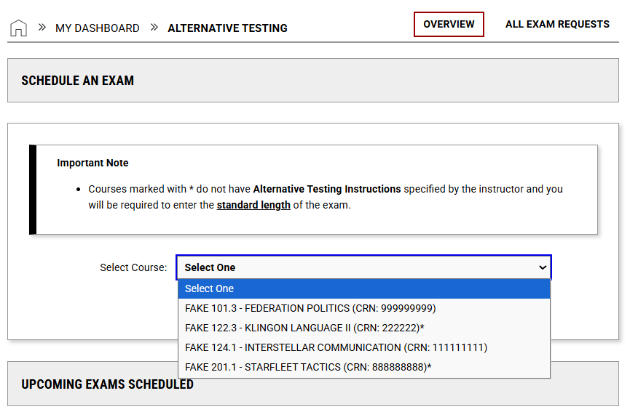
Then click the “Schedule an Exam” button, located below the drop-down menu.
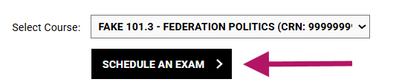

Before You Choose an Exam Date
Your screen might look different depending on what your instructor has already submitted to the SATC. You do not need to worry about these differences; you can schedule your tests either way. This information is just to help you understand why some classes may look different.
- If you see a * next to a class, your instructor has not provided their Alternative Testing Instructions to the SATC yet. That’s okay, you can still schedule your exam.
- If your instructor did already submit Alternative Testing Instructions, you may see some of those instructions when you schedule your test.

Scheduling Options
Review the “Schedule Exam Policy” for additional guidance and contact information. Scroll down past this section to begin scheduling your test.

A: If Your Instructor Provided Exam Dates to the SATC
If your instructor pre-selected test dates, you will see a dropdown menu with upcoming test dates.
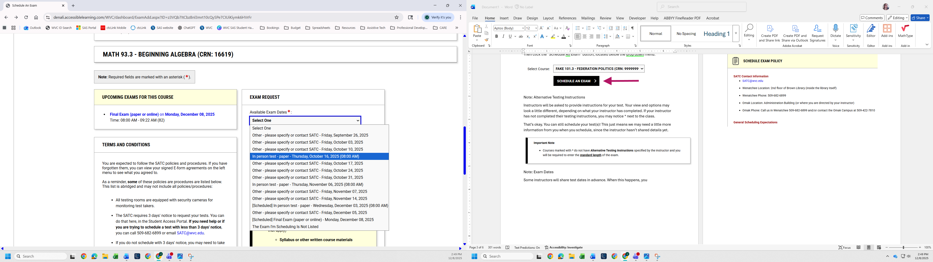
Choose the correct exam date from the list. Complete the remaining questions and go to the final confirmation (see “Final Steps” below).
If your exam date is NOT listed, select “The Exam I’m Scheduling Is Not Listed” and proceed with the instructions in the next section (B).

B: Instructor Has Not Provided Exam Dates (or You Need to Add One)
If your instructor did not enter test dates, or the test you are scheduling is not pre-selected, you will fill out the exam details yourself.
Screenshot and descriptions on next pages.
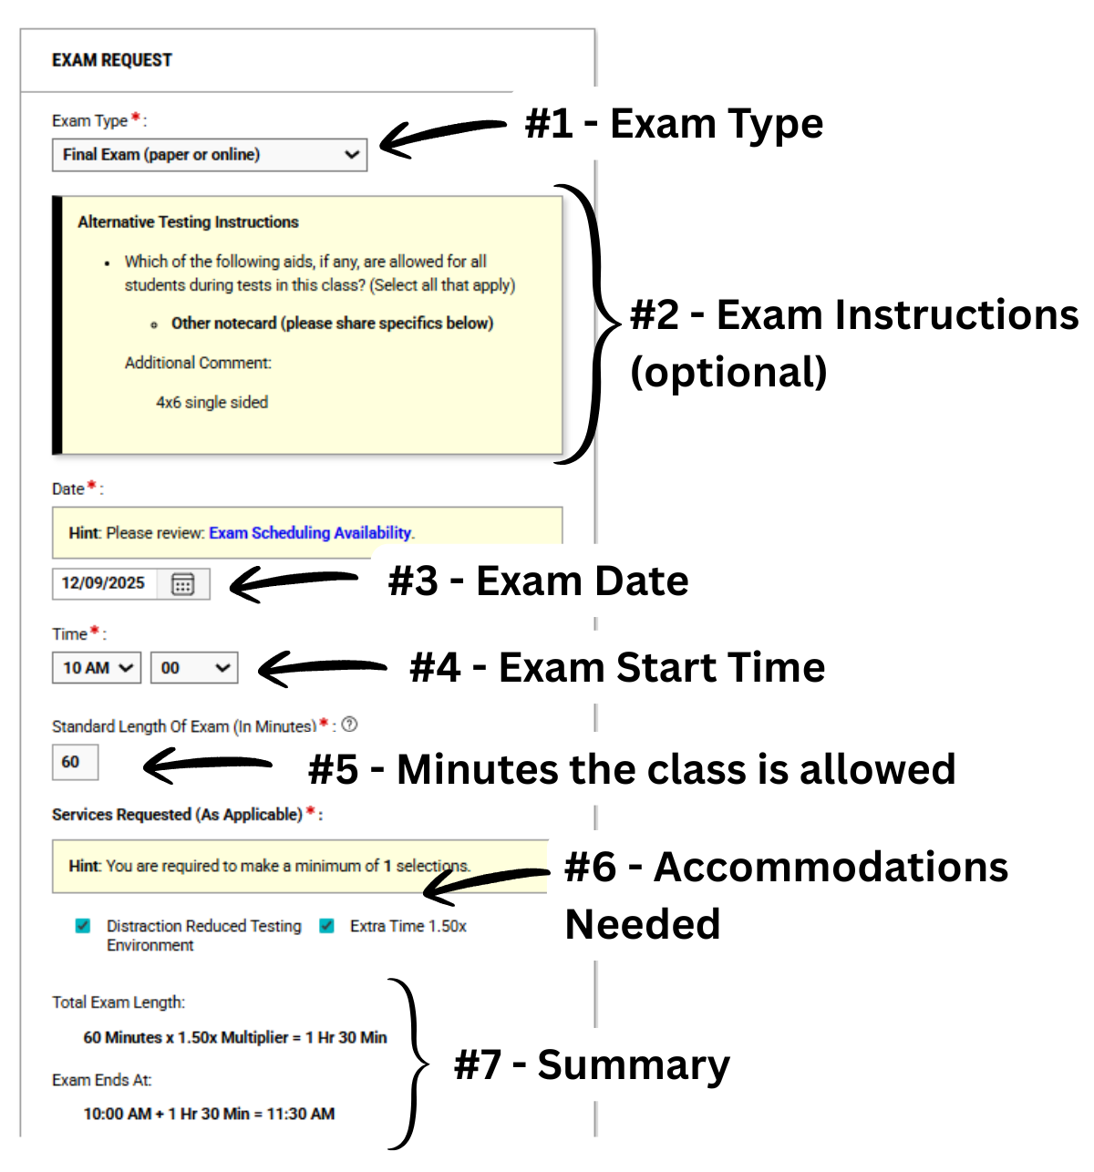

You will be asked to provide:
- Exam Type: Choose the best option. If you’re unsure, make your best guess.
- Alternative Testing Instructions (if available): If your instructor has shared instructions with SATC, they may appear in a yellow box below the Exam Type.
Not all exams will have this information; you will usually only see it if you are permitted additional materials or if certain things are needed to test.
This information does not include things related to your testing accommodations. These are the general rules for the class as a whole.
If something seems wrong with this information, contact your instructor or the SATC for clarification.
- Date: Choose the date you plan to take the test. This is usually the same date as the class.
- Time: Select the time you will begin your exam in the SATC. This is usually around the same time as the class, unless you need an adjusted time based on your accommodations.
- Standard Length of Exam (In Minutes): Enter the amount of time the class receives for the exam.
  - Do not include your extra time (if applicable). The portal will automatically calculate additional time based on your accommodations.
  - If you don’t know the standard time, enter your best guess. Please make a note in the “additional comments” box to let us know you’re unsure about the test duration.
- Services Requested (As Applicable): Check any testing accommodations you need for this exam.
- Review Your Summary: A summary at the bottom will show your total test duration and end time (including extra time if applicable).
You may use the “Additional Note” box at the bottom if you’d like to share any extra information with the SATC.

Final Step: Submit Your Request
Click Add Exam Request at the bottom of the page.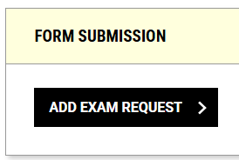
You will then see a confirmation banner showing your request was submitted successfully.
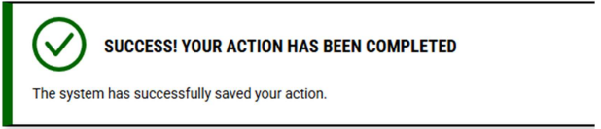
You may now schedule additional exams or leave the page.

Troubleshooting – Common Questions
I don’t know how much time the class gets:
- Use your best estimate and note it in the comments. Ask your instructor; you can go back and make edits or contact the SATC to follow-up. If you need help, the SATC can help confirm before your test.
My class time is outside the SATC hours (M-F, 8-5):
- Schedule for another time on the same day (or the next day) that works with your schedule. Follow-up with the SATC and/or your instructor.
My test is less than 3 business days away. Can I still schedule my test?
- We will do our best to try, but we cannot guarantee availability. Complete your request and follow-up with the SATC.
- If you cannot submit your (late) request, please contact the SATC directly through email SATC@wvc.edu or phone (509) 682-6899 to make your request.

