How to Use the Student Access Portal
The Student Access Services Portal (sometimes called the SAS Portal) is where you can manage your accommodations at Wenatchee Valley College. Follow these steps to get started.

Accessing the Portal
- Go to wvc.edu/studentaccess.
- Scroll down to the Current Students section and click SAS Portal Login.
- Use your WVC Student Email credentials to log in.
Or you can go directly to: https://denali.accessiblelearning.com/WVC

Reviewing and Signing Forms
You may need to review and sign accommodation agreements when you log in.
Read through the form(s) and scroll all the way to the bottom. Type your name in the consent box and click Submit Form to complete your signature.
Please note: your name information syncs with ctcLink. Please reach out if you have concerns or difficulties with this.
After submitting your form(s), you will be taken to your Dashboard.

Your Portal Dashboard
The dashboard is the main place to view and manage your accommodations. You can also use the SAS Contact section to schedule appointments with SAS staff.
Before requesting accommodations, take a look at some of the other options in the SAS portal by exploring the menu.

The Menu
The full menu is sometimes hidden. To open it, look for one of these icons in the top-left corner (under the WVC logo) – the icon may change based on your device:

Hamburger menu (three horizontal lines) 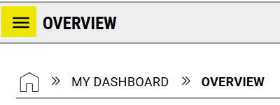Standard Menu (box with a line & arrow)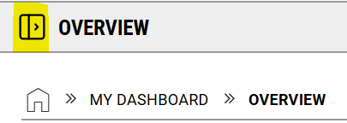

Menu Contents
Your menu options can look different, based on your accommodations.

Some key areas to explore include:
- My Eligibility – Review the descriptions of your approved accommodations. Please confirm they look correct (this section was recently updated).
- My E-Form Agreements – Revisit the required forms you signed.
- Accommodations – Review your submitted requests or make new ones.
- Alternative Testing – This is how you will schedule your test with the SATC (if you have testing accommodations).
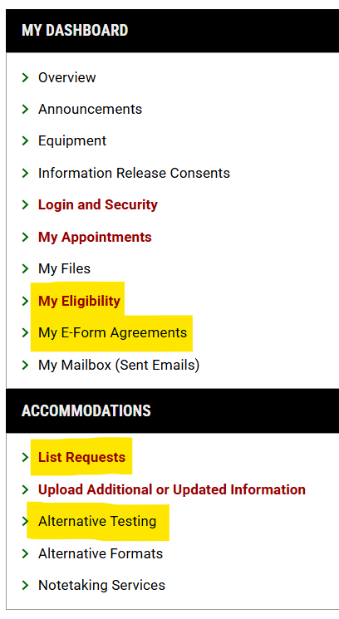

Requesting Accommodations
The Student Access Portal makes it easy to request your accommodations each quarter. There are a few ways to submit requests, but the easiest is from your Dashboard.

If you have not submitted a request yet this quarter

- Number of Requests: This will show 0 if you haven’t made any requests yet this quarter.
- Red Message: A yellow box with red text stating, “No Accommodation Request Found for [Quarter Year]”. This just means you haven’t made any requests to use your accommodations this quarter.
- Add Requests link: This link will take you to your current classes where you can make your accommodation request(s).
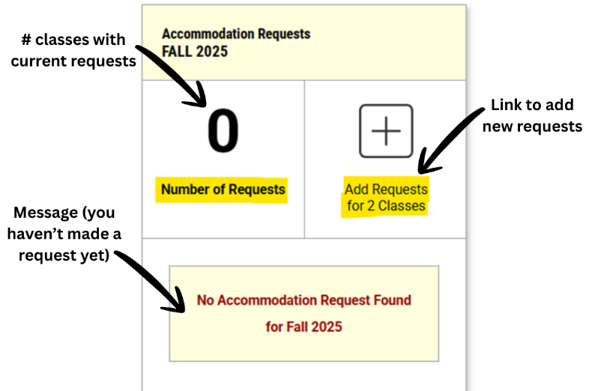

If you have made requests this quarter
If you, or someone in the SAS office, have already submitted a request for the quarter, you will see a summary on this page instead.

- Number of Requests: Shows the number of classes with active accommodation requests.
- View Request Detail link: Click to see the details of the requests you’ve already made this quarter.
- Add Requests link: Click to add additional requests.
- List of Accommodation Requests: Links to the details for each specific class.
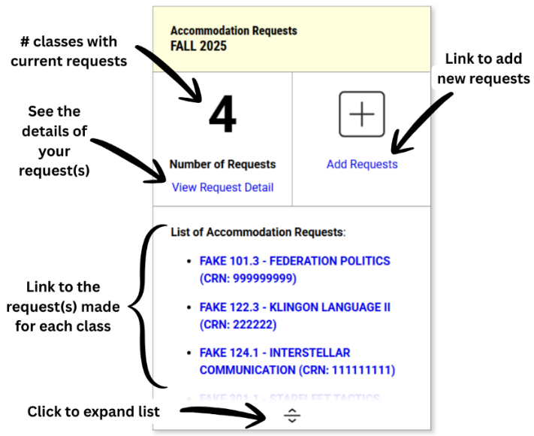

Starting Your Request
Click the link to Add Requests to get started.
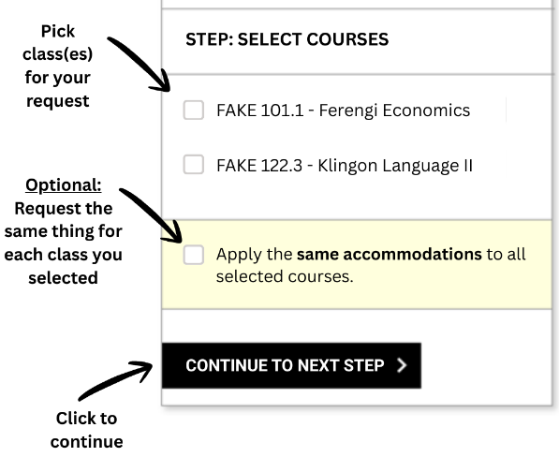
On the next screen you will see a list of your current classes.
Check the box next to the class(es) for which you are making your request. If you have a lab class, you may see it listed separately.
Select “Continue to Next Step”.

Select Your Accommodations
Review the accommodations you are eligible to receive.
Choose the ones you want to request for your course(s) by checking the box next to the accommodation.
If you do not need accommodations for a class, you can select “I do not need accommodations for this course” at the bottom.
Don’t forget to “Submit Request” in the final step.
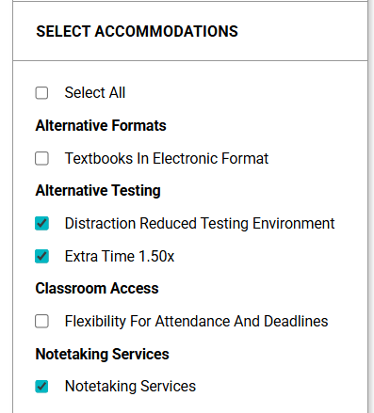

Reviewing Your Requests
The next screen will show you a summary of the requests you’ve made for the quarter. There are several helpful pieces of information to explore.
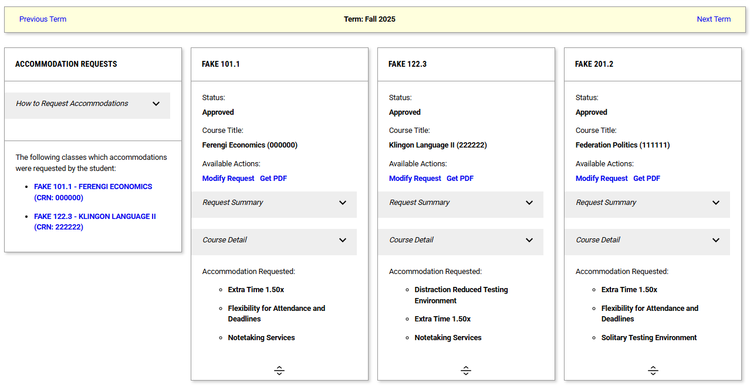
From that request summary screen, you can:

- Check the Status of your request: Some requests are automatically approved, while others may require SAS staff review. Most approvals are processed on the same day. Please reach out if you have concerns.
- Modify Requests: Make changes if needed
- Get a PDF: Get a copy of the notice your instructor will receive for this class.
- See the Accommodation(s) you Requested: Summarizes the request you made.
Note: Requested accommodations may not reflect your changes until the status changes to “approved.”
