Position Management – Position Management QRG
Nav>Workforce Administrator page>Position Management Tile>Manage Position Tile

For editing a current position, Add + a row, make the change needed and Submit.

Add a New Position (see documentation Position Management – Reclassify a Position for changing a current position to a different position)
Add New Position: click +Add , put Effective Date (be sure it is the start date or before start date), Continue

Position Data: Add Job Code (search if necessary) – the rest of job information will autofill (BE SURE JOB CODE INFO IS CORRECT because it pulls the info from it) – Change if necessary
Just fill in the * required fields – nothing else (Classified must have Salary Admin Plan and Grade). Next.

Step 1 of 5: Position Data
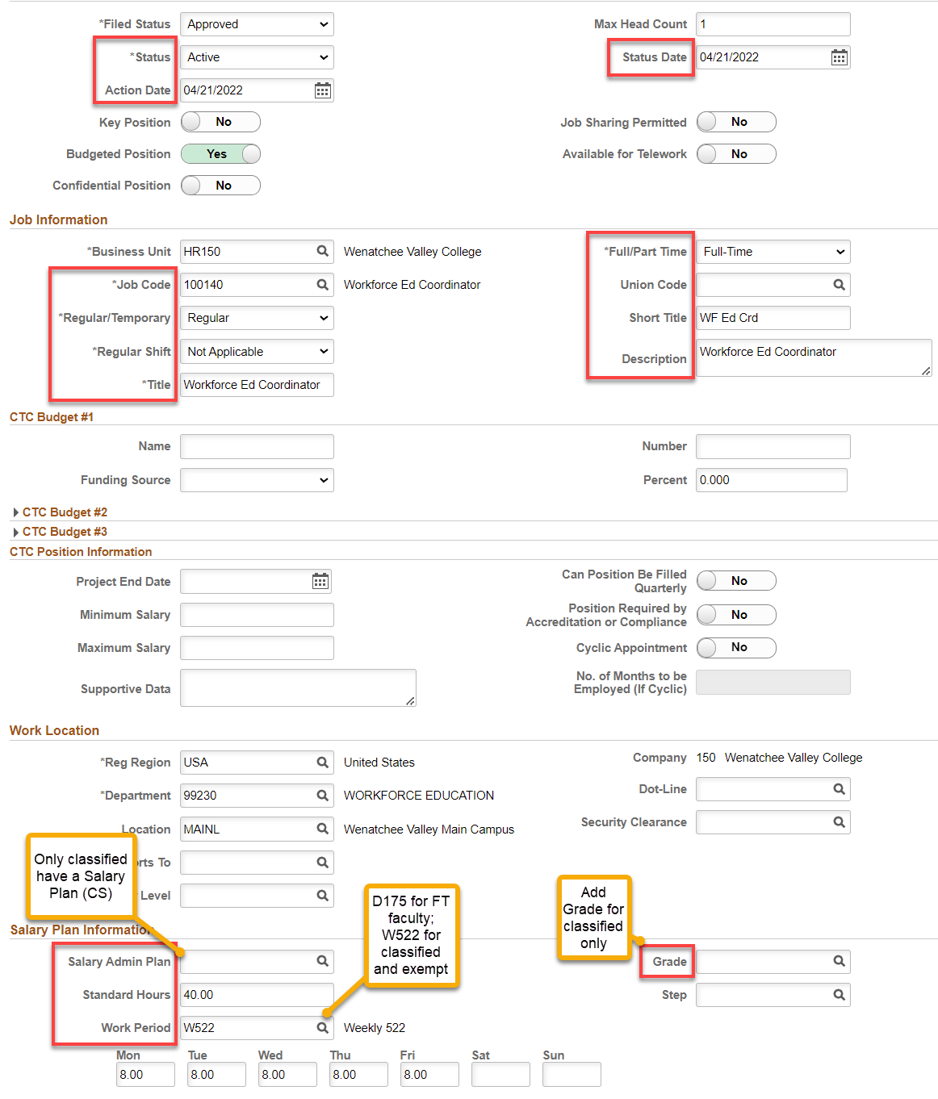

Step 2: Specific Information
Leave FTE at 0.00 or change to 1.00 (I like 1.00 so it autofill’s in Job Data).
Next

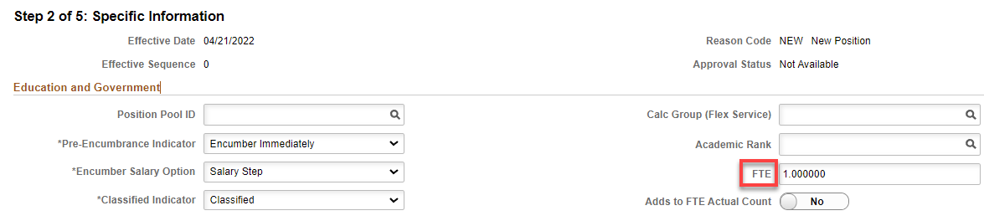

Step 3: Attachments
Nothing to add
Next

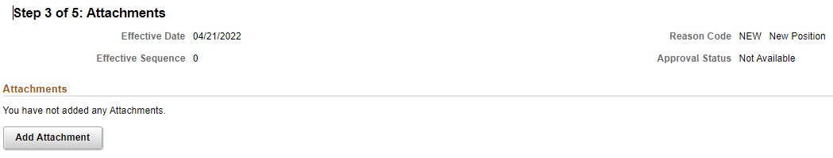

Step 4: Budget Incumbents
Nothing to add
Next

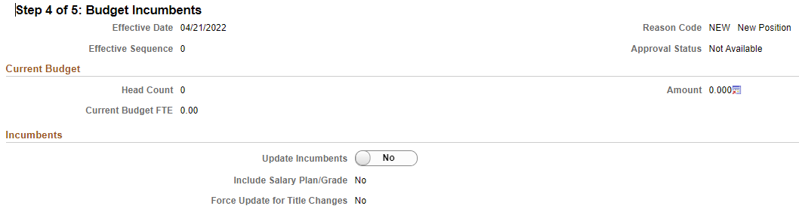

Step 5: Review and Submit
Review and hit Submit

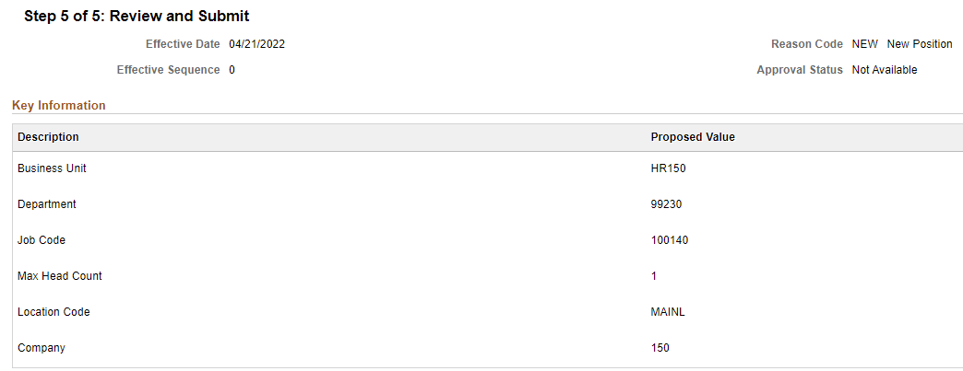

Position Confirmation
WVC has no approvers except Reagan or Tim
Click on Multiple Approvers to see who can approve

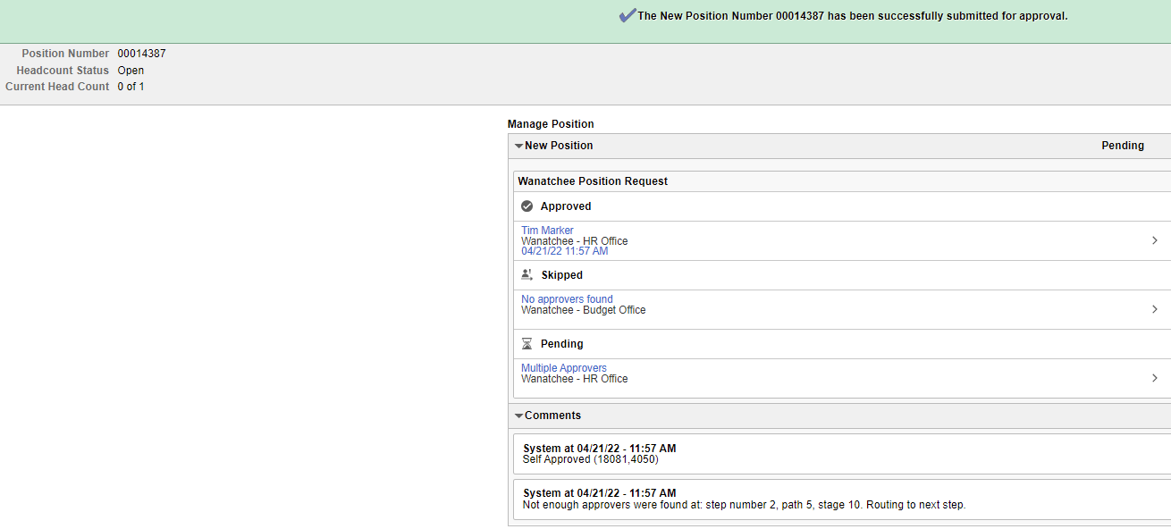
Write down the new Position Number

Check notifications (flag) for an alert or action to approve (if you are the approver).

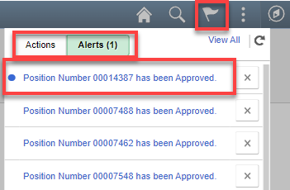

That’s it!

