Position Management – Position Management QRG
Nav>Workforce Administrator page>Position Management Tile>Manage Position Tile

For editing a current position, Add + a row, make the change needed and Submit.

To Add a New Position (see documentation Position Management – New Position
To Reclassify a Position (see documentation Position Management-Reclassify a Position with new job code).

To Copy or Clone a Position: Put in position number or Description; use wildcard IT%, for example, to narrow the search, Click Search.

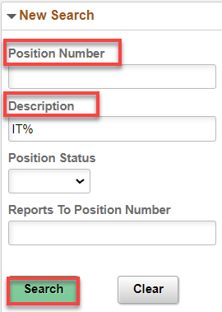

Click anywhere in the row you choose.

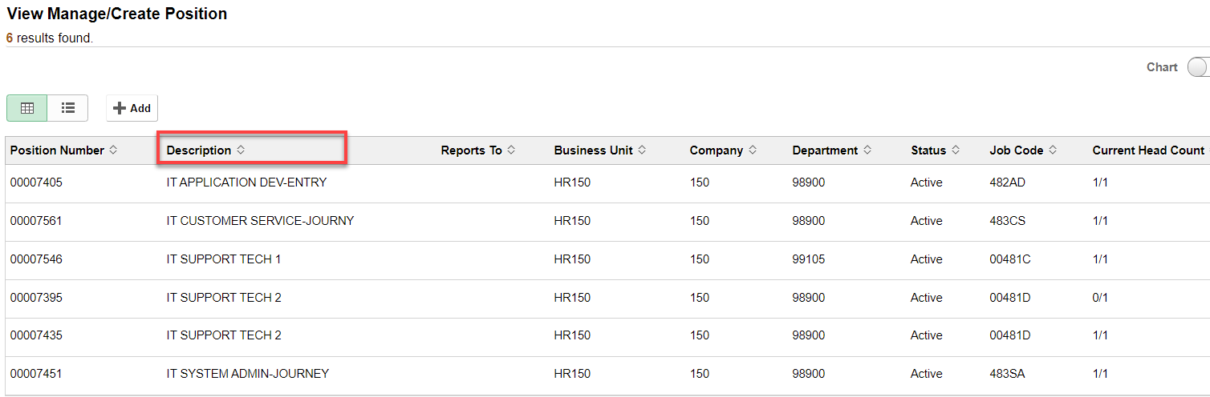

Click on Clone.

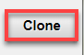

Put Effective Date (be sure it is the start date or before start date), Continue.

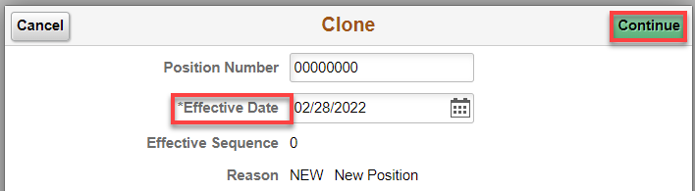

Position Data: Add new Job Code (search if necessary) – the rest of job information will autofill (BE SURE JOB CODE INFO IS CORRECT because it pulls the info from it) – Change if necessary
Just fill in the * required fields – nothing else (Classified must have Salary Admin Plan and Grade). Next.

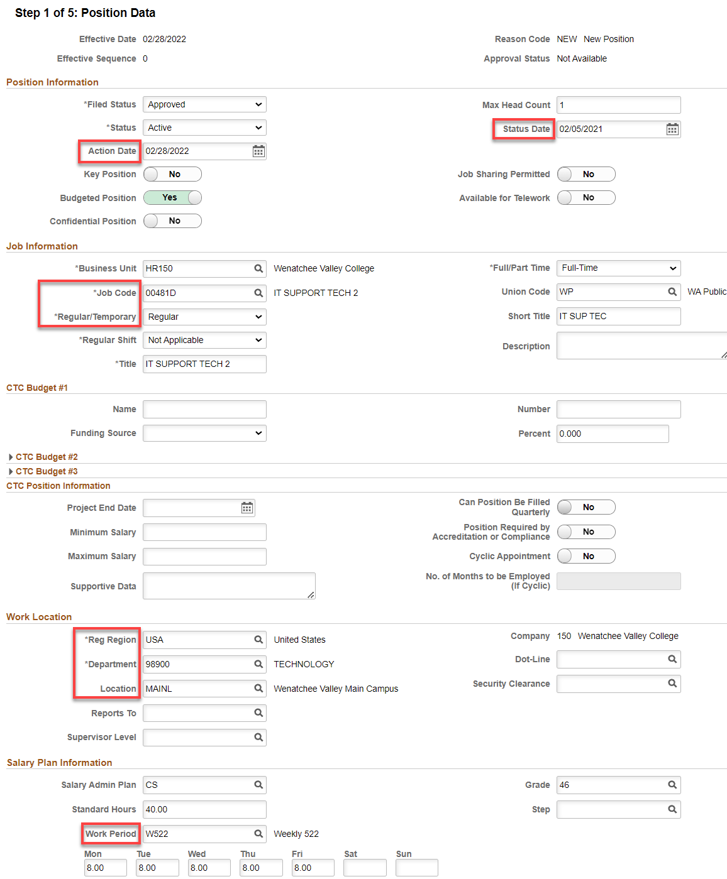

Step 2: Specific Information
Leave FTE at 0.00 or change to 1.00 (I like 1.00 so it autofill’s the New Employment Instance).
Next

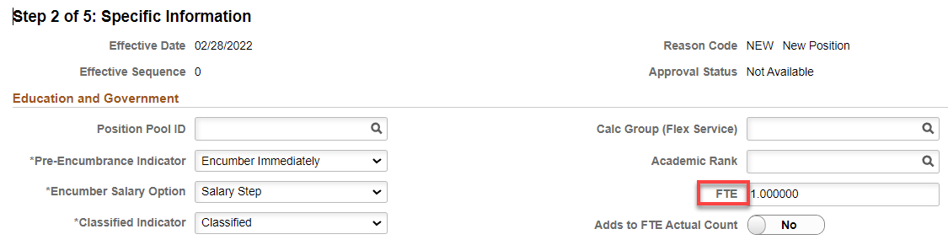

Step 3: Attachments
Nothing to add
Next

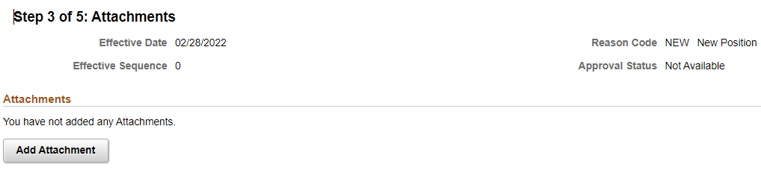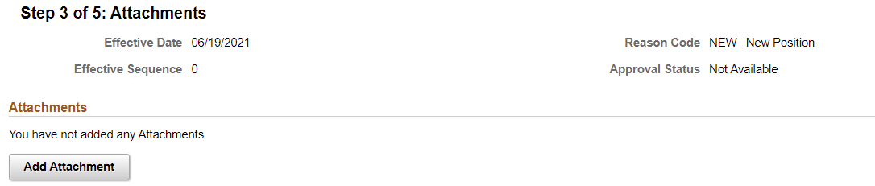

Step 4: Budget Incumbents
Choose not to Update Incumbents. Next

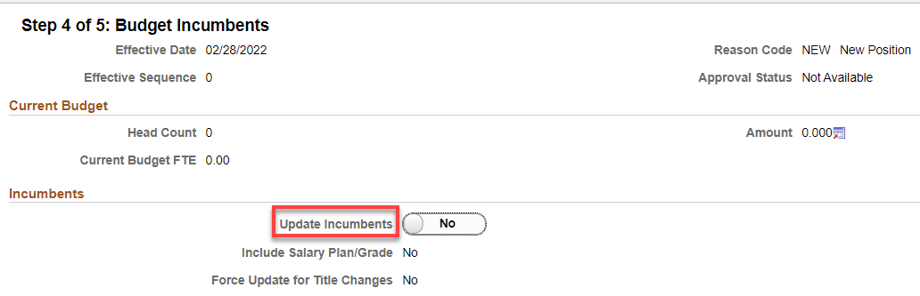

Step 5: Review and Submit
Review and hit Submit.

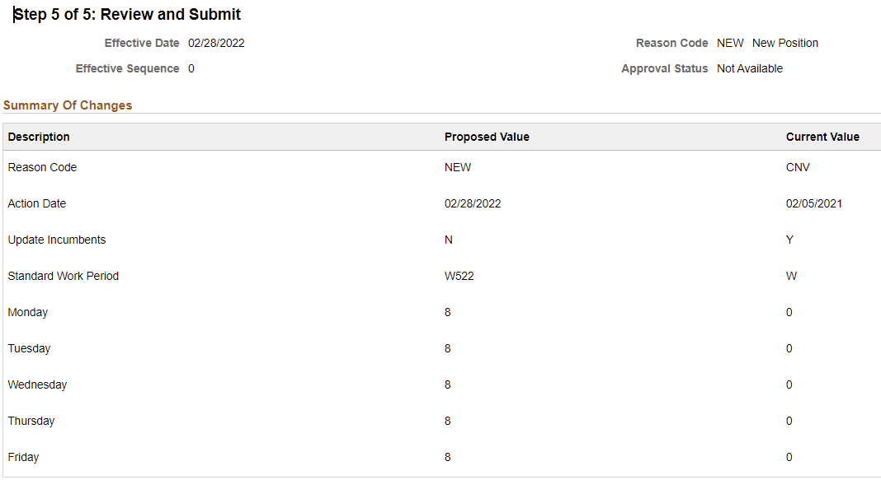

You may get the following warning: It means the job code does not match the position (it’s because, in this case, I need to update the Job Code). Click Ok.

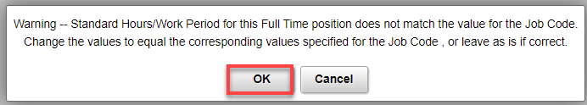

Position Confirmation
WVC has no approvers except Reagan or Tim
Click on Multiple Approvers to see who can approve

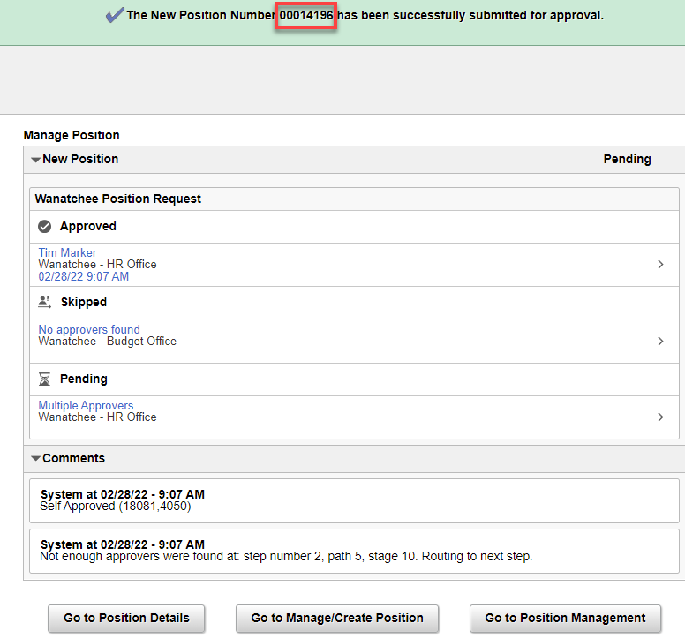

Write down the new Position Number

Check notifications (flag) for an alert or action to approve (if you are the approver). Click on the Action needing approval.

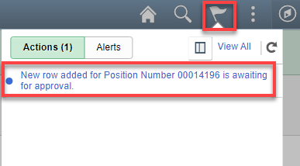

Approve, Deny or Pushback.

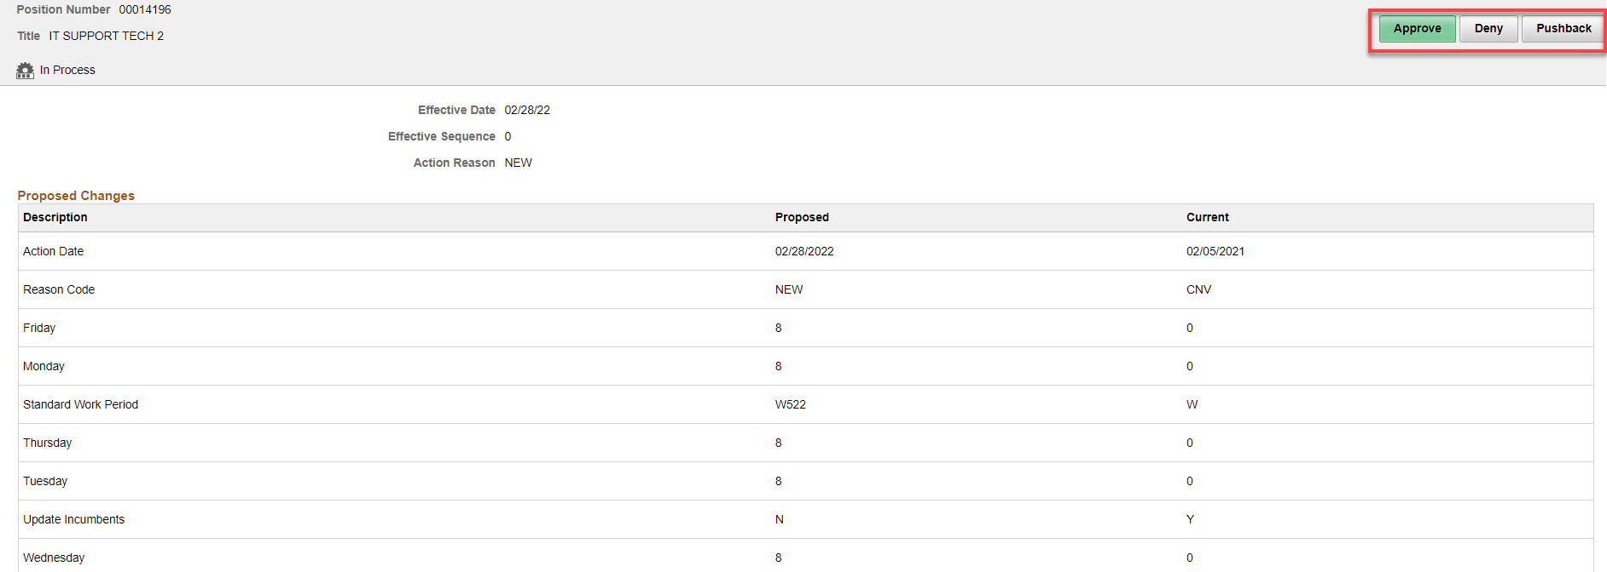

Submit.

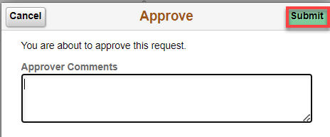

That’s it!

