View/Download/Print W-2/W-2C Form for Employee – (the QRG is great!)

Nav>Payroll for North America>US Annual Processing>Create W-2 Data>View W-2/W-2C Forms

The View W-2/W-2c Forms search page displays.
- Enter the Empl ID or appropriate Name field(s).
- Select the Search button.

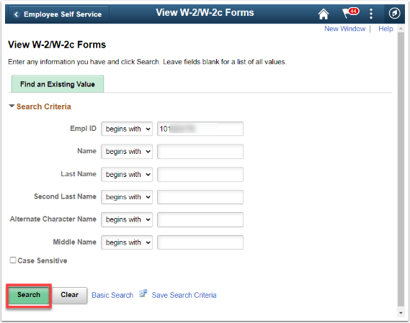

The View W-2/W-2c Forms page displays.
- The forms for the most recent tax year will display. To view other years, select View a Different Tax Year link.

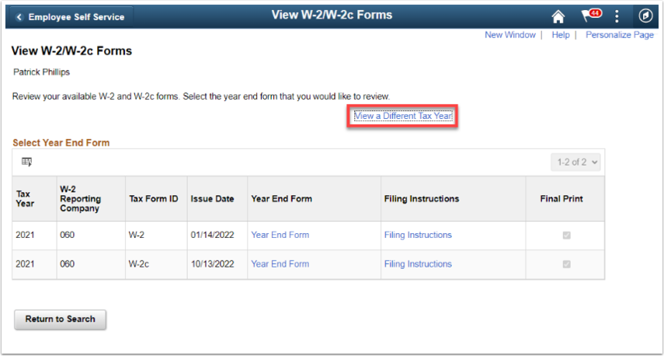

The Select Tax Year list displays.
- Select the desired year from the list.
- Otherwise, select the Return to Search button.

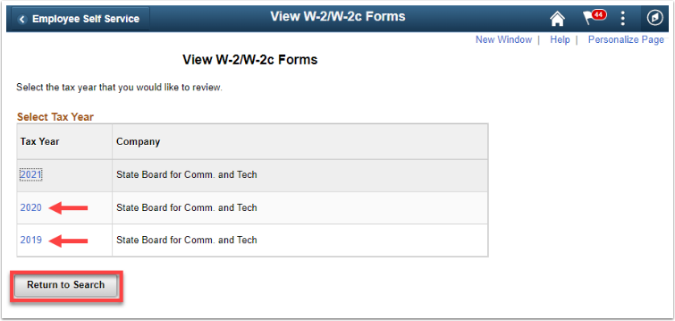

- From the list of Tax Form IDs (W-2 or W-2c), select the Year End Form that you wish to view.
- Select Filing Instructions for the appropriate tax form to view the filing instructions.

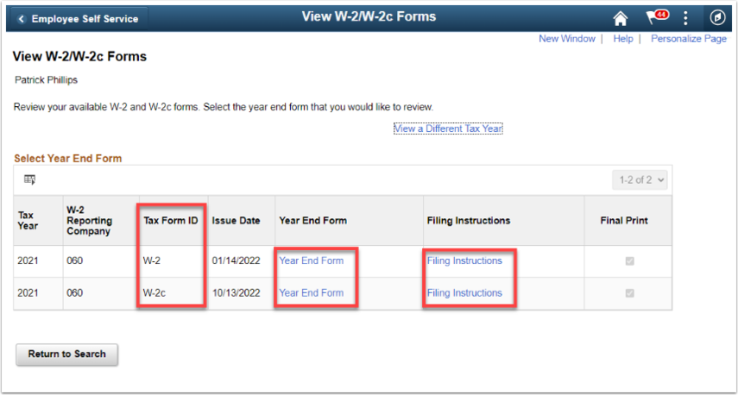

- The respective PDF document will open and could be downloaded and/or printed.
Below is an example of the W-2 Year End Form.
- To close the pdf window, click the X on the tab at the top.
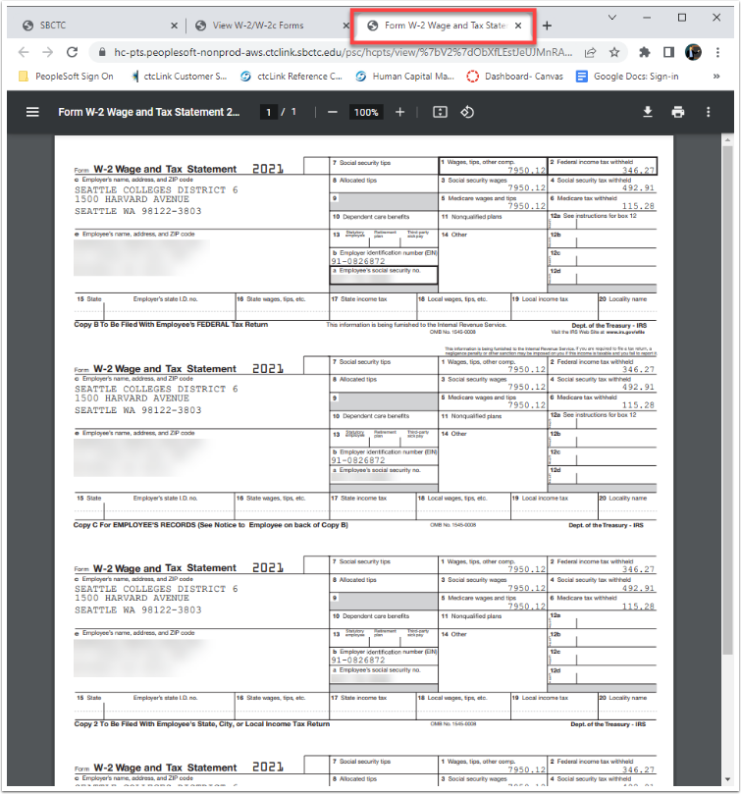

- Below is an example of the W-2 Filing Instructions.
- To close the pdf window, click the X on the tab at the top.
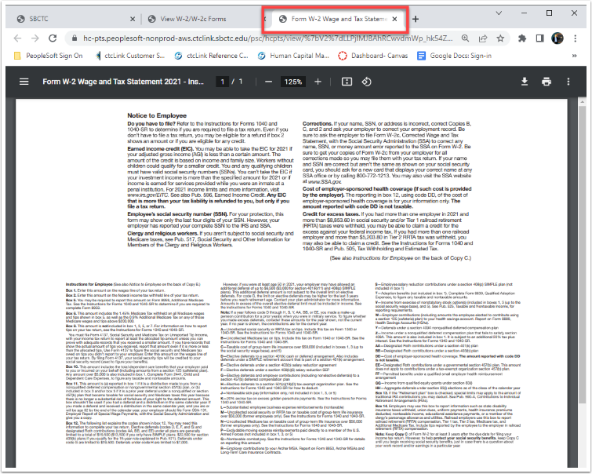

- Below is an example of the W-2c Year End Form.
- To close the pdf window, click the X on the tab at the top.
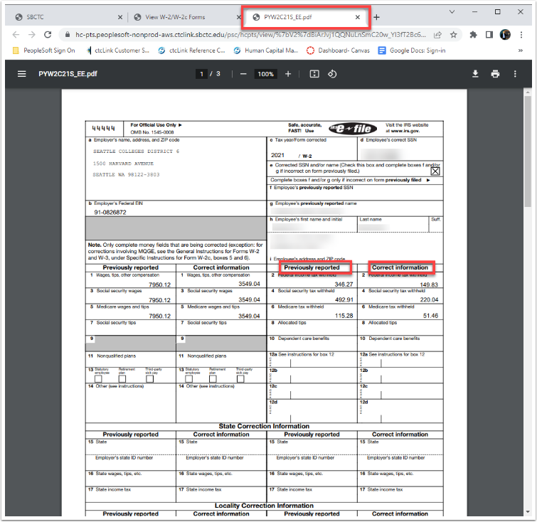

- Below is an example of the W-2c Filing Instructions.
- To close the pdf window, click the X on the tab at the top.
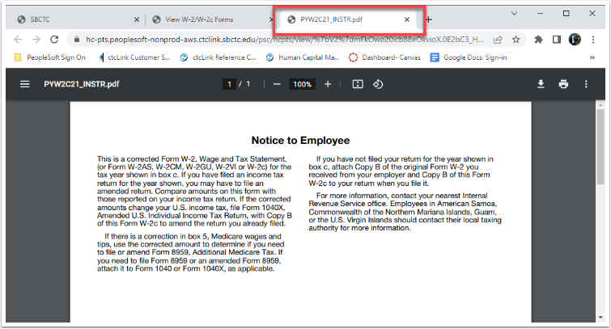
The process to view, download and print W-2/W-2c Forms is now complete.

That’s it!

