To view the W-2 consent status for an employee

Nav>Payroll for North America>US Annual Processing>Year-End/New Year Preparation>Review W2/W-2c Consent Status

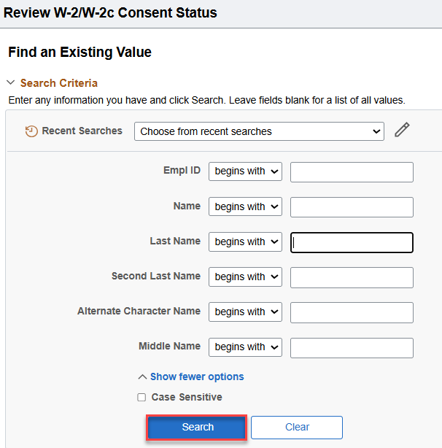

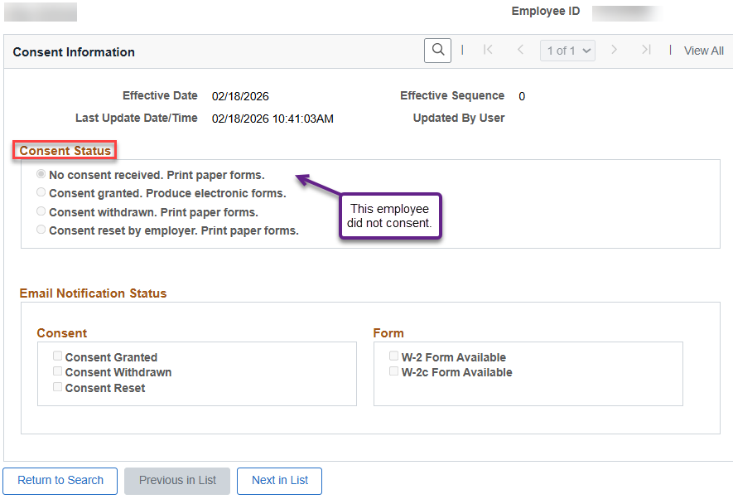
That’s it!

