The Department of Retirement Systems (DRS) website is great for a lot of things. You can always call Employer Support Services at 800.547.6657, option 6, then 2 for help.

First, you have to login to their website at:
https://www.drs.wa.gov/ Home page, click Employers, then ERA Login or go directly to https://eportal.drs.wa.gov/Account/Login. Also see Complete an RFEI guide with step-by-step instructions.

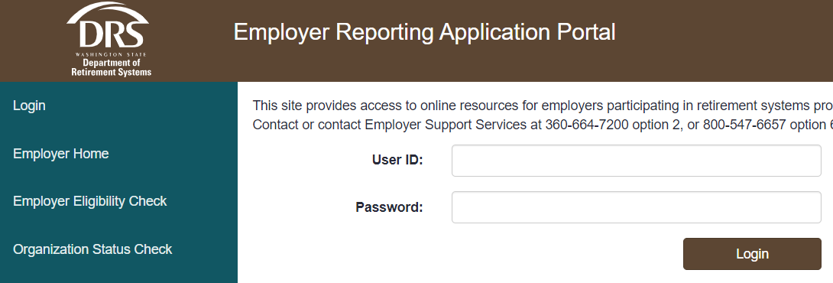

This will take you to Employer Reporting Application (ERA) portal.
Click on Processes and you will see several options.

Member Management: Click on Member Management, Start and enter a social security number (SSN) to lookup to see if someone is a member in any plan.

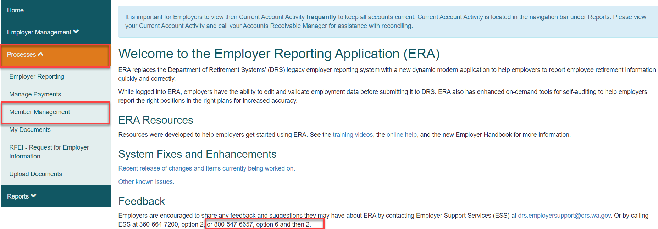

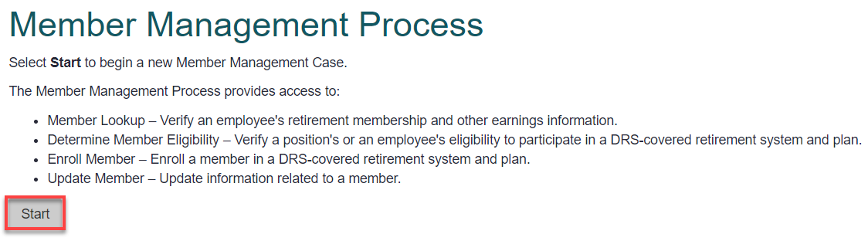
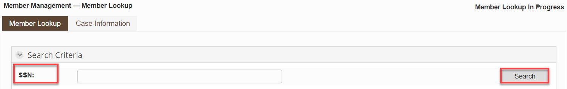

My Documents shows any documents loaded for WVC, including Deferred Compensation enrollments from employees (save a copy of the document in the HR-Business shared folder and make sure to make the changes to the employees listed in their Savings Plan under Benefits Administration-THESE REPORTS DO NOT CHANGE ANYTHING THAT IS ALREADYIN PLACE; IT ADDS TO WHATEVER IS THERE [UNLESS IT SPECIFIES A CHANGE]), Transmittals from payroll, PDF and Excel Interactive Reports that show changes we made in an employee’s account.

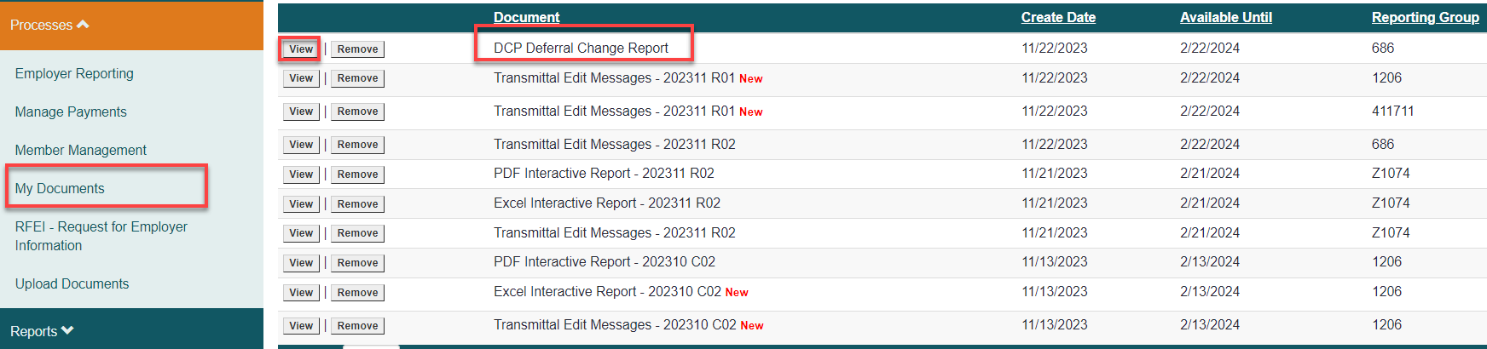

RFEI - Requests for Employer Information shows all the requests that need attention. Anything under the Name column means a person at DRS requested the RFEI; anything that is all Caps means the DRS system autogenerated the request and probably only need separation information for retirement or deferred compensation.

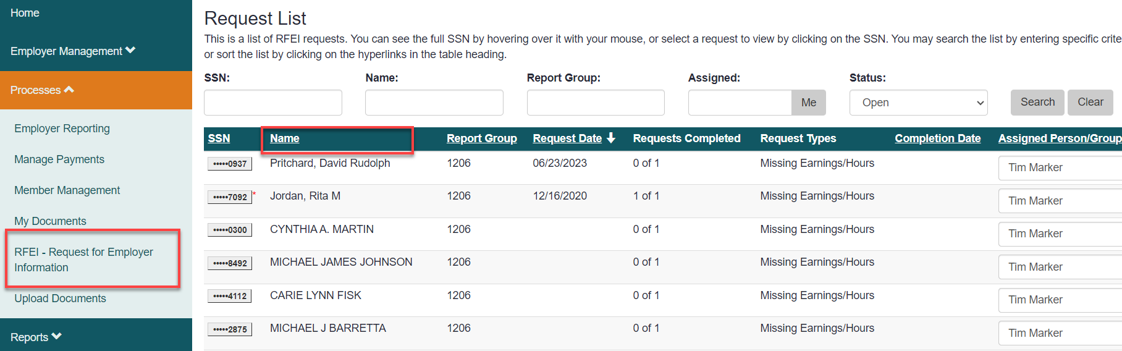

The following will show how to fix some of them.

Example #1: Fixing compensation and reporting hours

Click on the SSN of the person you want to look at. Review the request, click on View Earnings. If you don’t know where to start, contact DRS or Send and message and select the Complete and Send to DRS button and they will respond.
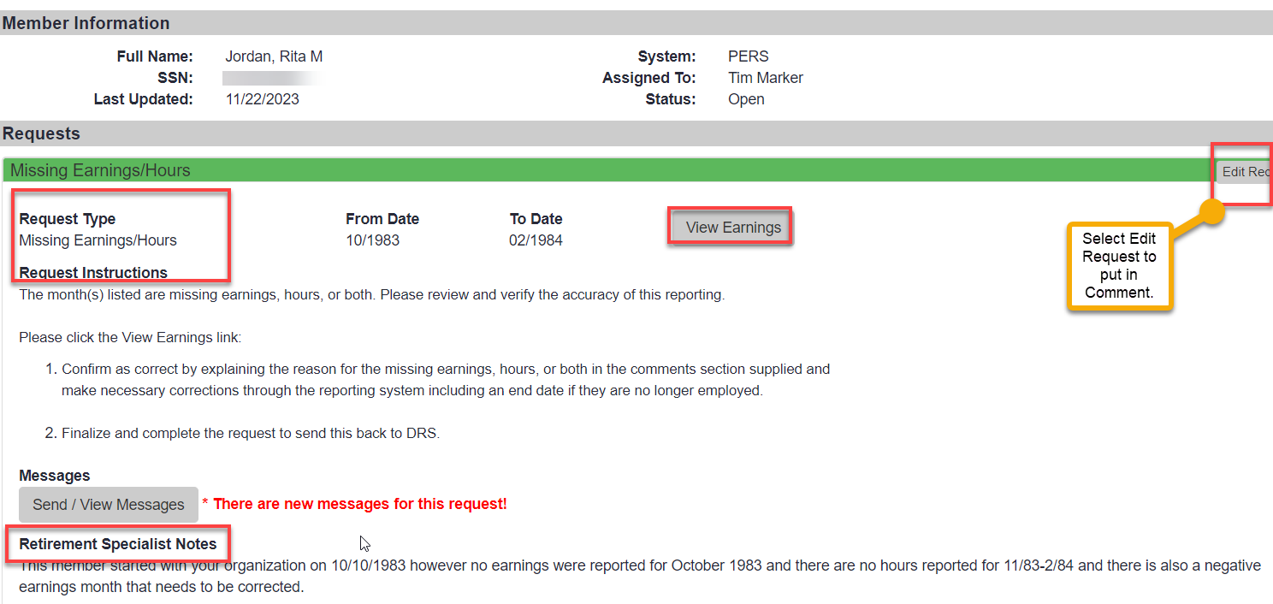
The Comment box was not available because I didn’t choose Edit Request, but I made notes so when I go into ERA, I will know what to put in.

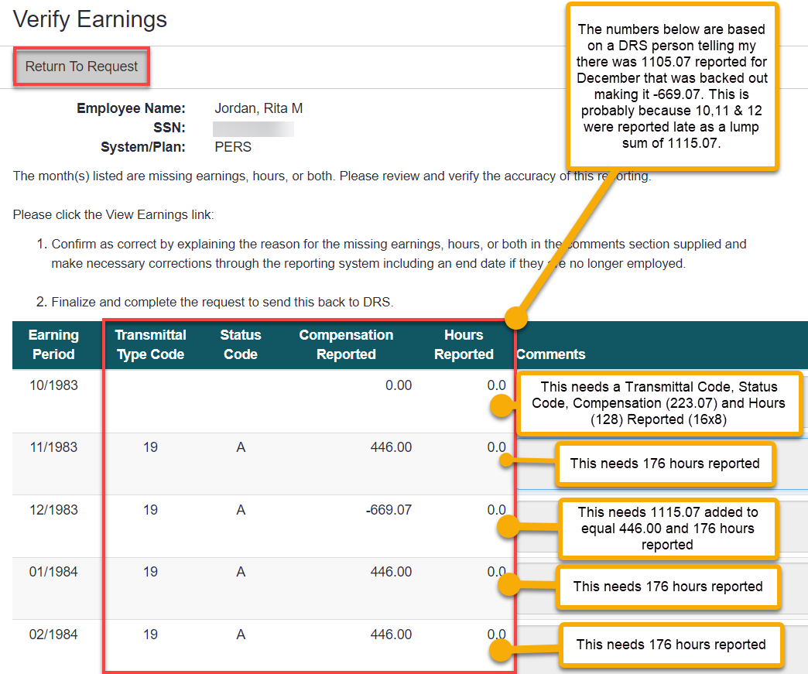
Now that I have all the information I need, Save, copy the SSN, Return to List and go into ERA Employer Reporting and Start a Employer Reporting Process. If you start a ERA but don’t finish, when you come back, you need to go to the Tasks at the top right of the screen to choose it again.

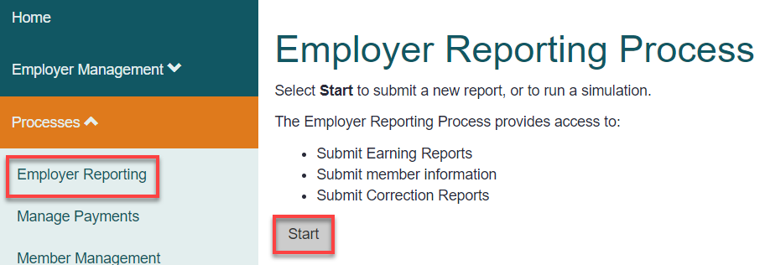

For this Report, choose Reporting Method Interactive and Report Group 1206, then select Next.

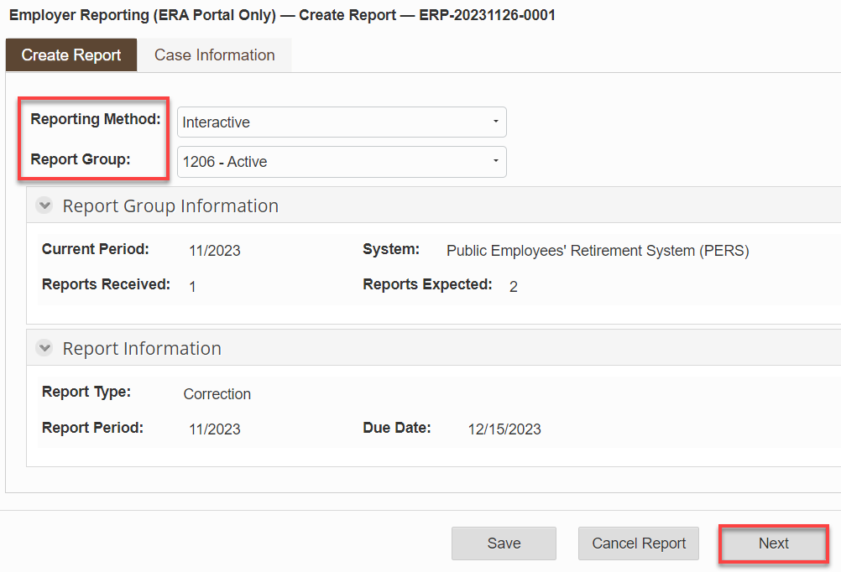

Select Add Member.

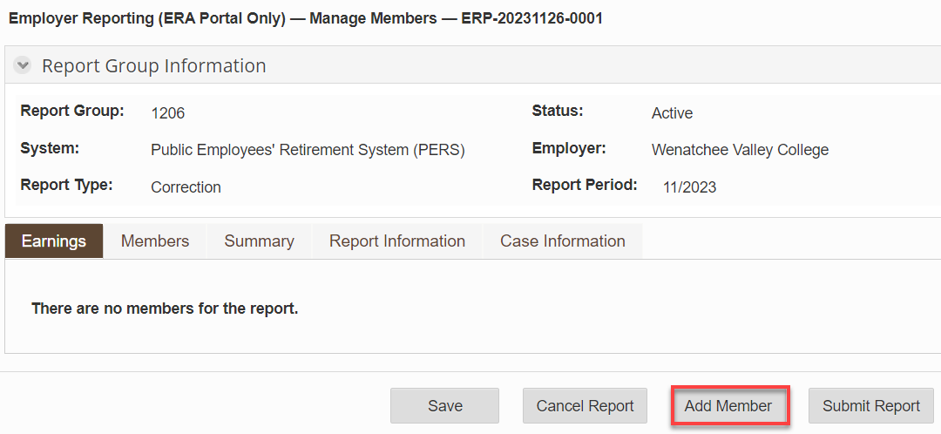

Add SSN, select Search.

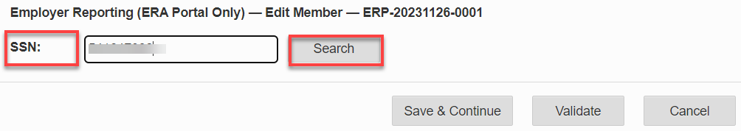
I made the following changes but had to turn it back over to DRS because the validation would never be ok since she had transferred tom PERS 3 and PERS 3 didn’t exist back in 1983.

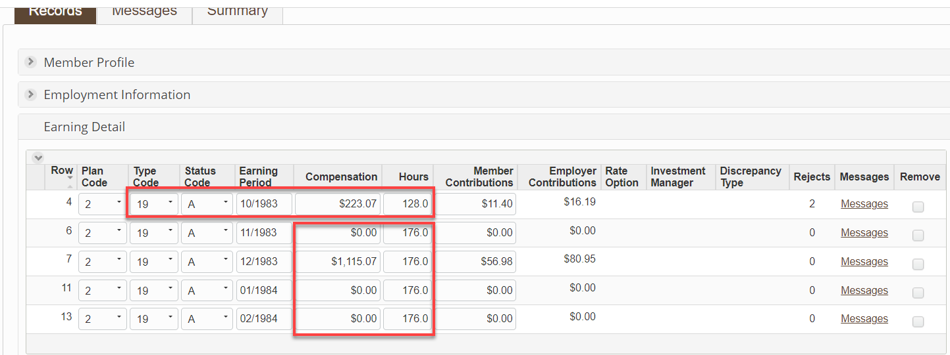

I went to the bottom of the page, selected Validate, saved and returned. Because this had to be fixed by DRS, I went to the bottom of the page again, selected Remove, then back to the bottom of the page and selected Cancel Report.

Example #2: Request askes if we had any furlough days during the pandemic. WVC did not.
- Put in notes, Save
- View Verification of Reduction Efford form, Save, Return to Request
- Finalize Request.
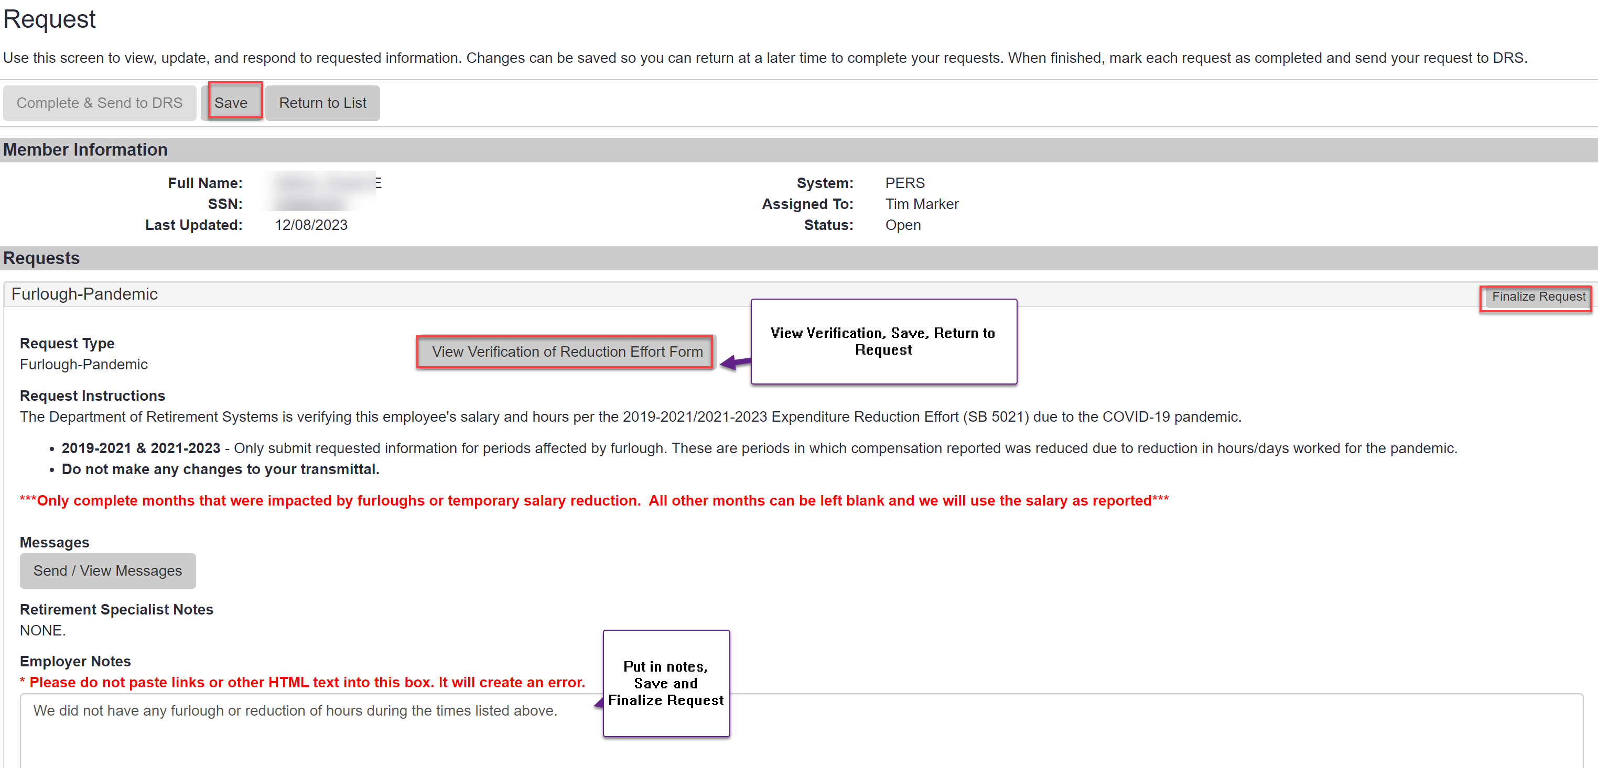
- Complete & Send to DRS
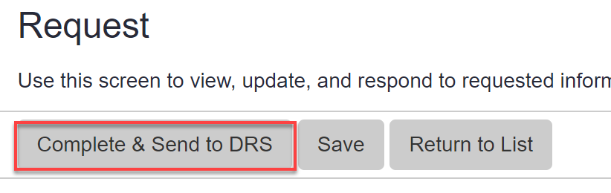

Example #3: Request needs hours worked 6/2005.

- Look in Legacy to see if the info is on the paystub (if employed full time, one could look to see how many working hours that month).
- Add notes to request.
- Save.
- Open a new tab and go to DRS and complete ERA.
- Add to note in Request when ERA is completed, Save, select Finalize Request & select Complete & Send to DRS.

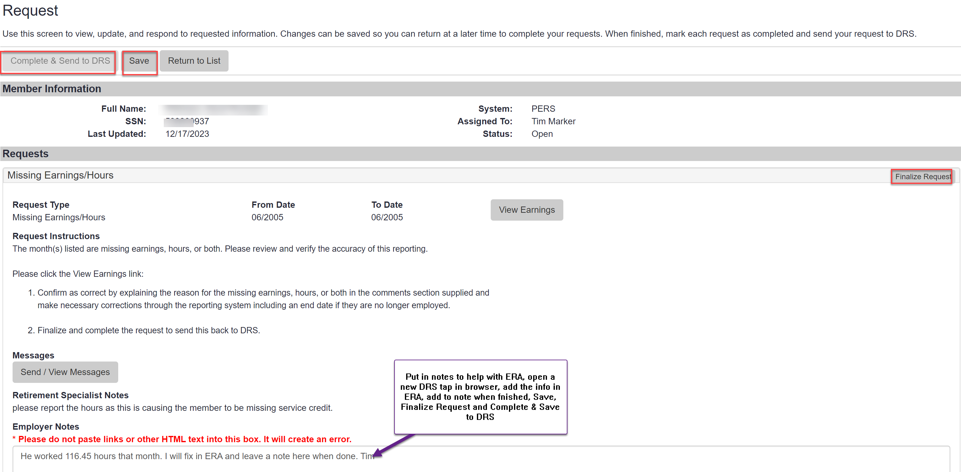

Now that I have all the information I need, Save, copy the SSN, Return to List and go into ERA Employer Reporting and Start a Employer Reporting Process (or better yet, open another browser tab and go into DRS). If you start a ERA but don’t finish, when you come back, you need to go to the Tasks at the top right of the screen to choose it again.

For this Report, choose Reporting Method Interactive and Report Group 1206, then select Next.

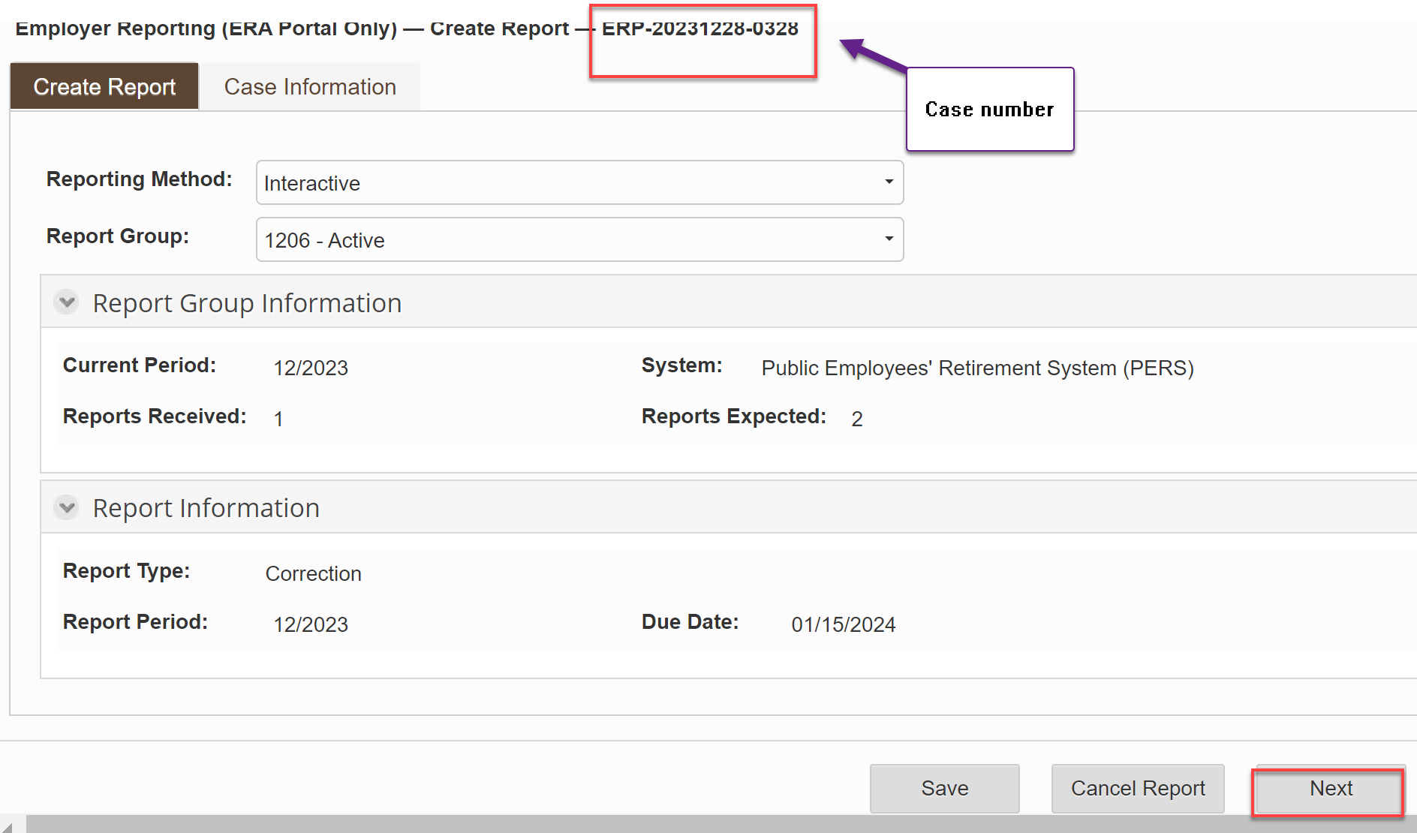

Select Add Member.
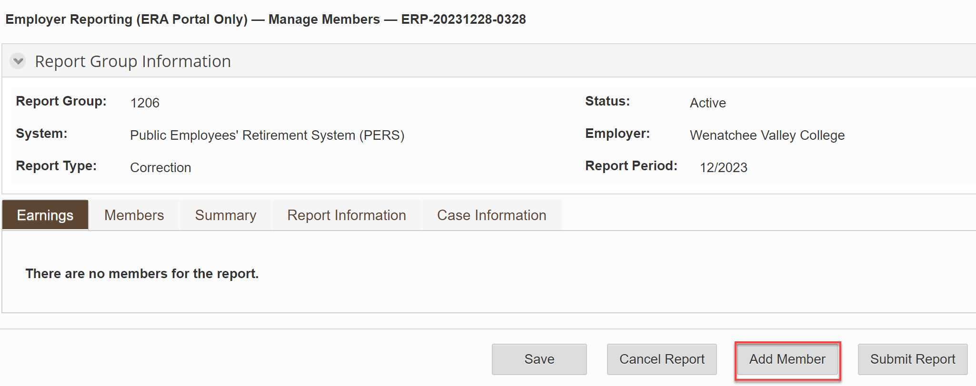

Add SSN, select Search.

Under Earnings Detail, Choose Type Code, Status Code, Earning Period, leave Compensation 0.00 since they already have that, add Hours and select Validate. Fix any error messages and Select Save and Return.

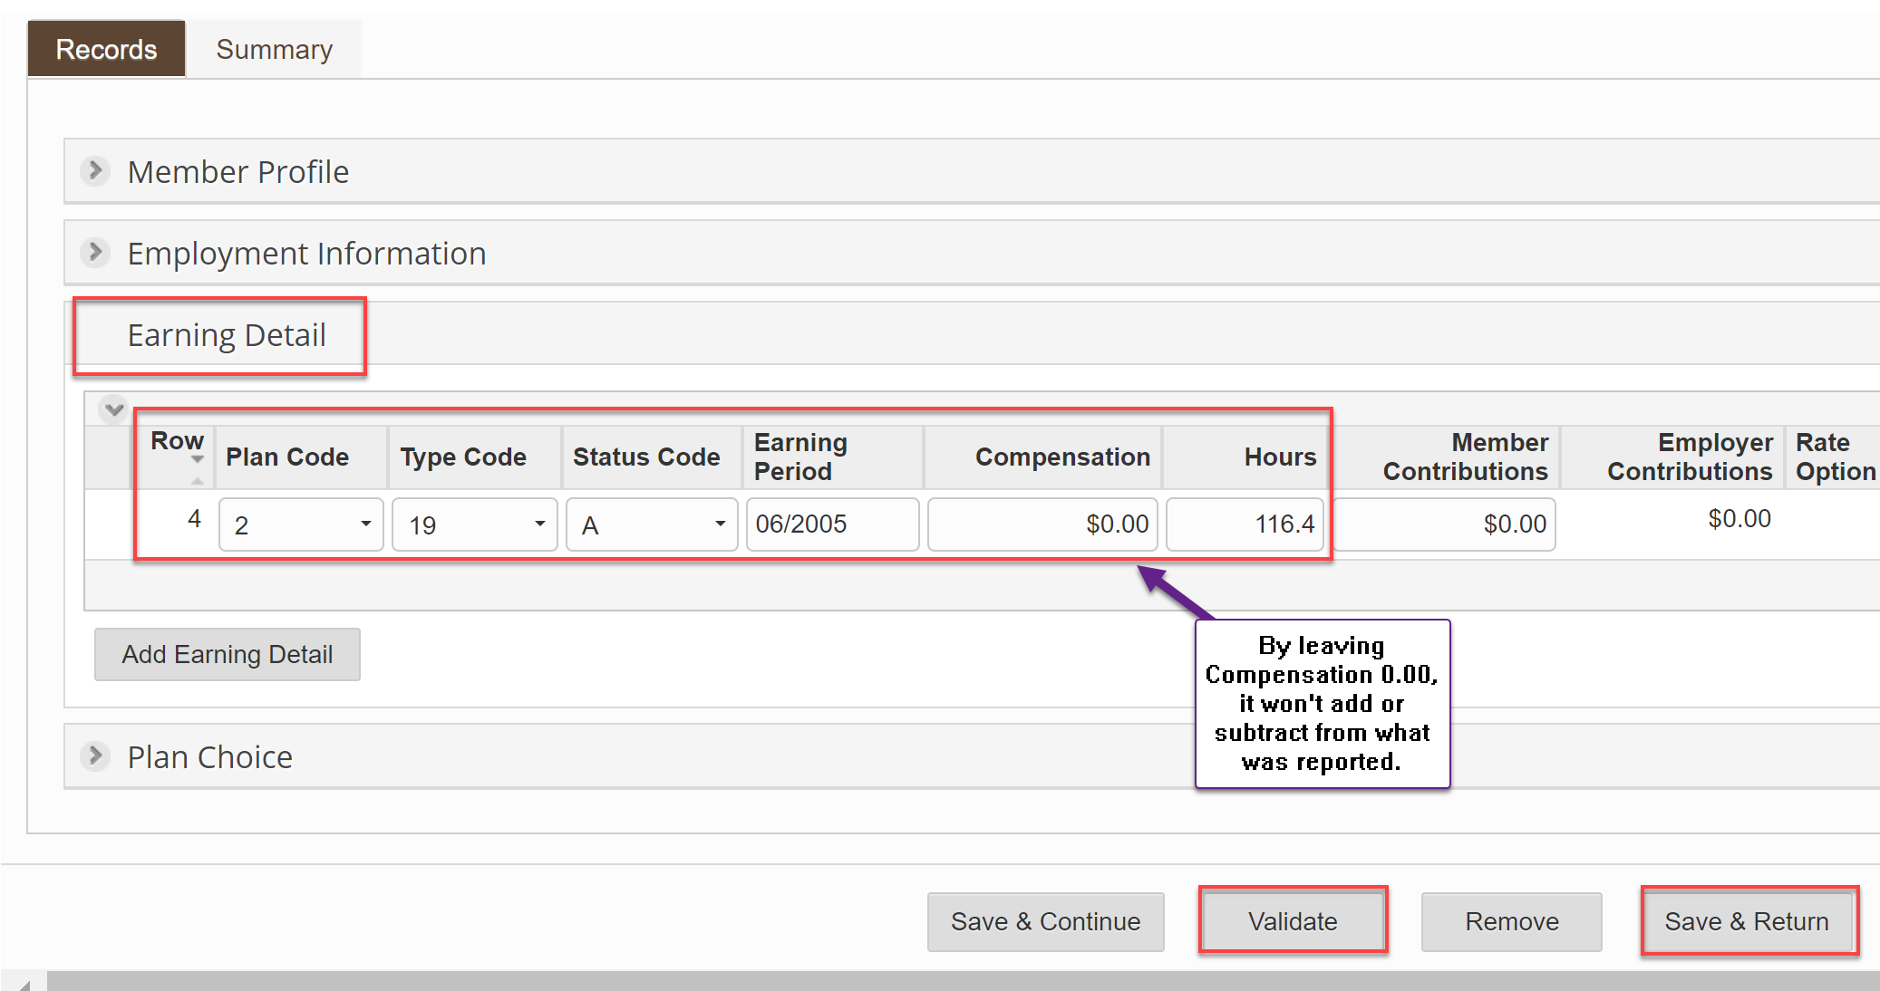

If finished, select Submit Report.

Now, copy the ERA info (Employer Reporting (ERA Portal Only) — ERP-20231228-0328), go to the Request, add that it was fixed and paste the ERA number, select Finalize Request then select Complete & Send to DRS

Example #4: Putting in Separation dates

- Login to two DRS windows (one for REFI Request for information and one for ERA.
- Open a request and copy the SSN.
- Start an ERA.
- Select Interactive for Reporting Action and 1206 for Reporting Group.
- Select Next.
- Select Add Member.
- Add SSN and select Search.
- Select Employment Information.
- Select Add Employment Information.
- Clear Begin Date, add End Date, select Validate.
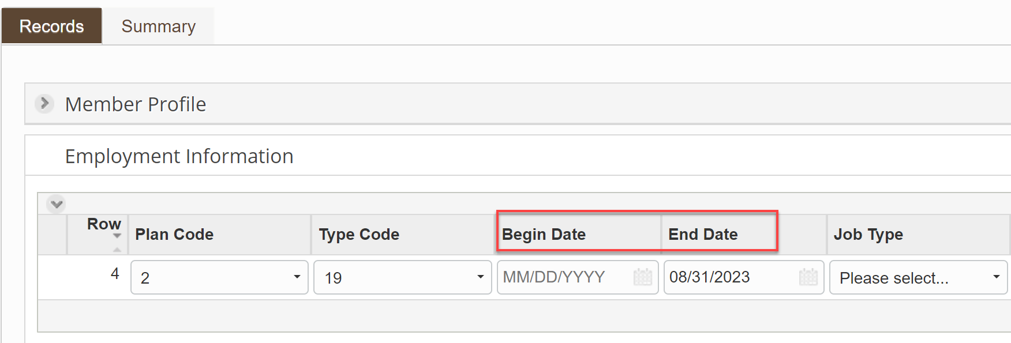
- Select Save and Continue or Save and Return.
- Select Submit Report if finished.
- Go to Request and add the date finished and paste the ERA number, Select Finalize Request and select Complete & Send to DRS.
- If adding another member to ERA, copy the SS from the request, go to the ERA tab and select Add Member to add another member for correction (you can add as many members to an ERA as needed (they must be in the same Report Group, e.g., 1206).

Example #5: Adjusting for a default into PERS2 and then the person chose PERS3 (after being paid). THIS DIDN’T NEED TO BE DONE (I DELETED IT) BUT LEFT THE EXAMPLE FOR HOW TO DO SOMETHING SIMILAR IF NEEDED.

Here is the PSHUP to “R” refund the PERS2 deduction of 130.73 and “A” add a PERS3 deduction of 99.35.
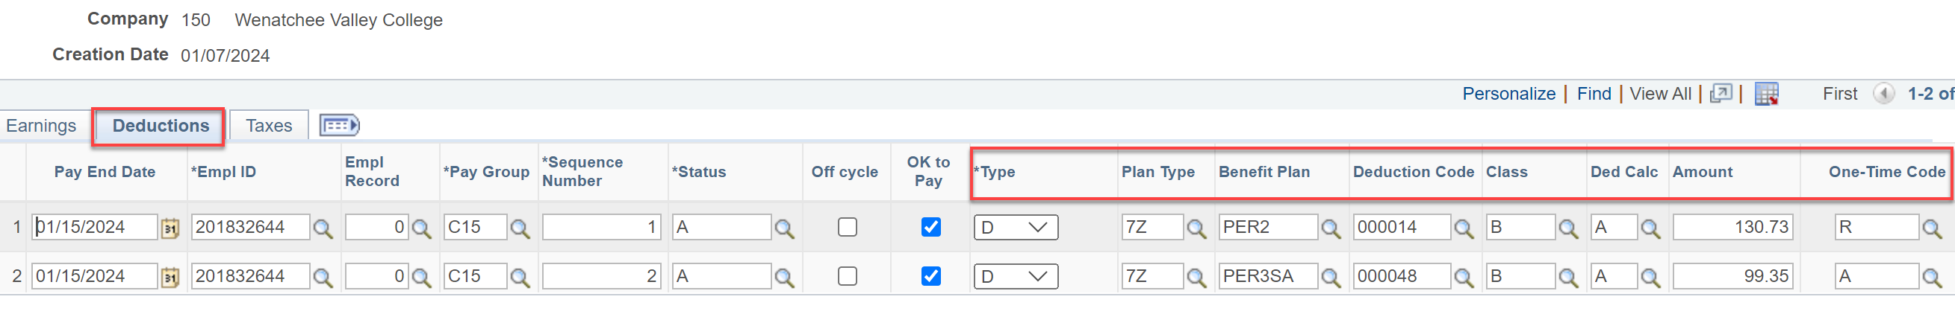

Example #6: DRS needed hours and compensation but this employee had a break in service so this is how to put in zero compensation and hours.

- Login to two DRS windows (one for REFI Request for information and one for ERA).
- Open a request and copy the SSN.
- Start an ERA.
- Select Interactive for Reporting Action and 1206 for Reporting Group.
- Select Next.
- Select Add Member.
- Add SSN and select Search.
- Select Employment Information.
- Select Earnings Detail.
- Add as many rows needed.
- The Plan Code should populate, add B for Status Code, add Earning Period(s), leave Compensation and Hours zero.
- Select Validate (fix any errors).
- Select Save and Continue or Save and Return.
- Select Submit Report if finished.

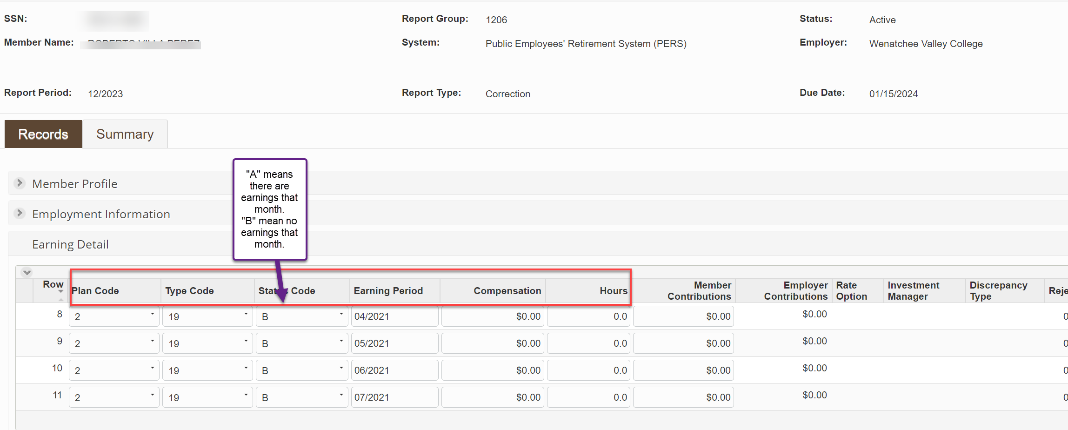

- Go to Request and add the date finished and paste the ERA number.
- Select Finalize Request and select Complete & Send to DRS.
- If adding another member to ERA, copy the SS from the request, go to the ERA tab and select Add Member to add another member for correction (you can add as many members to an ERA as needed (they must be in the same Report Group, e.g., 1206).

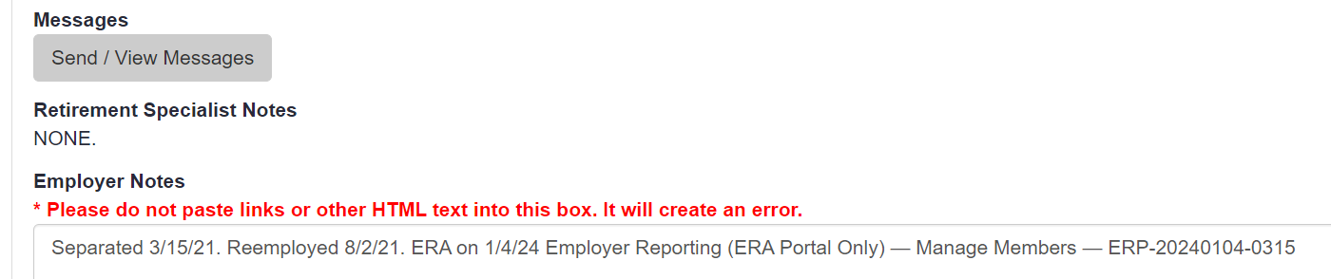

Example #7: Adjusting TRS member for compensation and hours not reported due to not defaulting or adding a retirement plan timely.

Login and get to this point as usual.

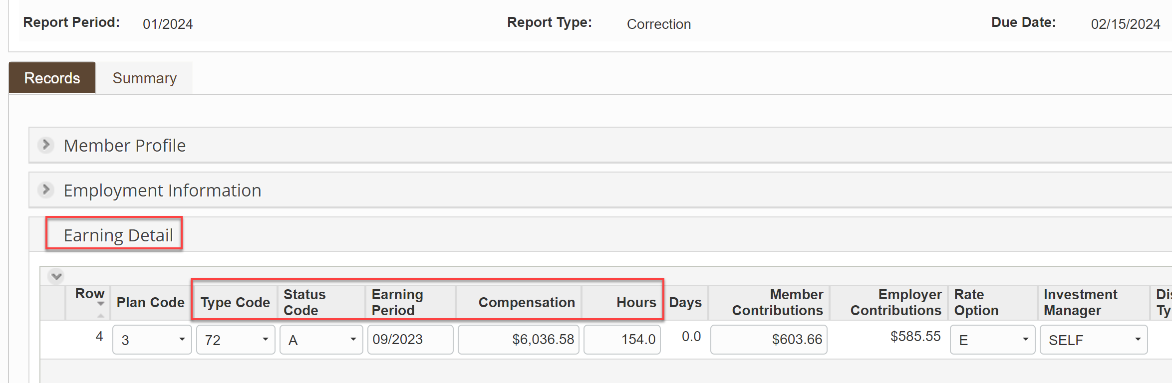

Validate, Save and Submit.
Create a PSHUP file for employee portion. DRS will bill us for employer portion.

Example #8: Reporting retire-rehire member for compensation and hours not reported due to not being changed to rehire in DRS Transmittal in Benefits Administration in a timely manner.

Login and get to this point as usual. Use A and B payrolls for the month. Plan Code 0 for no plan

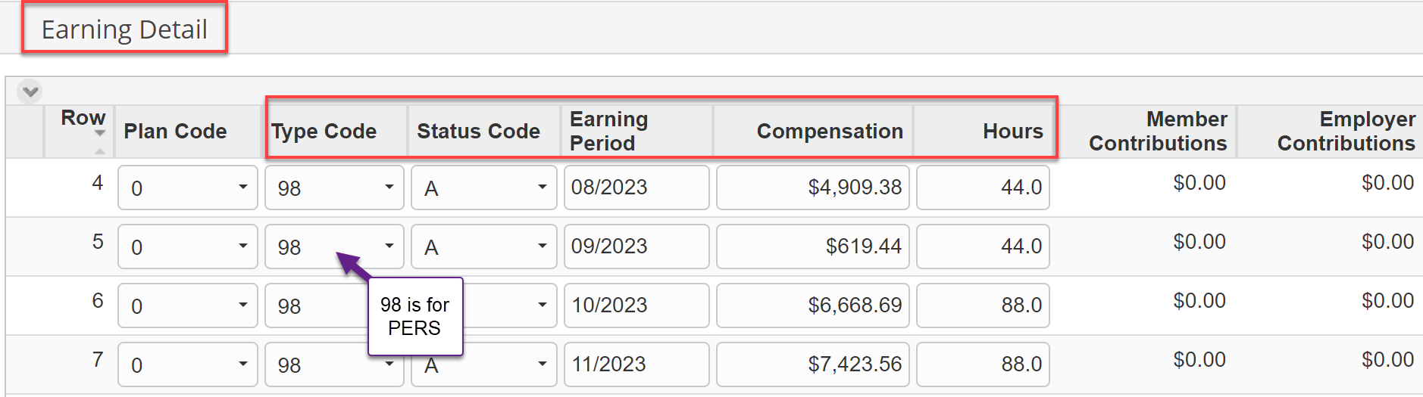
Validate, Save and Submit.
Example #9: Reporting missed Deferred Comp payment because he was termed in retirement and it termed him in DCP.

- Log in to ERA
- Click the Processes drop down arrow
- Select Employer Reporting
- Click “Start”
- "Reporting Method” should be Interactive
- “Report Group” should be 686
- Select the “Correction” bubble
- Click “Next”
- Click “Add Member” at the bottom of the screen
  - Enter a SSN
  - Click Search
- Click the Defined Contributions drop down arrow
  - Click "Add Defined Contribution"
  - Enter the withheld amount
  - Ensure the Pretax or Roth selection is chosen
- Click Validate
- Click Save & Return
- Click Submit Report

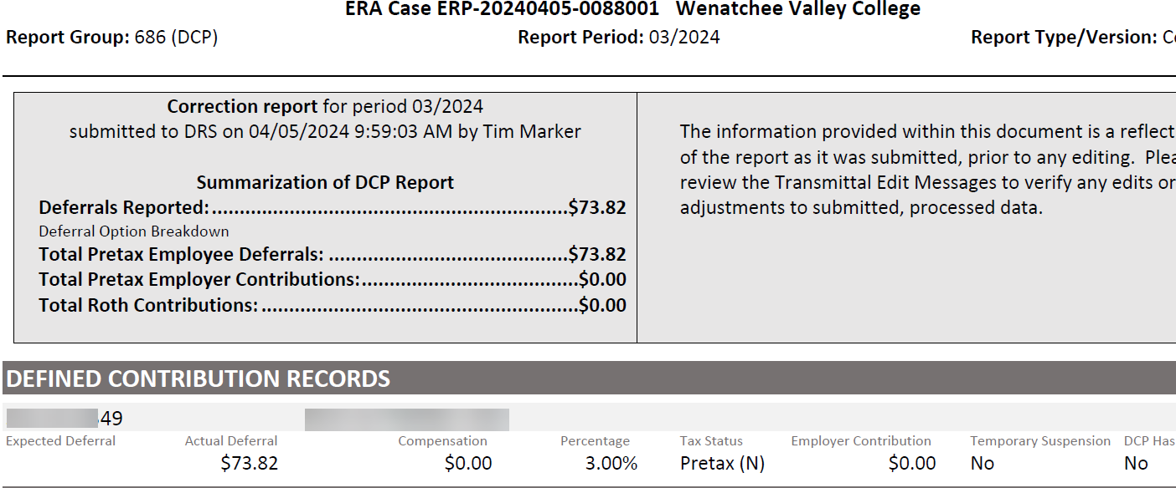

Example #10: DCP monies taken from check but no account with DRS. Nothing to correct with DRS; just do a PSHUP.

Here are the details for the PSHUP.
When you get to the last field on the right, the one-time code, use the drop down and enter it as a refund.
Make sure you enter the dollar amount as a positive not a negative.
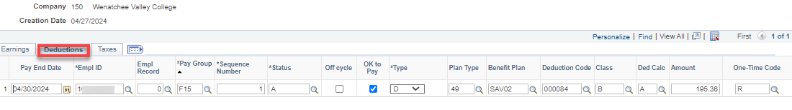

Example #11: Putting in Separation dates, Compensation and Hours for termed employees. Follow all other things to do in Example #4.

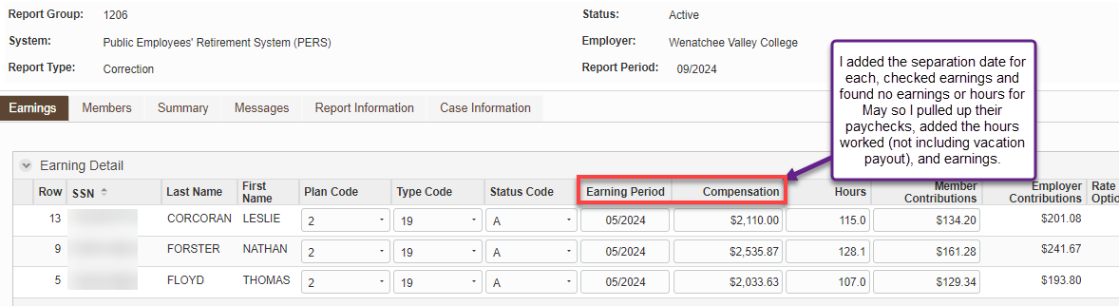

Example #12: Putting in separation dates for DCP for termed employees. Follow other instructions above to get to the ERA for DCP 686.

- Log in to ERA
- Click the Processes drop down arrow
- Select Employer Reporting
- Click “Start”
- "Reporting Method” should be Interactive
- “Report Group” should be 686
- Select the “Correction” bubble
- Click “Next”
- Click “Add Member” at the bottom of the screen
  - Enter a SSN
  - Click Search
- Click Employment Information
  - Click "Add Employment Information”
  - Enter the withheld amount
  - Enter end date
- Click Validate (if the validation message states no enrollment form or no open enrollment, etc., Click Remove and go to the next Member (#22 above), if applicable.
- Click Save & Return
- Click Submit Report when all members have been added

Example #13: Putting in Hours for employee that did not receive service credit for September through December 2018. Lookup in Legacy – not found because they were not reported so look at work schedule and count the work days on a calendar.

