Cannot View Paychecks as PDF

If you cannot view any of your paychecks as a PDF, you probably have your Screen Reader mode on. Here is how you can fix this:

1. In ctcLink, click on My Preferences, General Options: Set the Accessibility Layout to: Screen reader mode off. Save.

2. Log out, clear browser cache and re-start the internet browser.

3. Login and click through the tiles to get to Payroll tile, Paychecks.

Here’s the process with screenshots:

1. Click on My Preferences, General Settings.

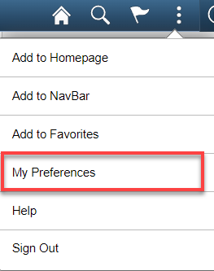

Cause of the issue: Accessibility Layout in My Preferences is set to Screen reader mode on

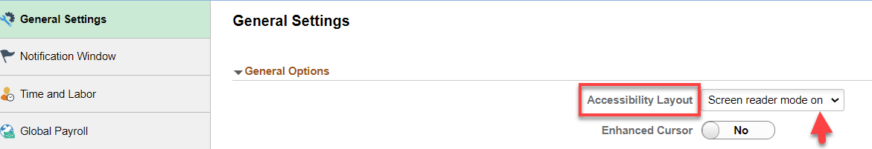

Set the Accessibility Layout: Screen reader mode off, save.

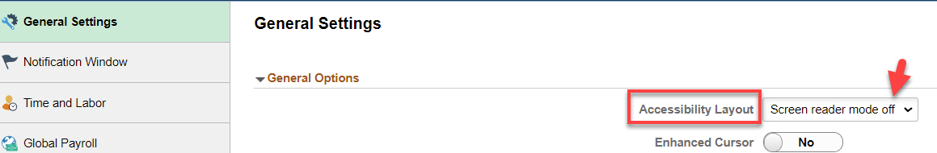

Select Save. Then select Ok.

Log out, clear browser cache and re-start browser.
Login and click through the tiles to get to Payroll tile, Paychecks:

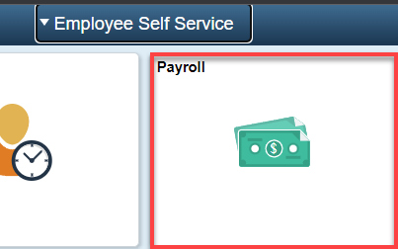

Paychecks are listed in the normal format and the chevron icon is enabled and available to link to the PDF version of a paycheck. Click on the chevron icon to view the PDF pay advice/check for pay period:

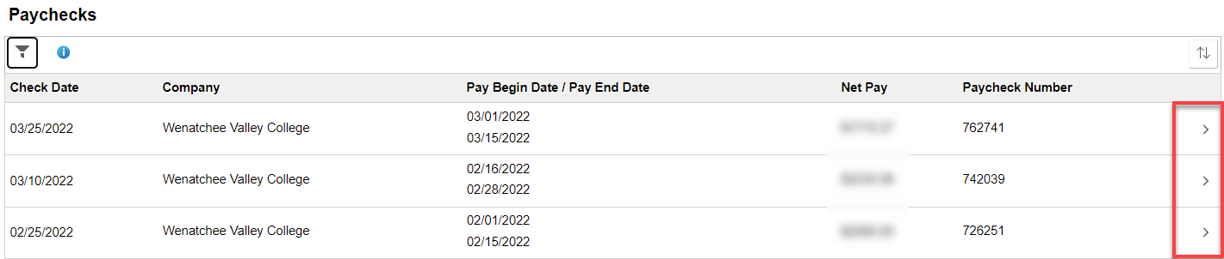

If you have PDFs opening in Adobe, you will see a PDF “Icon,” like the one below, download somewhere on your screen. Click on it to open the PDF.



If you have PDFs opening in your browser, the PDF will display, if pop-ups are allowed:

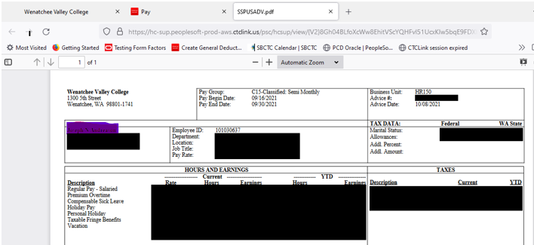

That’s it!

