Running Automated Step Increment Processes (QRG is great)

Nav>Compensation>Base Compensation>Maintain Plans>Automated Step Increment

Add a New Value if this is your first time. If not, select Existing Value.

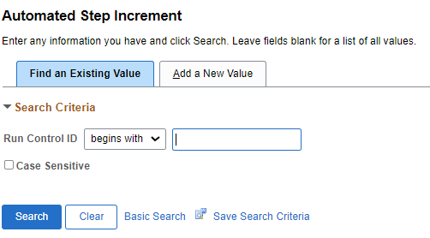
I’m assuming the base information has already been set up (if not, see QRG).

Explanation: Change From Date and End Date for each month and Sal Plan (need to run process for each Salary Plan), Run (automatically saves when you select Run).

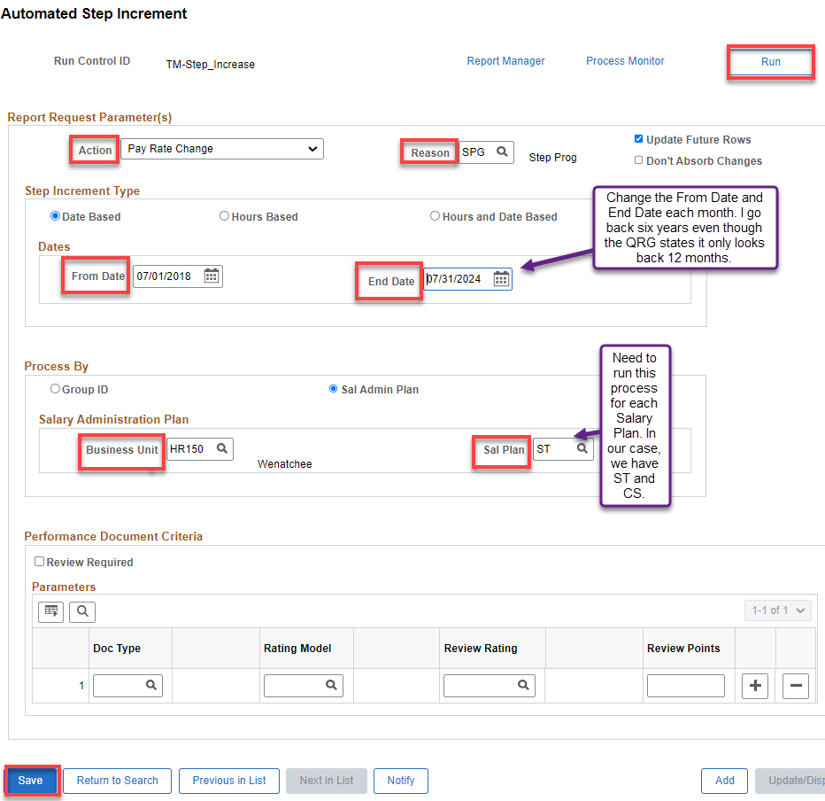
NOTE: The system only looks back 12 months from the last Step Entry Date. If the date is older than the 12 month look back period, a manual step increase will need to be processed. See 9.2 Entering Pay Increases Using Steps QRG. (THE SYSTEM DOES INDEED LOOK BACK SIX YEARS – Try it! )
Calculate Automated Step Increment

Run process HR_CMP007 to select eligible employees, click OK.

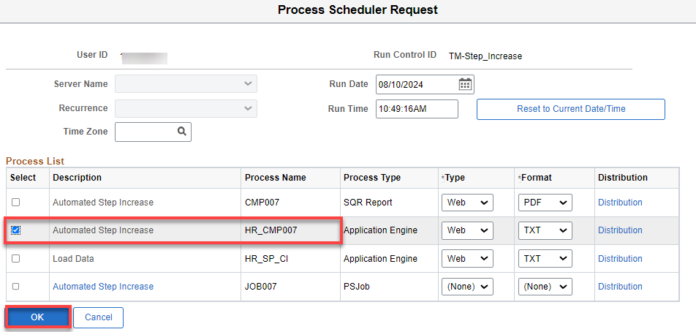

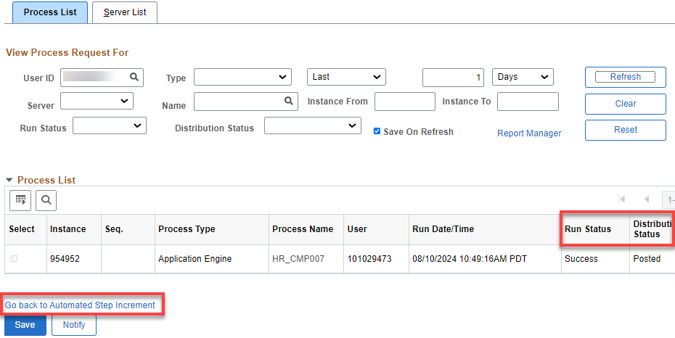

After the process runs to Success and is Posted, select Go Back to Automated Step Increment.
Select Run again.

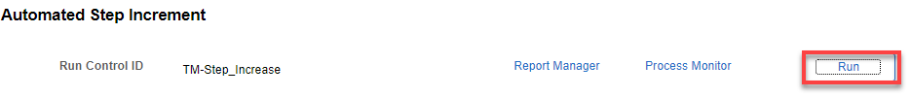
Select CMP007, OK.

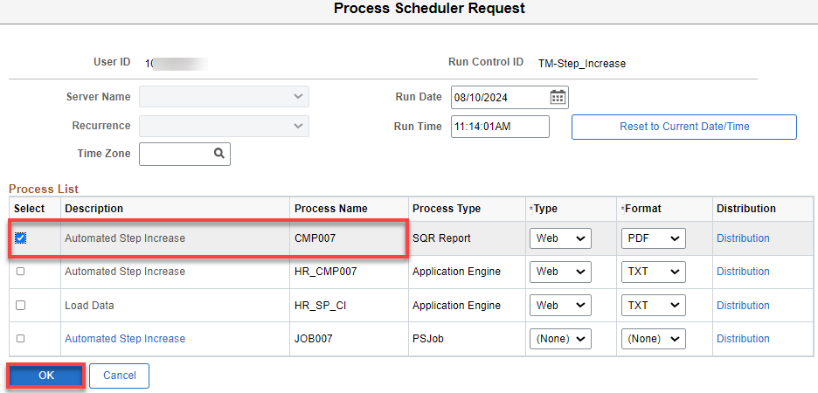

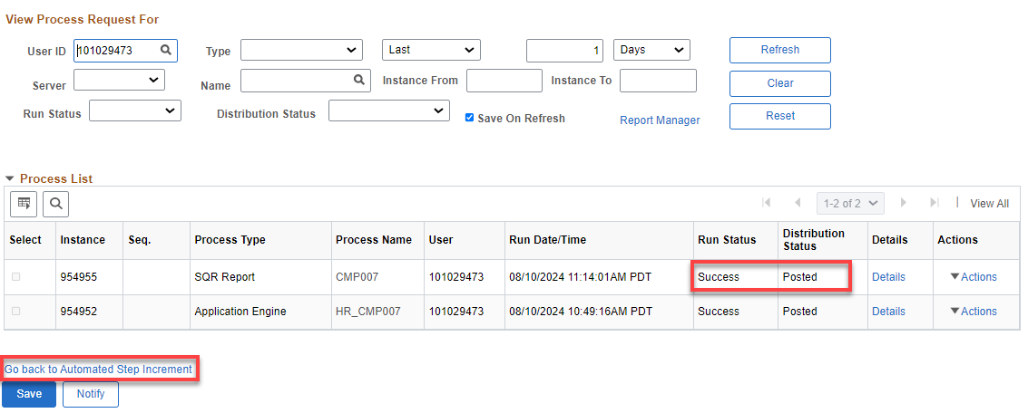

After the process runs to Success and is Posted, select Go Back to Automated Step Increment.
Select Report Manager link.

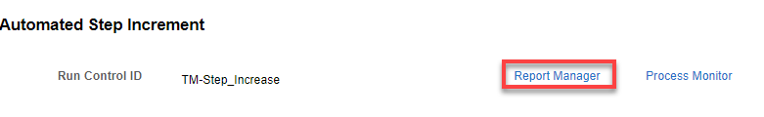
Select CMP007 link.

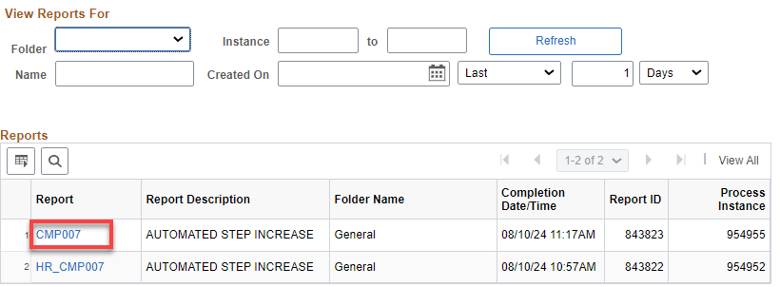

Select cmp007…PDF (the PDF shows who will receive an Increment). I save it in our HR-Budget Folder

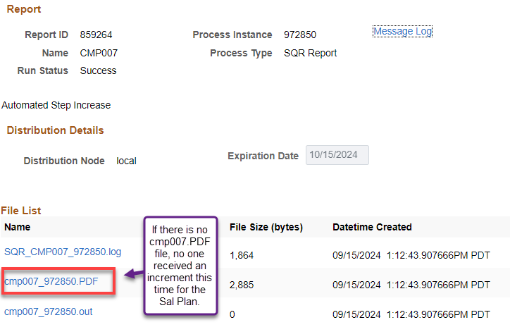

On the Report Index page, select the List button (top left corner) to return to the Report List.
Select the Go back to Automated Step Increment link.
The Automated Step Increment page displays.
Select Run.
The Process Scheduler Request page displays.
Run application engine HR_SP_C1 to update Job Data pages for selected employees.
Select OK.

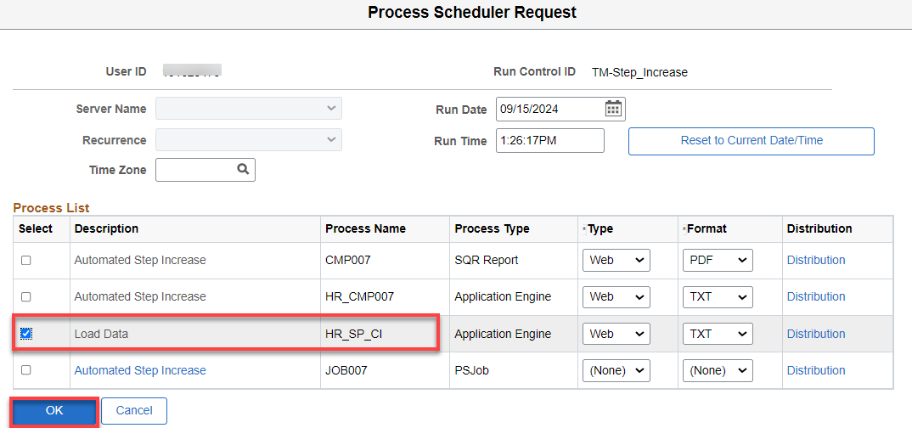

Once the process runs to Success and is Posted, select Go back to Automated Step Increment and rerun the processes for the other Sal Plan(s).

I also keep a query CTC_HR_Job_Data spreadsheet to double check who should be receiving increments.

Be sure to check each employee on the PDF to make sure it posted properly and that it did not add an extra Compensation Row (it will add a new row if the salary is manually entered rather than entered by selecting the Default Pay Components). If it did, remove the old one and be sure to recheck the Apply FTE box under Compensation tab>Conversion tab if it is a less than FT position and you are using that feature. See Below.

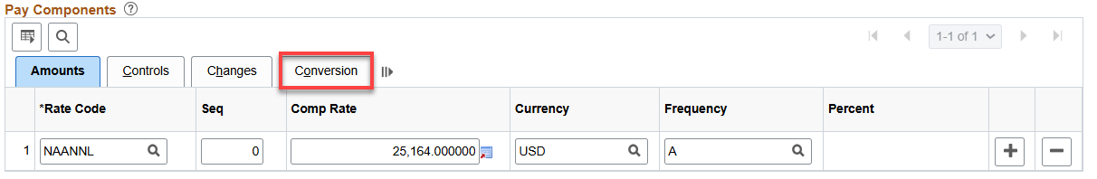

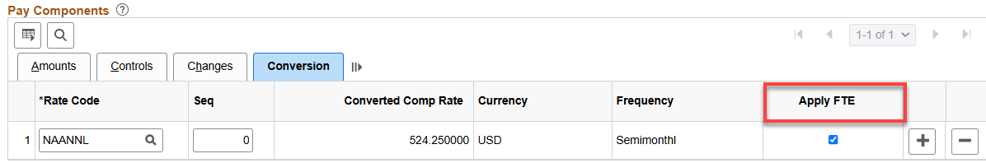

That’s it!

