Updating FWL Assignment Type Rates
1) Navigate to Assignment Type page and click on '+' to add a new row
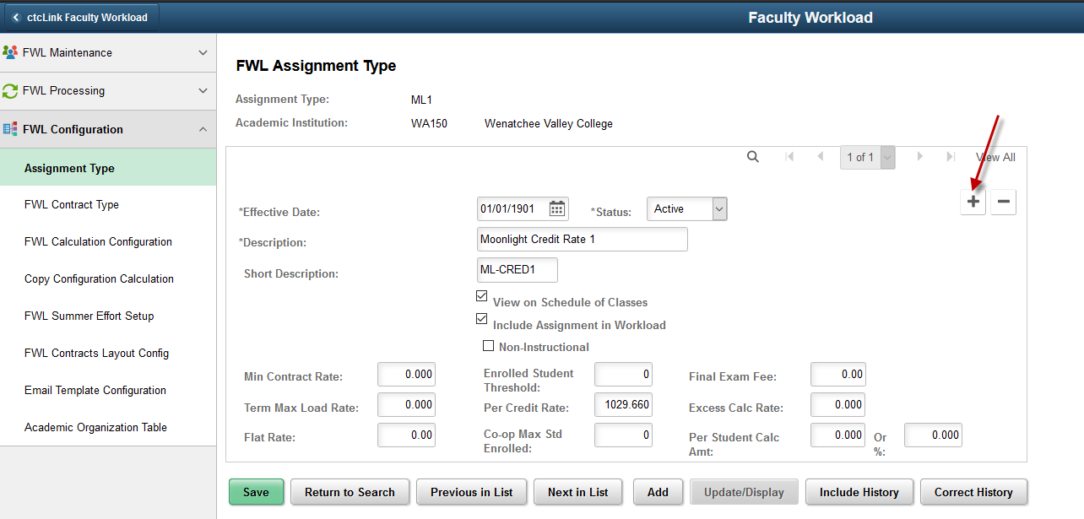

2) Effective Date: Enter new Effective Date
Update the rate in the desired pay rate field. e.g.- for ML-CRED1 enter new Per Credit Rate and click Save
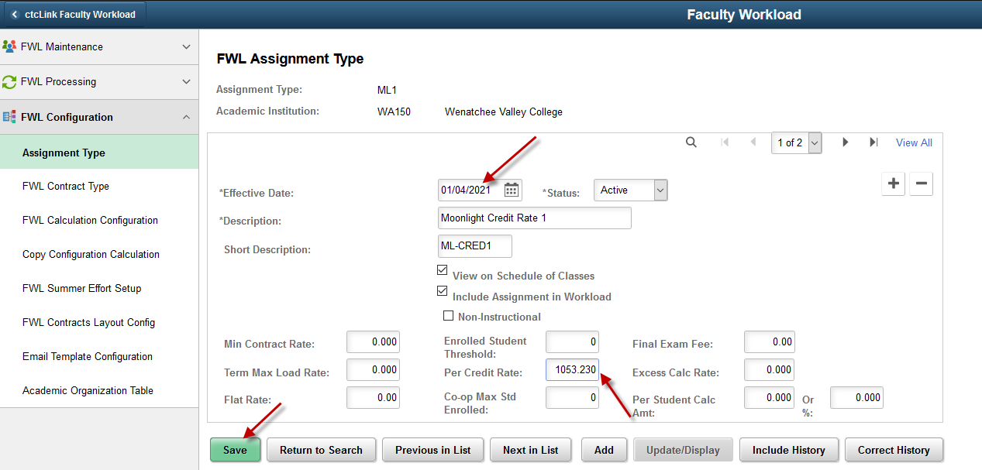

Current Assignment Types
Assign Type | Descr | Short Desc
DS1 | Directed Studies 1 | DIR-STUDY1
IP1 | Independent Projects 1 | IND-PRO1
RP2 | Release PT Overload | RP-OverPT
RT1 | Release FT Load 1 | RT-LOAD1
SA1 | Special Assignment 1 | SA-1
RT2 | Release FT Load 2 | RT-LOAD2
SA2 | Special Assignment 2 | SA-2
SA3 | Special Assignment 3 | SA-3
SA4 | Special Assignment 4 | SA-4
SA5 | Special Assignment 5 | SA-5
RP1 | Release FT Overload | RP-OverFT
MU1 | Individual Music Instruction 1 | MUSIC-IND1
PR1 | Prorated Class | PRORATED1
ML1 | Moonlight Credit Rate 1 | ML-CRED1
AD1 | Adjunct Credit Rate 1 | PTF-CRED1

I give the rates to Aimee Pope and she updates as well as does everything else in FWL

