Running the Savings Age Catch Up Extension Process (formally known as the Identify Age 50 Extensions (QRG is GREAT I just modified it a bit)

Purpose: Use this document as a reference for how to run the Age 50 Extensions for 403b and 457 savings plans in ctcLink.

The Savings Age Catch Up Extension process identifies the employees who are age 50 or more and it creates Age-50 limit extension records that increase the 402(g) Savings Plan limits, the 457 Savings Plan limits, or both for elective deferrals as authorized by IRS regulations.

This process identifies and allows for those employees eligible for the 457 15 year catch-up, and the 403(b) age 50 extensions, to have the additional deduction limit of $xxxx.xx added to their 457 and 403(b) plan
- Verify limit amounts with IRS. The 402(g) is the limit type for the 403(b) plan.

This process should be ran prior to payroll processing.

Running the Savings Age Catch Up Extension

NAV>Workforce Administrator>Benefits tile> Extensions OR Nav>Benefits>Monitor Savings Pln Extensions>Savings age Catch up Extensions

- The Savings Age Catch Up Extension run control ID search page displays.
- Enter the Run Control ID or select Add a New Value.
- Select the Search button.

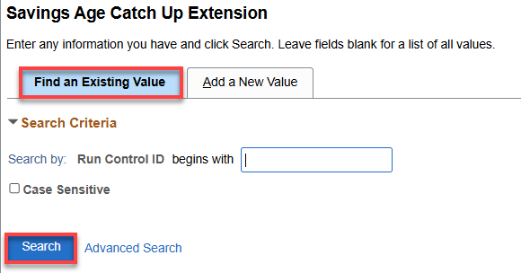

- The Savings Age Catch Up Extension page displays.
- In the As of Date field, enter the last day of current calendar year (ex. 12/31/25). While this process needs to be run prior to each payroll processing cycle (15th and last day of the month), throughout the year, the As of Date should always be the last day of the current calendar year. The only exception is when completing this process for 12B payroll processing cycle, users should use the last day of next calendar year (ex.12/31/26).
- Enter the Company or select from the search icon.
- Enter the Empl ID if needed.
- Within the Limit Type Extension, select the following two Limit Types: 402(g) Limit and 457 Limit.
- Add the first limit type by using the drop-down menu and selecting 402(g) Limit.
- Add a New Row by selecting the [+] icon.
- In the new row, again click the drop-down menu and select 457 Limit.
- Select the Run button.

By selecting Run, the system automatically saves your Run Control and Report Request Parameters.
However, if you are not able to run the process now, you can select the Save button to capture the information entered so far. When it is time to run the process, use the Find an Existing Value in the search page.

NOTE: You can run this on individual employees if needed but typically you will run it for the entire company.

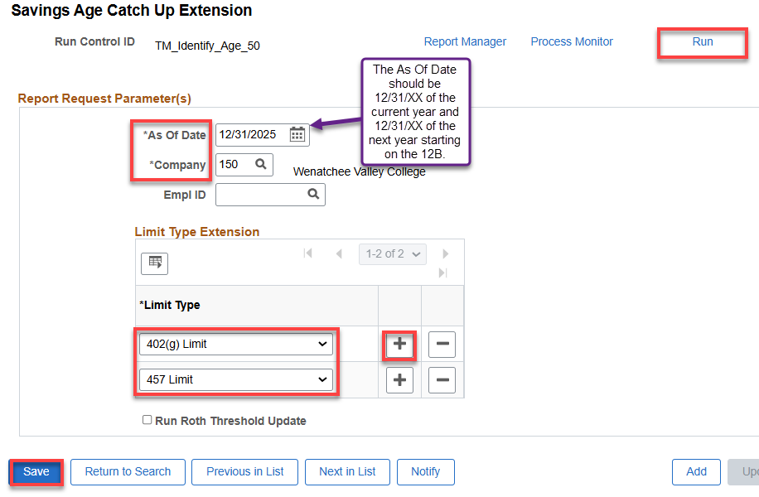
- Select OK at the following Message:
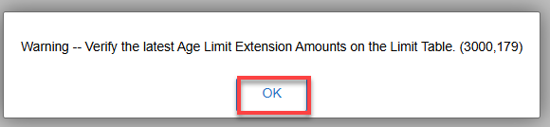

NOTE: The Annual Cap Expansion amounts are now accessed and applied directly from the Limit Table which is maintained by SBCTC Central Payroll.
For more information about the Annual Cap Expansion amounts, please refer to the IRS Retirement Plans > Topic Index > Retirement Topics 403(b) Contribution Limits for catch-up contribution limits based on the year!
https://www.irs.gov/retirement-plans/plan-participant-employee/retirement-topics-403b-contribution-limits
- The Process Scheduler Request page displays.
- Select the OK button.
- The Savings Age Catch Up Extension page displays.
- Select the Process Monitor link.
- The Process Monitor page displays.
- From the Process List tab, select the Refresh button until the Run Status = Success and Distribution Status = Posted.
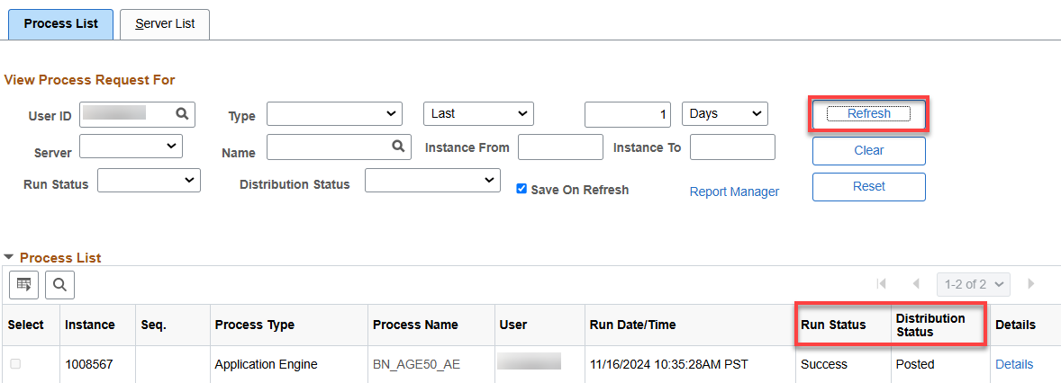

- The process to run the Savings Age Catch Up Extension is now complete.

If you forget to run this process and someone reaches the under 50 limit, you HAVE TO go to Nav>Benefits tile>Benefit Savings Management and manually add the extra deferral amount allowed (for 2024 it’s $7500). Add the Adjustment Amount and Save. See below for an example:

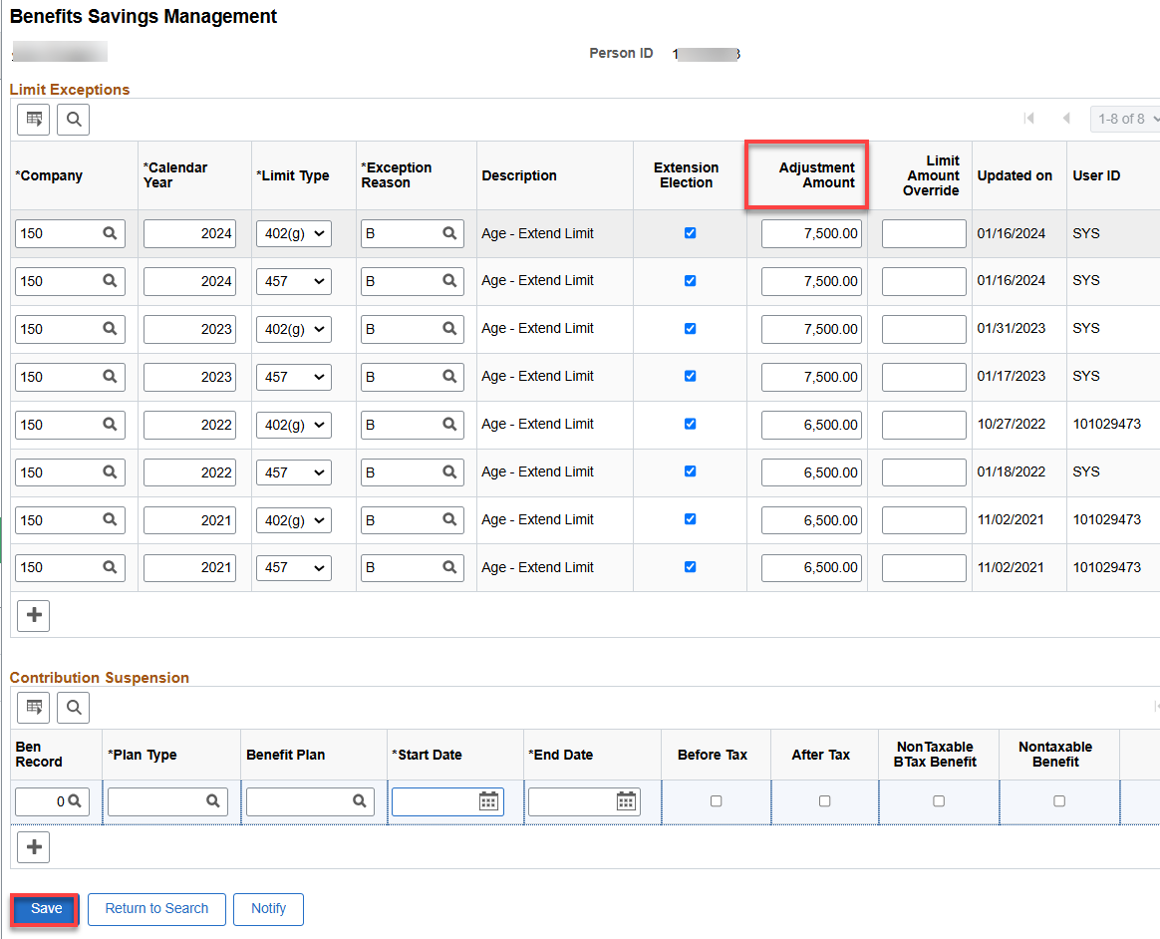

That’s it!

