LTD-Reviewing/Updating ABBRs for PT Faculty – The QRG is really good.

Nav>Workforce Administration tile>Benefits Admin tile>Review ABBRs

Reviewing Annual Benefit Base Rates (ABBRs) – I don’t see much of a need to review when you can see the ABBRs under Update

Nav>Workforce Administration tile>Benefits Admin tile>Enroll/Maintain benefits>Update ABBRs

Part Time Faculty Salary Base Calculation and ABBR Updates – The QRG is great!

Nav>Benefits>CTC Custom>PTF LTD Report

Each PT faculty on benefits with employee-paid LTD must have their full-time equivalent salary put in each time there is a salary change. With this process, all jobs are updated so there is no need to do individual calculations like in the past. I run this after the 10th day each quarter.

The Salary Base Calculation Report only lists those PTF with employee paid (optional) LTD.

First, run the Salary Base Calculation Report (see QRG) or go to Nav>Benefits>CTC Custom>PTF LTD Report.

Part-Time Faculty Salary Base Calculation Report
Navigation: Benefits > CTC Custom > PTF LTD Report
- The PTF LTD Salary Base Calc run control search page displays.
- Select the Add a New Value tab and enter a new Run Control ID if this is the first time ever running this report. Otherwise, enter the existing Run Control ID.
- Select the Add or Search button.
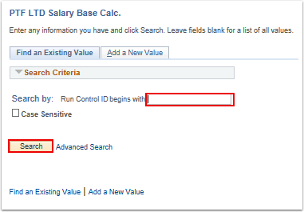
- The PTF LTD Salary Base Calculation Report page displays.
- Enter the Company.
- Enter the As Of Date.
- Select one of the following report options (only one type of report can be run at a time):
  - All Active PTF
  - Active PTF with Opt LTD
  - EMPL ID(s)
- Select the Run button.
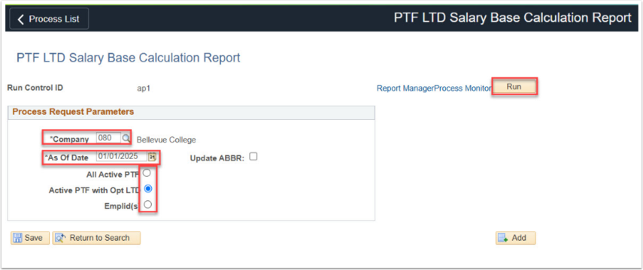
- The Process Scheduler Request page displays. Select the OK button.
- Select the Process Monitor link.
- The Process List tab displays.
- Select the Refresh button until the Run Status is 'Success' and Distribution Status is 'Posted'.
- Select the Details link.
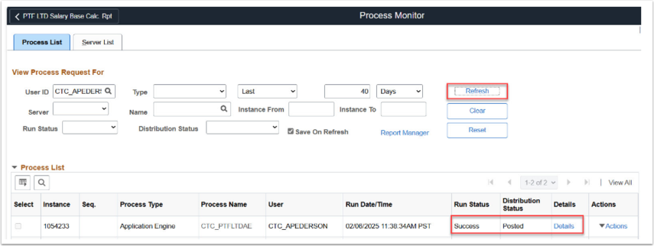
- The Process Detail page displays.
- Select the View Log/Trace link.
- The View Log/Trace page displays.
- Select the first CTC_PTFLDAE.csv file to view part-time faculty’s quarterly and monthly wages for the prior four quarters.
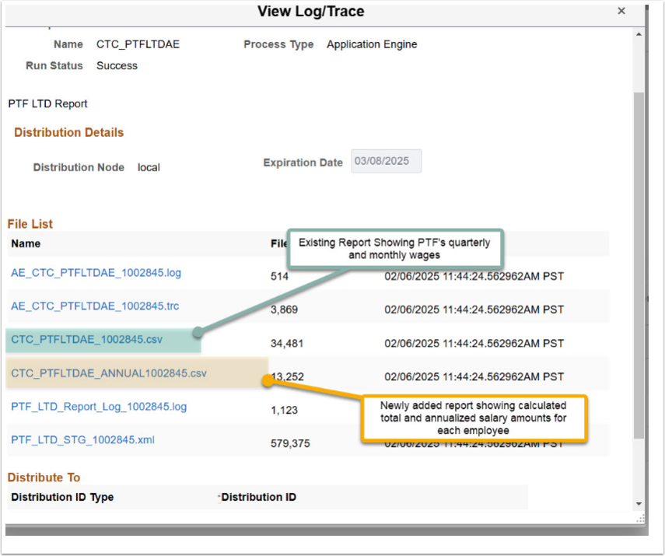
- Next select CTC_PTFLTDAE_ANNUAL.csv file to validate calculated total and annualized salary amounts for each employee.
Annual Base Rate (ABBR) Update
Navigation: Benefits > CTC Custom > PTF LTD Report
- Once calculated annualized salaries have been validated, return to PTF LTD Salary Base Calculation Report’s parameters page and check the Update ABBR box.
- Select the Run button.
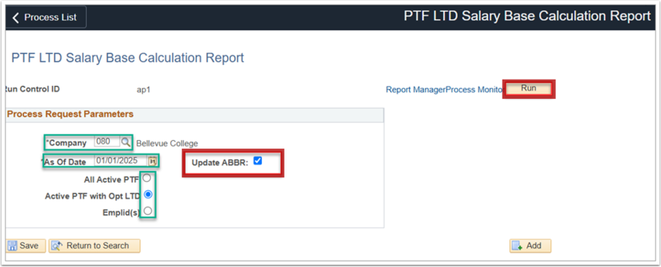
- Select the Process Monitor link.
- The Process List tab displays.
- Select the Refresh button until the Run Status is 'Success' and Distribution Status is 'Posted'.
- Select the Details link.
- The Process Detail page displays.
- Select the View Log/Trace link.
- The View Log/Trace page displays.
- Select the first PTF_LTD_Report_Log_.log to view processed part-time faculty ABBR rate updates in Update ABBR’s page.
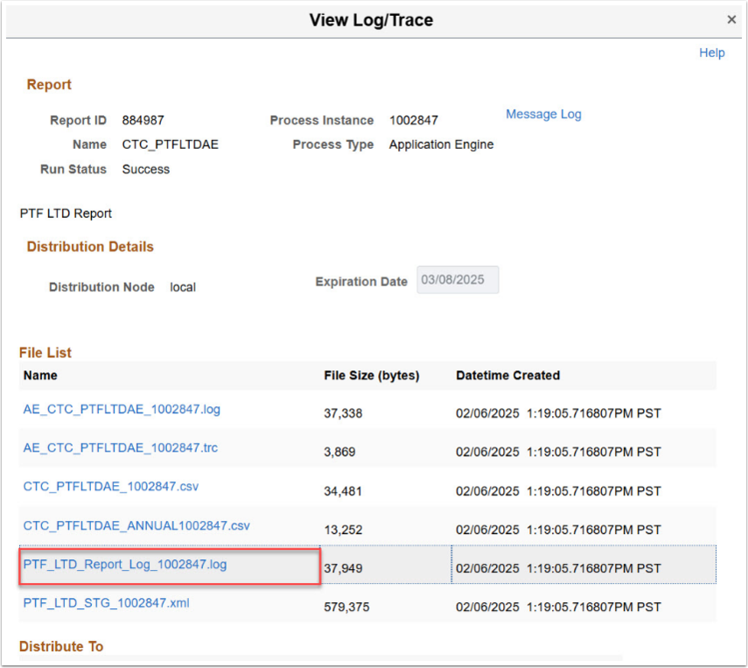
Go to Update ABBRs.

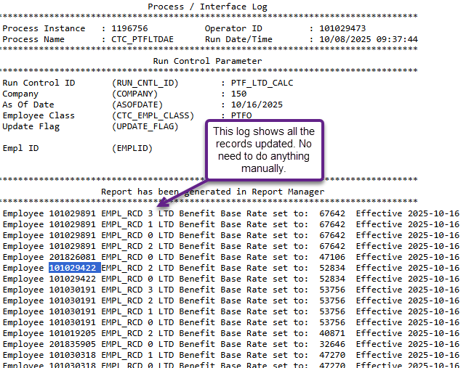
The process to run the salary base calculation and ABBR rate updates report is now complete.

To see the updated records, you can go to Update ABBRs (Benefits Admin tile>Enroll/Maintain Benefits> Update ABBRs.

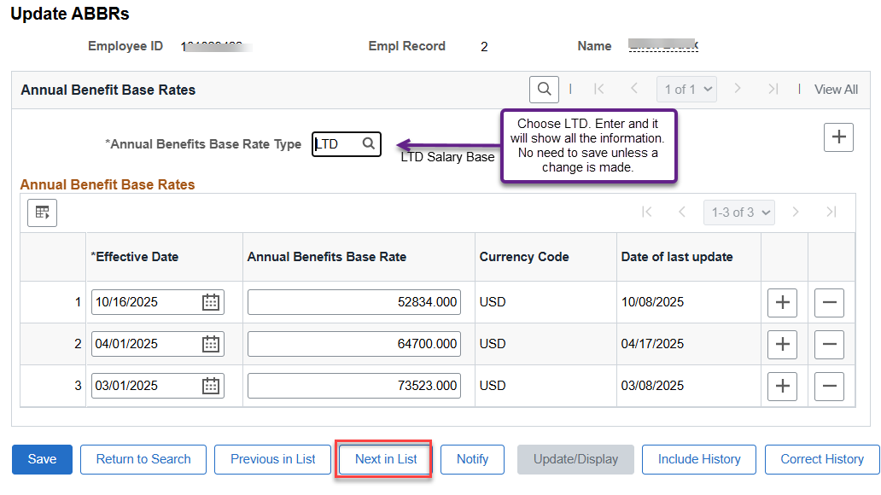

That’s it!

