9.2 Enrolling an Employee in Spending Accounts

Nav>Benefits>Enroll in Benefits>Spending Accounts

FOR FACULTY THAT WORK IN THE SUMMER (PT or other), the deduction/reduction WILL be taken out. FOR THOSE THAT DO NOT WORK DURING THE SUMMER, have payroll NOT TAKE RETRO DEDUCTIONS/REDUCTION.

Enrolling in FSA, HSA or DCAP:
For full year enrollment for full time employee (24 payments (20 for FT faculty – 19 for PT faculty?)-Jan 10 through Dec 25 pay dates (12B through 12A) – Coverage Begin Date and Deduction Begin Date should be 12/17 or later, not to exceed 12/31.

For current employees reenrolling, the system will auto term on 12/16 so we add the new enrollment on 12/17 or later, not to exceed 12/31.

For those with less than 24 payments, take the Annual Pledge/number of payments and put in the amount in Flat Deduction Amount Override – Optional.

FOR FLAT DEDUCTION AMOUNT, ROUND UP ONE PENNY IF NOT A WHOLE NUMBER (e.g., 3200/20=133.33 so round up to 133.34). Deduction will stop once Annual Pledge is met.

You don’t have to figure Flat Deduction Amount, however, I recommend it in case there is a change in a person’s contract, the deduction will continue to be taken.

Choose Plan Type (HSA, FSA [FSA, specify regular or limited purpose (limited purpose is only for those with the CDHP medical plan] or DCAP), fill out Coverage, Save.

Health Savings Account

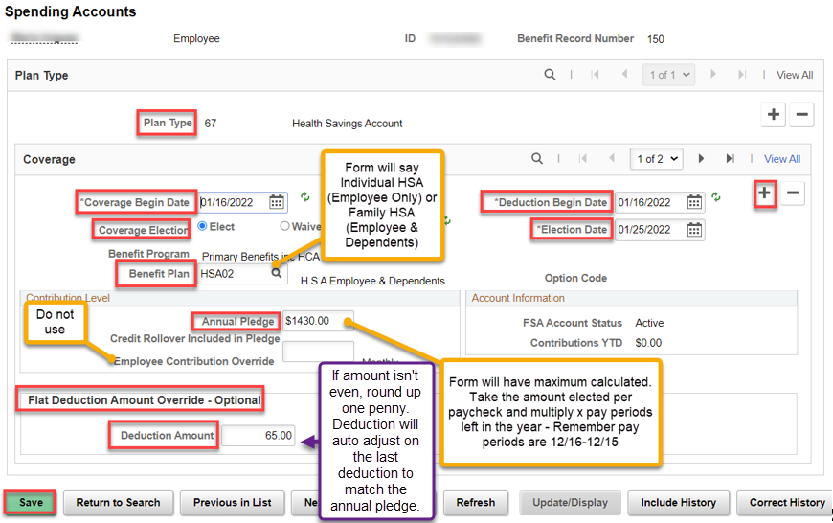

The following Warning will happen. Click OK. Save.

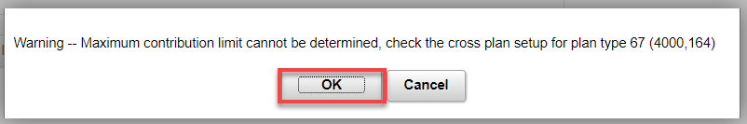

Flexible Spending Accounts

For Benefit Plan, use FSA01 with the regular FSA and FSA02 for the Limited Purpose FSA.

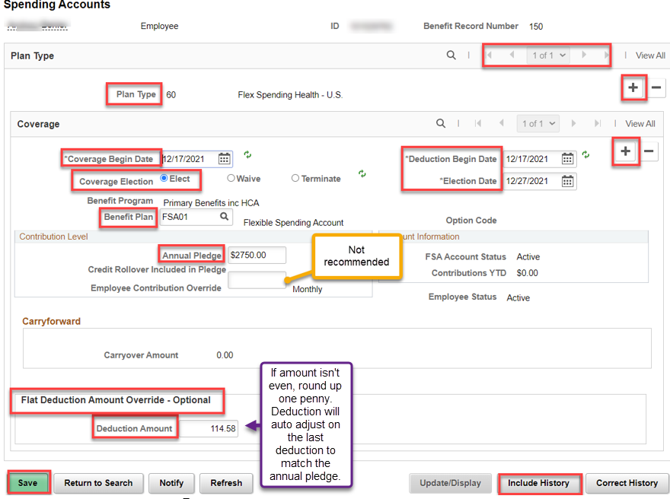

Dependent Care Assistance Program (DCAP)

If adding FSA and DCAP, Include History and Add + or arrow over to the Plan Type, add + a row for coverage and fill out Coverage, Save.

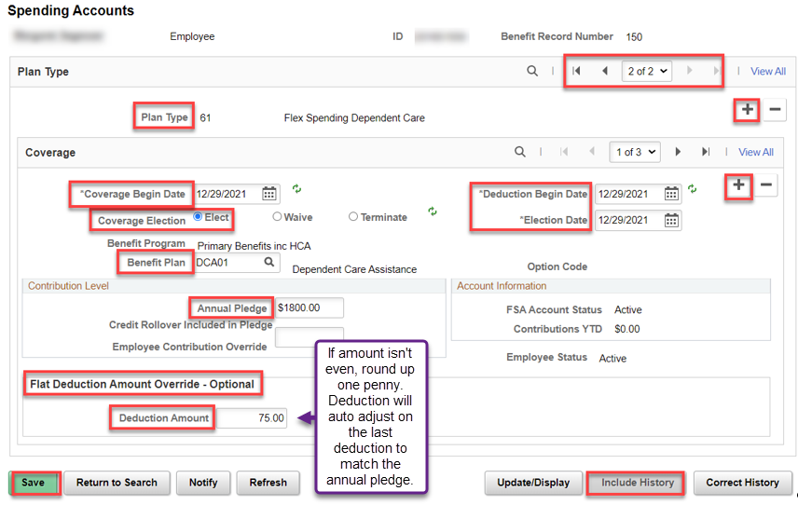

Changing FSA Amount (only allowed during an open enrollment): Add + a row, put the new Coverage Begin Date, Deduction Begin Date, the new Annual Pledge and figure the per check Flat Deduction Amount. In this case – 1500 -208.35 already contributed = 1291.65/19 remaining payments = 67.98, Save.

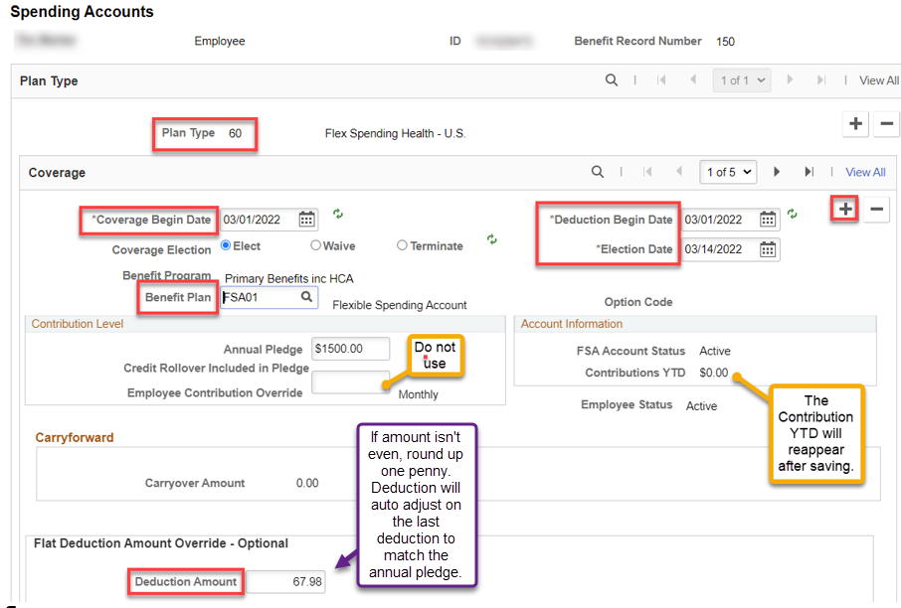

Changing HSA Amount: Add + a row, put the new Coverage Begin Date, Deduction Begin Date, the new Annual Pledge and figure the per check Flat Deduction Amount. In this case, they wanted to decrease from $2942.92 to $2000. $2000 - 613.97 already contributed = 1386.03/19 pay periods remaining (03A through 12A) = $72.95, Save.

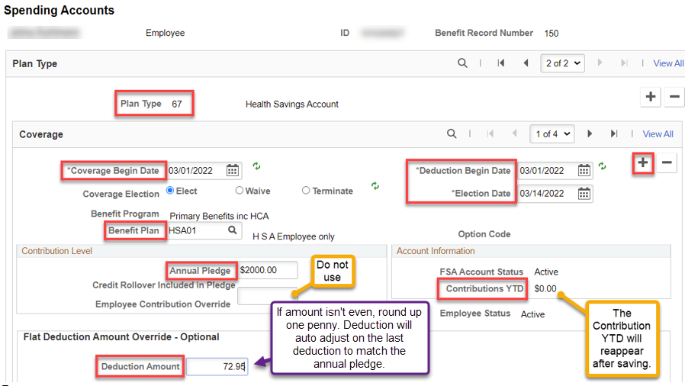

Terminating FSA or HSA:

Before Termination:

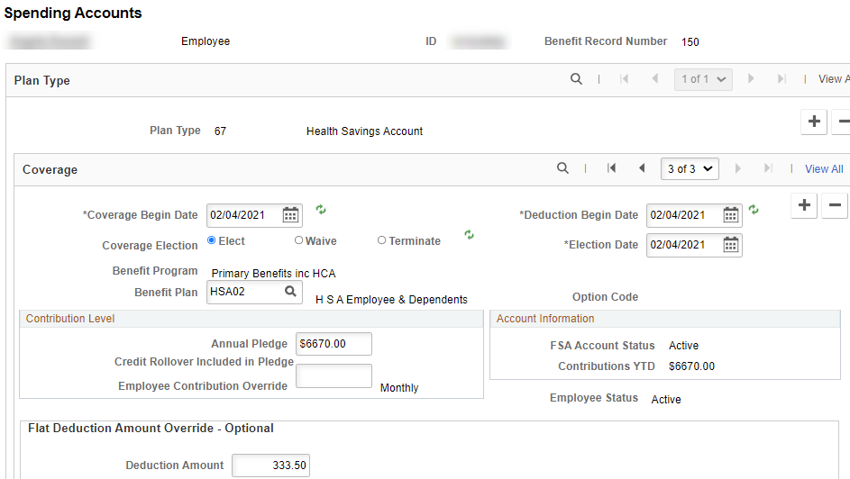

Add + a row to Coverage, put in the termination date (You can’t put the 1st of the next month because the benefit plan is SBO) and Refresh. The screen will update. Save. The system will automatically remove the Benefit Plan, Annual Pledge and Flat Deduction Amount. IF NO PLAN IS SELECTED, NO NEED TO DO ANYTHING.
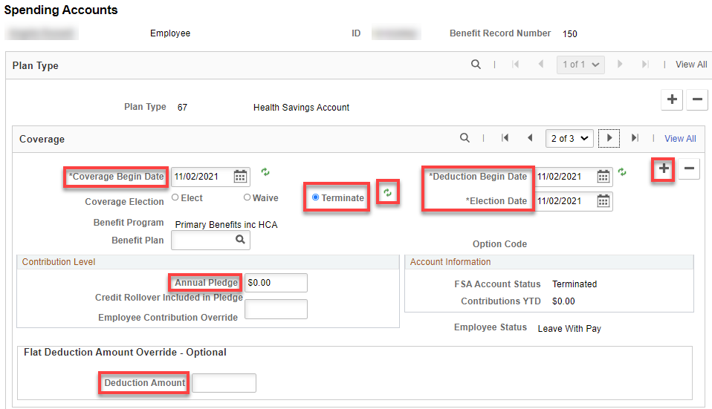

That’s it!

