Add A New Employee Instance
Nonresident Alien Setup QRG (Very good GRG)

Nav>Workforce Administration>Job Information>Add Employment Instance

THIS IS THE MOST UP TO DATE (as of 6/28/25). It doesn’t flow well but the pieces are there.

Nonresident Alien

Work Location tab: Put start date as Effective Date, add Reason, Company, Department and hit tab and the rest will autofill. If the Last Start Date has a different date, it will update after you refresh or hit OK at the end of the process. IF CHANGING A CURRENT EMPLOYEE, USE EARNINGS DISTRIBUTION CHANGE

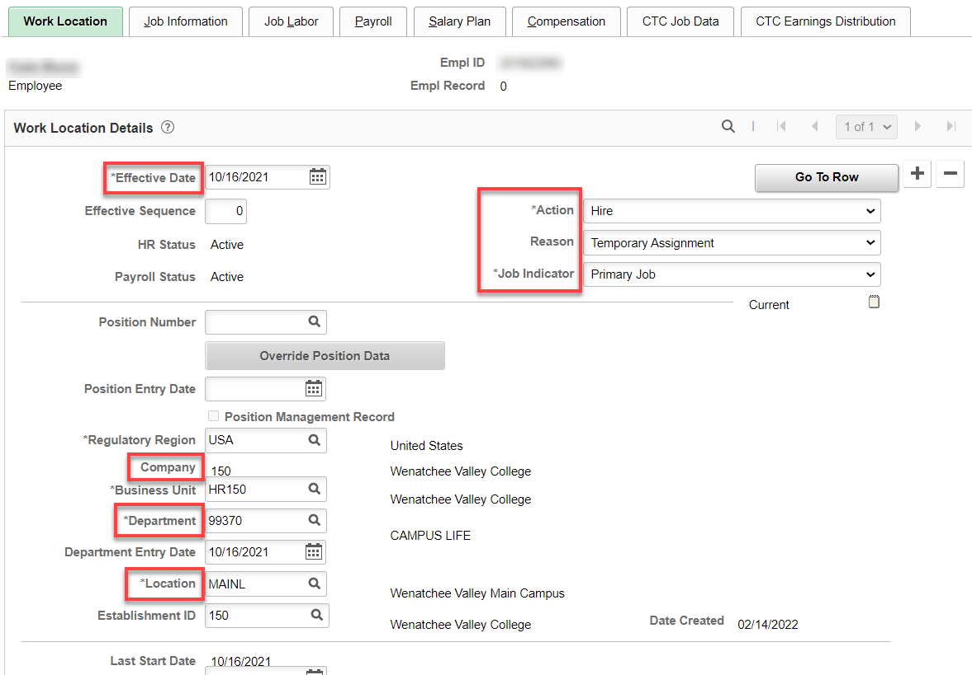

Job Information tab: Add Job Code, Supervisor ID, Temporary, Part-Time, Empl Class and the rest is auto-filled (double check though in case the position data is not correct).

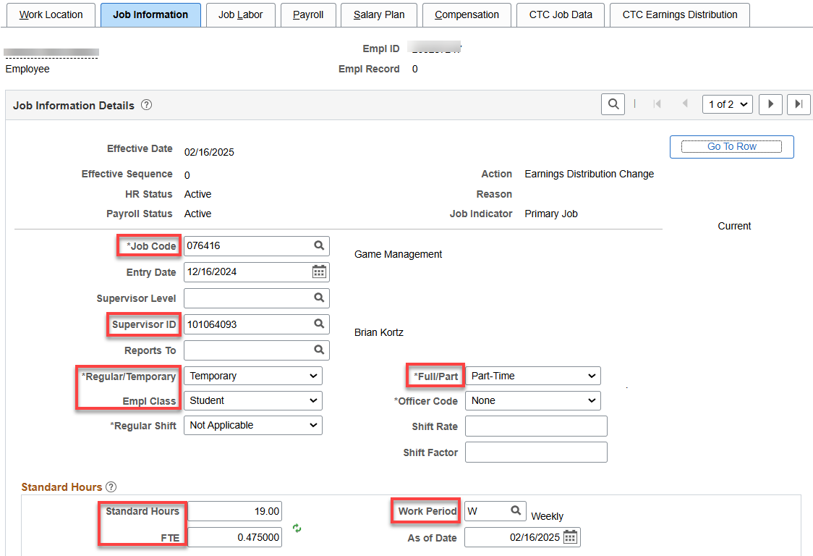

Nothing for Job Labor

Payroll tab: Add Absence System (Absence Management) and Pay Group, the rest will autofill. IF ALREADY IN ABSENCE MANAGEMENT for another Empl Record, LEAVE “Other” IN ABSENCE SYSTEM.

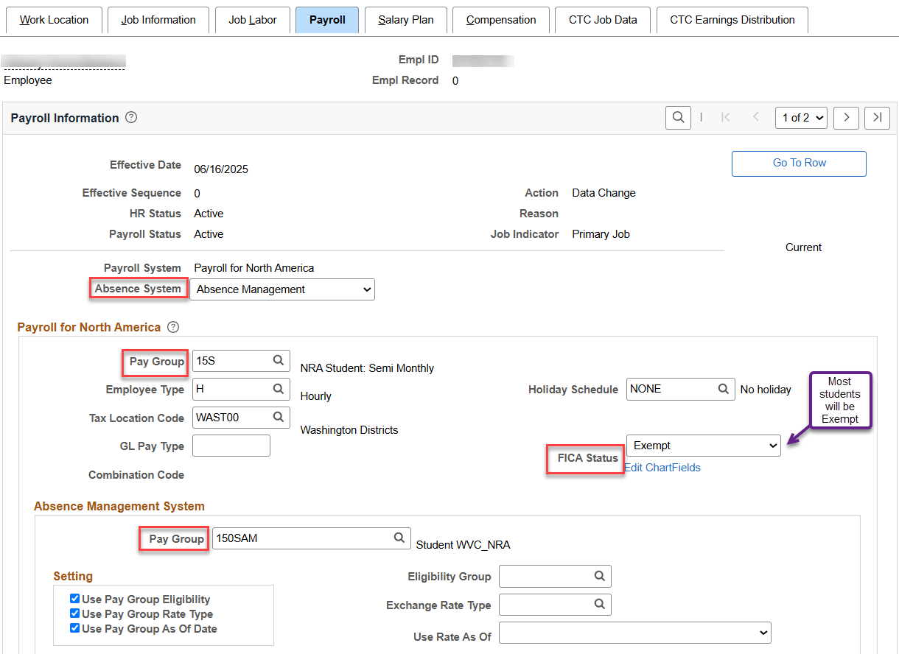

Nothing for Salary Plan unless classified or part time nonpermanent

Compensation tab: Enter Rate Code, Comp Rate, and make sure Frequency is H for hourly. Other Empl types- follow the directions for adding that employee type and hit Calculate Compensation.

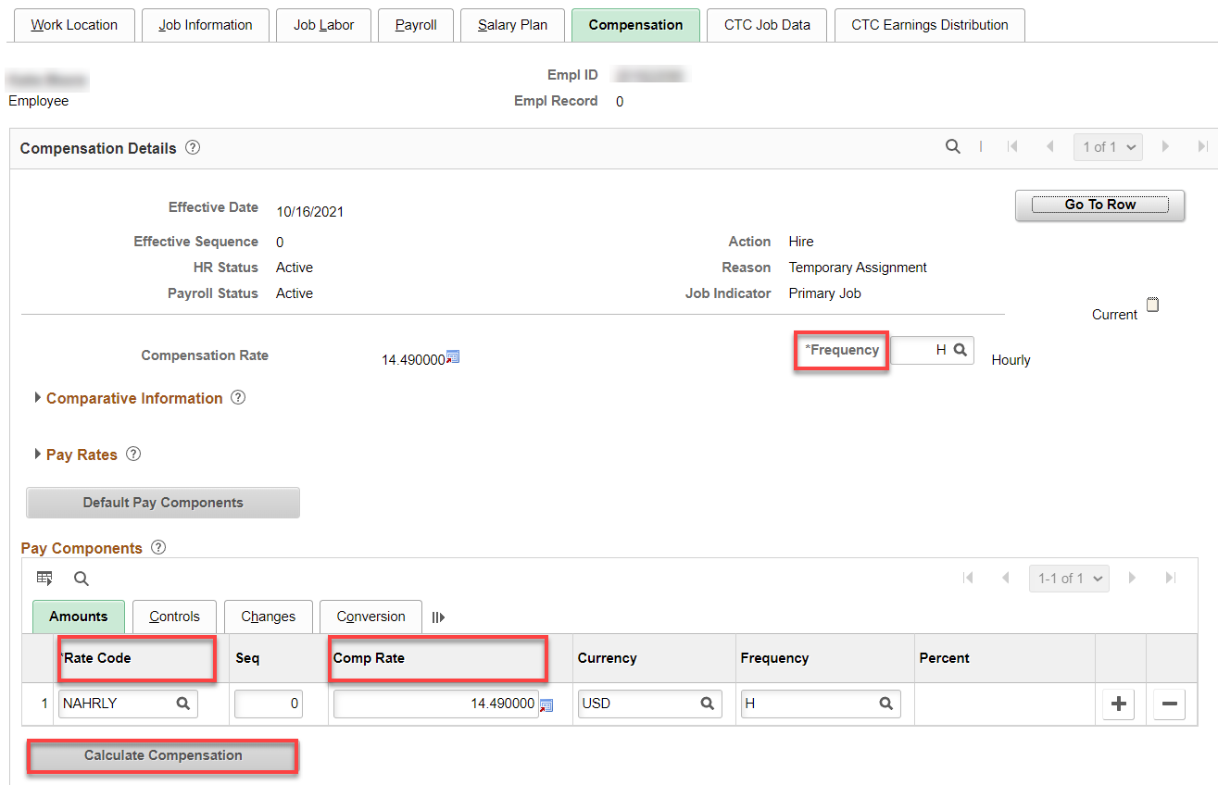

CTC Job Data tab: HOURLY: Leave accrual date is the first of the month of the start date. Put in Job Emp Type. You can put in start and end date (they are not necessary) but I like them. Other Empl Types: follow the directions for adding that employee type.

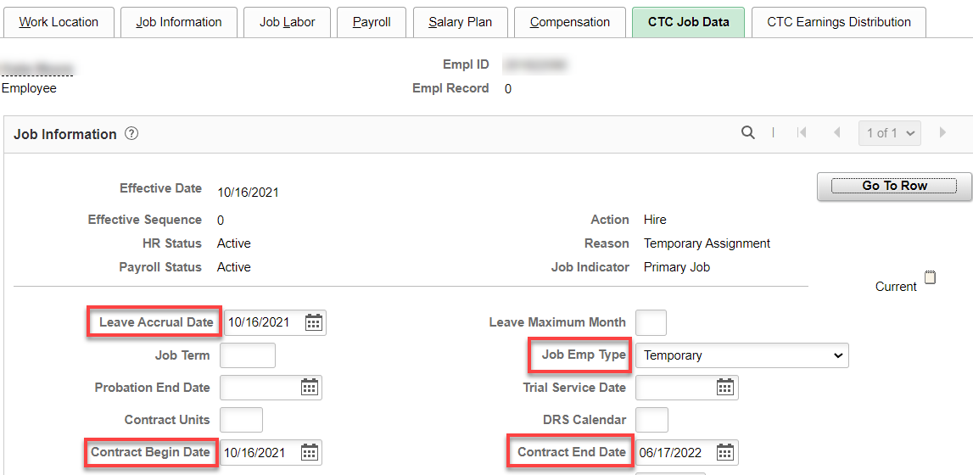

CTC Earnings Distribution tab: Enter the Earnings Code, Percent of Distribution, check Primary on all codes (if more than one); click on Edit Chart Field.

The Workgroup, Rule Program ID, Earnings Code/Time Reporter Code and Holiday Schedule are different for each type of nonresident alien type. See table and descriptions below:

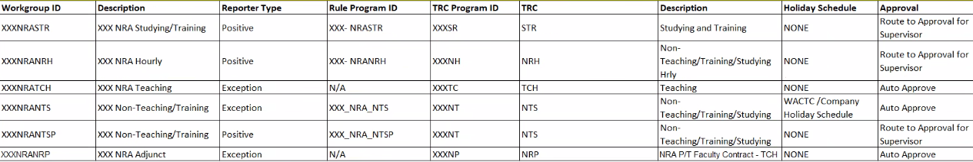
XXX - Refers to Company Code

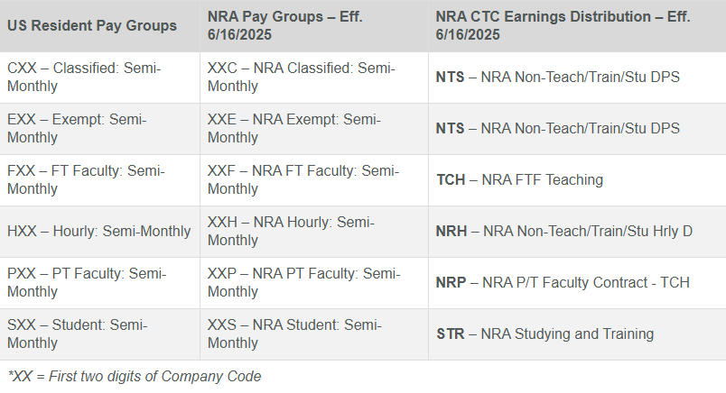
Student Hourly
Earn Code/Earnings Distribution/Time Reporting Code: STR – Studying and Training; Income Code (for 1042-S): Studying and Training
Workgroup: XXXNRASTR

Temporary Hourly (subject to FICA)
Earn Code/Earnings Distribution /Time Reporting Code: NRH – Non-Teaching/Training/Stu Hrly; Income Code (for 1042-S): Dependent Personal Services
Workgroup: XXXNRANRH

Part-time Faculty (subject to FICA)
Earn Code/Earnings Distribution: NTS – Teaching; Income Code (for 1042-S): Teaching
Workgroup: XXXNRANPR

Full time Faculty (subject to FICA)
Earn Code/Earnings Distribution: TCH – Teaching; Income Code (for 1042-S): Teaching
Workgroup: XXXNRATCH

Classified, Exempt, Part Time Nonpermanent (subject to FICA)
Earn Code/Earnings Distribution /Time Reporting Code: NTS – Non-Teaching/Training/Studying; Income Code (for 1042-S): Dependent Personal Services
Workgroup: XXXNRANTS (Exempt) or XXXNRANTSP (Overtime-Eligible)

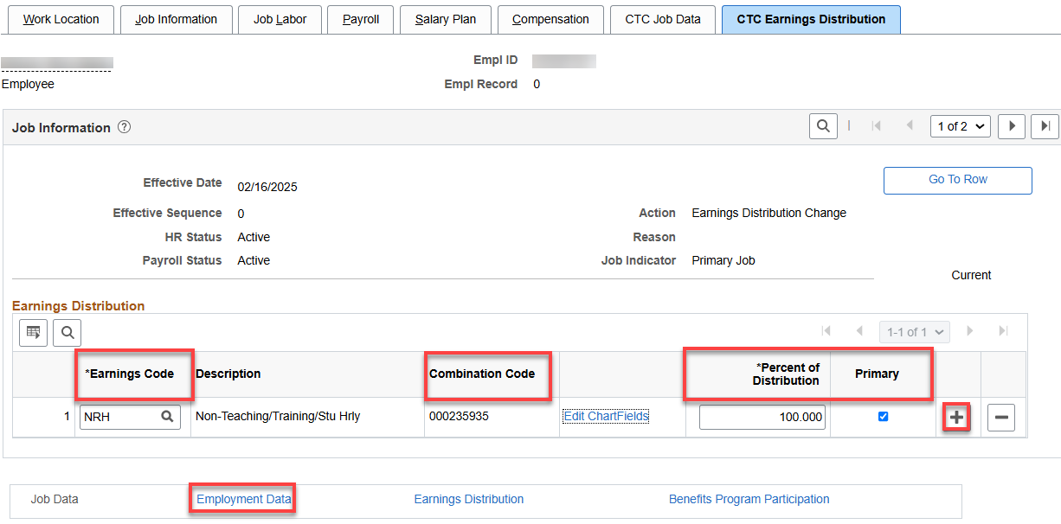

Enter the combo code, hit enter for the chart field to complete and check to see if they are correct, Save.

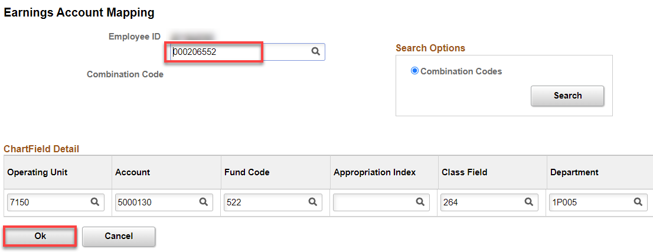

Click on Employment Data hyperlink
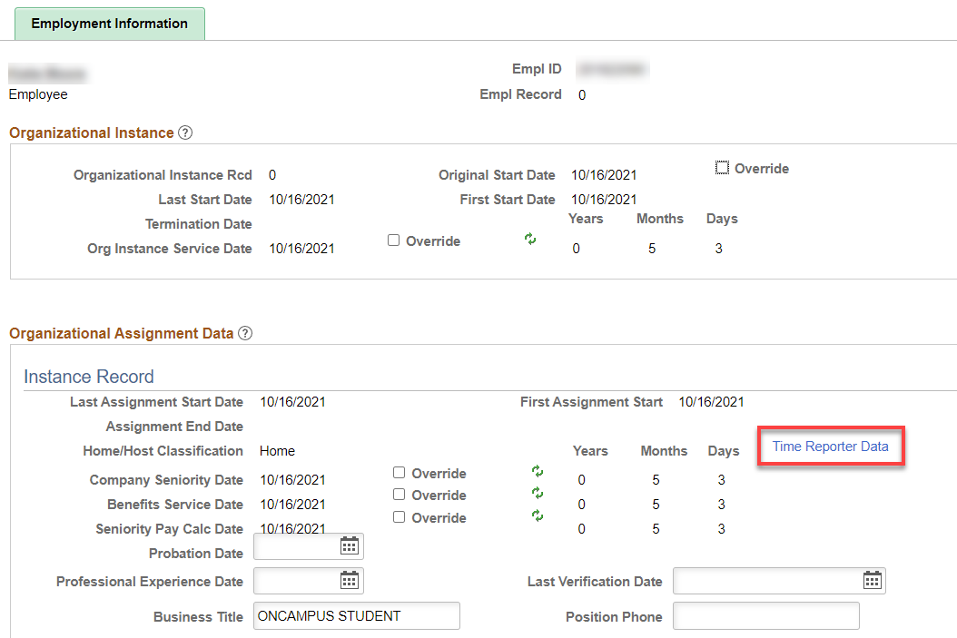

Click on Time Reporter Data hyperlink.

Change the effective date to the hire date, if needed, put in the Time Reporter Type, Punch Time Template, Work Group, Task Group and hit refresh. That will update the Employment Information screen (above).

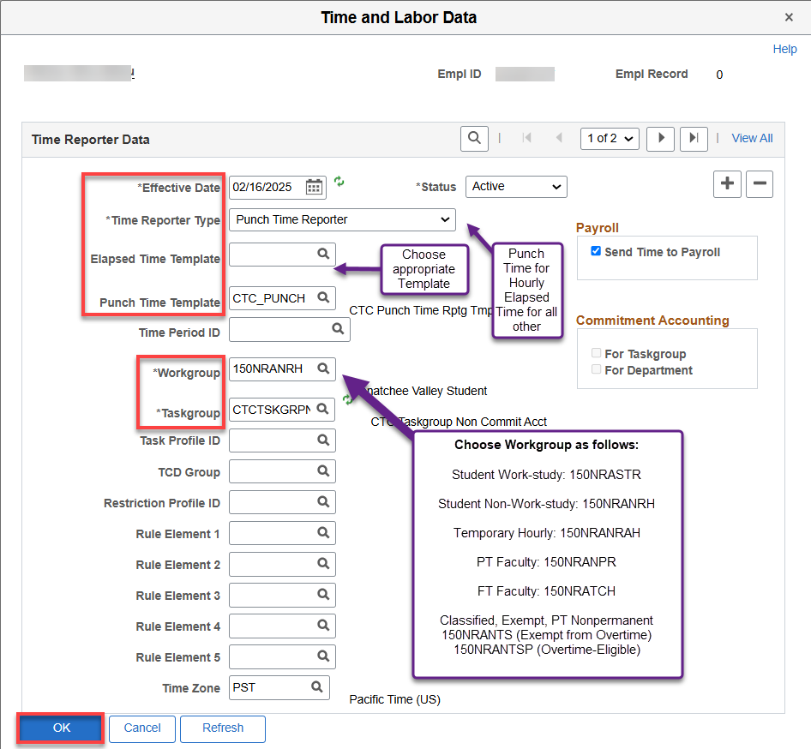

Click on the Earnings Distribution Link. After saving, the Earnings code should change to match the Earnings Code.

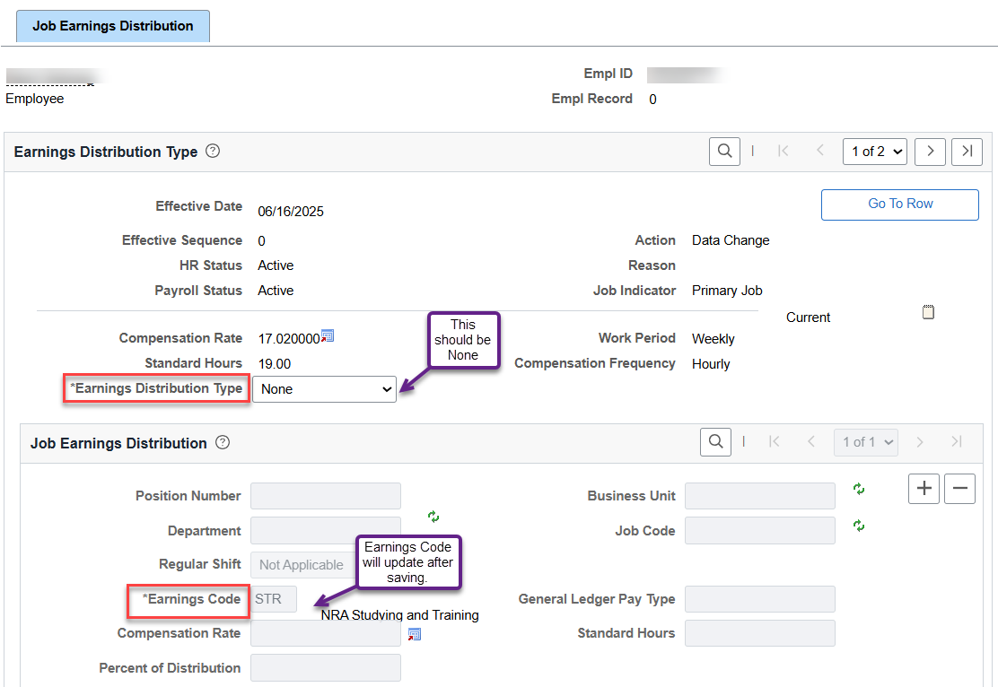

NOTE: AFTER SAVING, CHECK TO MAKE SURE THE TIME REPORTER CODE IS ACTIVE ON THE TIMESHEET AND CHANGE IF EE HAS ALREADY SUBMITTED HOURS.

If the code does not show up, run Refresh Dynamic Groups Process – see Documentation.

Click on Benefit Program Participation hyperlink, add the Benefit Record Number, Benefit Program Participation Details, if applicable, Save.

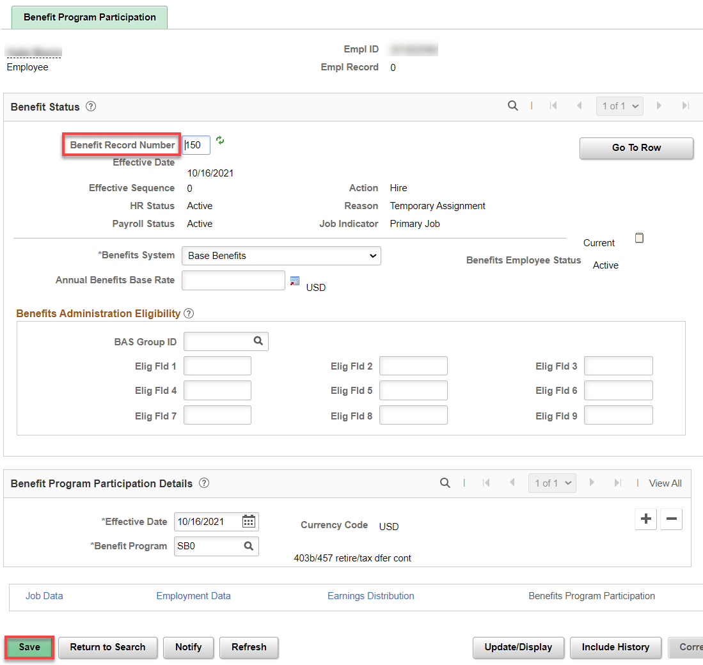

Assign ACA Status – Nav>Benefits>CTC Custom>Assign ACA Status
Enter proper ACA Employment Status.
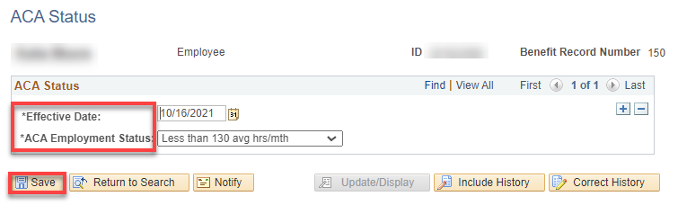

Update Employee Tax Data for Nonresident Alien – Nav>Payroll for North America>Employee Pay Data USA>Tax Information>Update Employee Tax Data
See Nonresident Alien Setup QRG for a complete explanation of Tax Data setup (VERY similar as below)

- The Update Employee Tax Data search page displays.
- Enter search criteria and select the Search button.
- Add a row if later than new hire date, add Effective Date
- From the Federal Tax Data tab, select the Nonresident alien for the Special Withholding Tax Status field. *This is a required field.

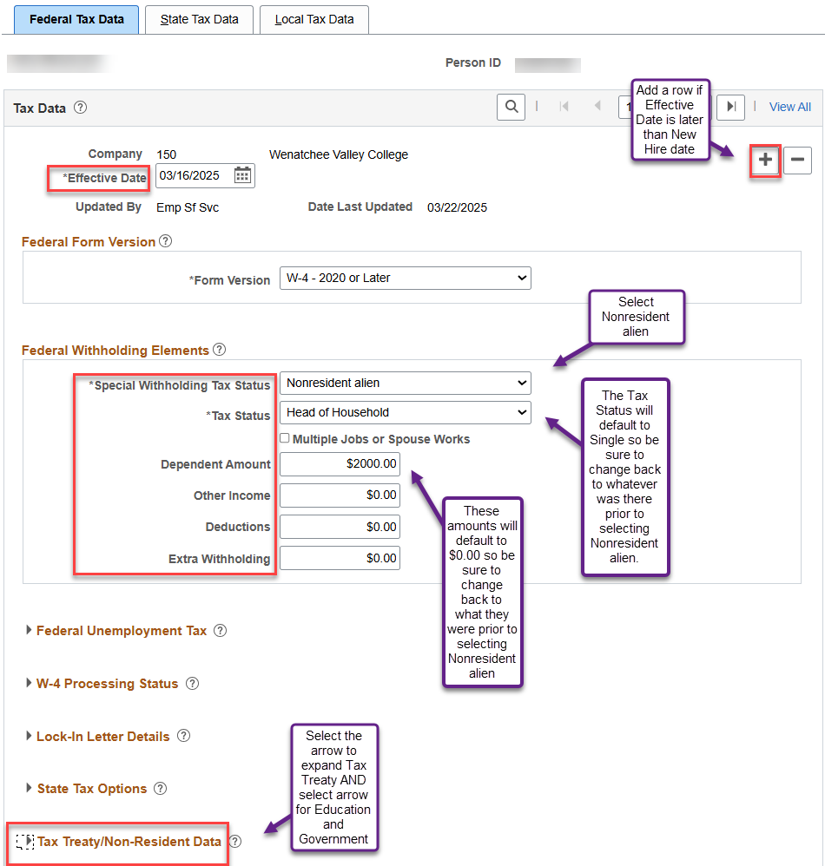

- Expand the Tax Treat/Non-Resident Data section by selecting the arrow as shown below.
- Select the appropriate Country. (see https://www.irs.gov/businesses/international-businesses/united-states-income-tax-treaties-a-to-z for IRS list of treaties. IF THE COUNTRY IS NOT LISTED, PUT $S (No Treaty); ADD TREATY ID OF QKNA () or QKNA2 (). IF AN ERROR CODE DISPLAYS, Choose NO TREATY CODE AGAIN.
- Select the appropriate Treaty ID.
- If the NRA is not subject to FWT withholding, select No for the Form W-9 Received option.
- Select the appropriate NRA Withholding Rule. By default, Subject to Rule is displayed.
- Select arrow to expand the Education and Government section.
- Enter the appropriate Date of Entry. The College will need to determine the Date of Entry, as this usually reflects the time of when the NRA employee is on-boarded. The Treaty Expiration Date will default for treaties that have Expiration information in the delivered Tax Treaty set-up table. However, you must have entered the appropriate Date of Entry in the previous field, otherwise the system cannot determine the Expiration Date.
- Select the appropriate option for the Form 8233 Received field. *This is a required field.
- Whether or not Form 8233 was received, the earnings will be taxed as 1042, unless the Treaty Tax Rate for when the Form was not received is 0.9999.
NOTE: If Form 8233 is NOT received by the employee, then the Tax Rate Before Form Received noted in the Allowable Earnings Codes section will be used. If the Tax Rate Before Form Received is "0.9999", then the earnings will be taxed as W-2 and not 1042.

- Enter the appropriate Form 8233 Effective Date and Form 8233 Expiration Date fields.
- Select the appropriate option for the Form W-8 Received. *This is a required field.
- If a W-8 form was received, enter the Form W-8 Effective Date and Form W-8 Expiration Date accordingly.
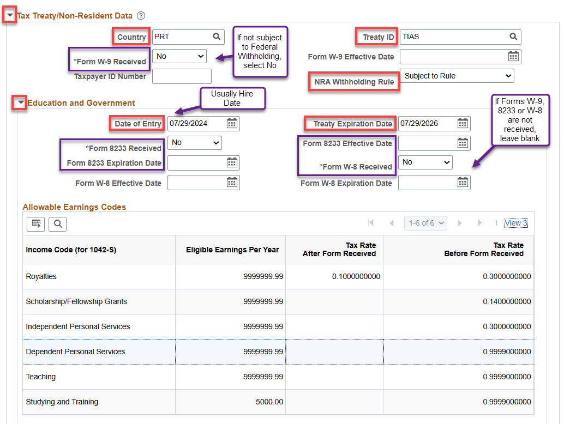

- Select the State Tax Data tab, located at the top of the page, to continue the process.
- Every employee must have at least one State Information row for the State of Washington (WA). They may have more than one row if they reside in another state. If the employee does not have a WA row, then one must be added.
- Steps 18 - 21 relate to the WA row: Uncheck the Resident checkbox if it is on.
- If the employee has only one State Information row (resides and works in WA), then the UI Jurisdiction checkbox and the Exempt From SUT checkbox are on.
- The LTC Status field is set to Subject, unless the employee has submitted an Exemption letter, in which case the status would be Exempt. For employees residing in another state, LTC Status will be Not Applicable.
- In the State Withholding Elements section, in the Special Withholding Tax Status field drop-down menu, select None.
With None selected, the Tax Status field should be N - Not Applicable.

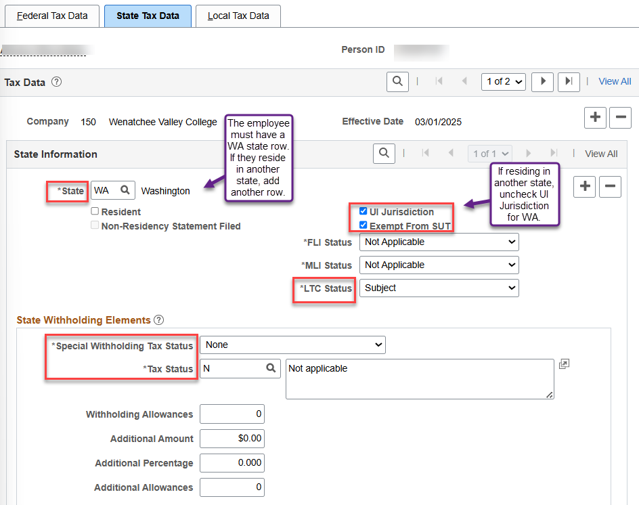

- Now, for the Non-resident alien that resides in another state, the Administrator will need to add a new row for a non-Washington state, if one does not already exist. The Special Withholding Tax Status would be Nonresident Alien and select the appropriate option for the Tax Status field. UI Jurisdiction would be On for the residing state and Off for the WA row.
- Select the Save button.

The image below represents an example where the employee resides in another state and that second row is added. The first row for WA would be as it is above, minus the UI Jurisdiction checkbox.

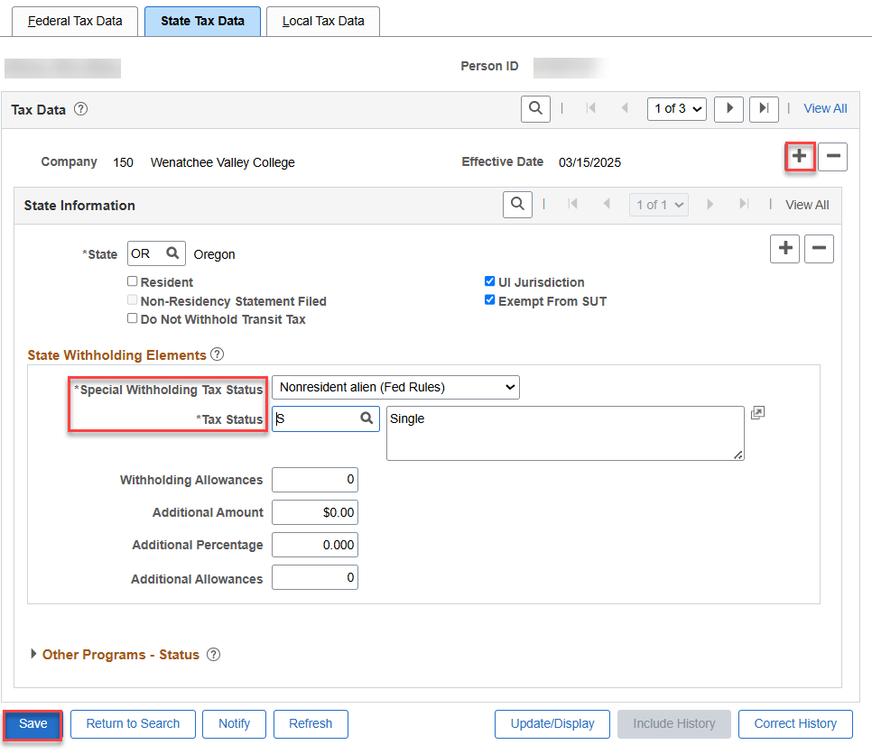
That’s it!

