Entering & Processing Shared Leave

The Shared Leave page allows users to make a record of the leave donation; it does not actually perform the process. In order to adjust leave for employees related to shared leave, follow the instructions on the 9.2 Correcting or Reversing Leave Balances/Running the Absence Management Off Cycle on Demand Process QRG.

Step 1 – Entering Shared Leave

Nav>Global Payroll Absence Management>CTC Custom>Shared Leave

Add a New Value – I use the last name of the person needing leave. A New Value must be added each time a person needs shared leave so the Benefit Factor and Recipient Rate is correct and it allows you to enter a donor that has donated before. Also, go to https://ofm.wa.gov/sites/default/files/public/legacy/policy/25.40.htm to check the Benefit Factor Rate. Put in a ticket if the rate needs updated.

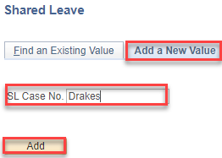

Add Adjustment Leave Code(s), as many rows as necessary, enter minus “-“ hours for subtracting hours (DO NOT USE “-“ FOR LEAVE TAKES) and Begin and end Date (put in comments if you want).

We still use the Entitlement Calendars*. Use the green highlighted codes for balance adjustments (transfer in/out, term, moving from one record to another, etc., orange for accrual adjustments (adding/subtracting P/H, PRL, vac, etc.), blue for adjustments to takes for Absence Balance Report, sick leave balances for sick leave buyout, shared leave donation, etc.

*The January Entitlement Calendar cannot be used for P/H (Use 01A Take); the June Entitlement Calendar cannot be used for PRL (use July 01A Take).
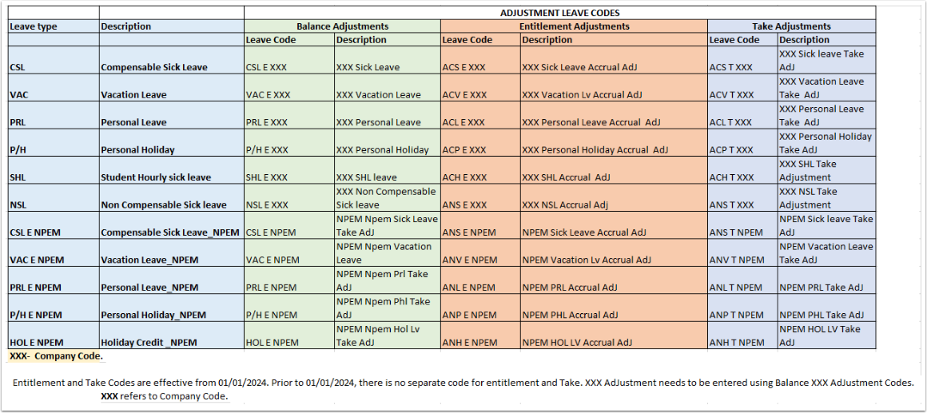

The following refers to the Absence Administration tile>Results by Calendar Group>Accumulator tab>Accumulator Results.

Using CSL, VAC, etc., will make the adjustment to the year-to-date Balance Accumulator but will not add/subtract the adjustment to the year-to-date Entitlement or Take Accumulator nor will it adjust in the Review Absence Balance page (for administrators).

Using ACS, ACV, etc., will make the adjustment to the year-to-date Balance Accumulator and the Entitlement or Take Accumulator and it will adjust the Review Absence Balance page (for administrators).

Add recipient ID, Donor ID, Element Name, correct Empl Record, Donated Hours and check Approved, Denied or Adjusted, Save.

No need to enter an Agency Name (leave blank)

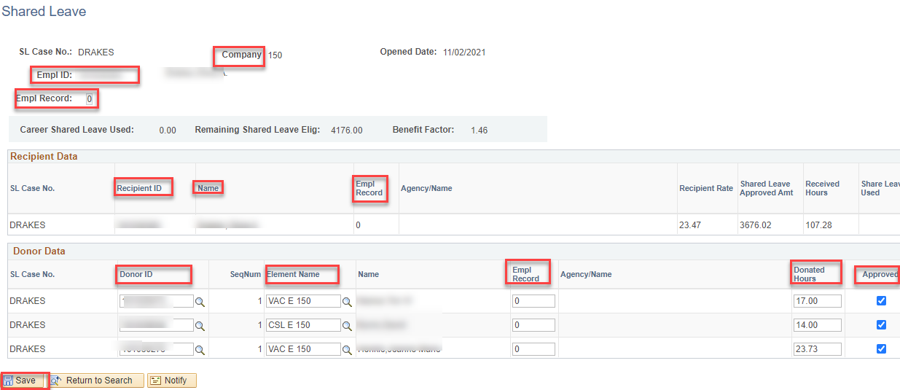

Enter more donors by adding + a row.

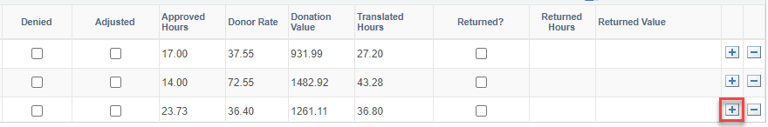

Step 2 – Entering Absence Balance Adjustment for Donor & Recipient

Nav>Global Payroll Absence Management>Payee Data>Adjust Balances>Absence

Donor(s): enter Empl ID, Search and select the Last Finalized Entitlement Calendar (e.g., for 12A and 12B payroll, choose Nov. ENT (ENT2024M11 in this case).

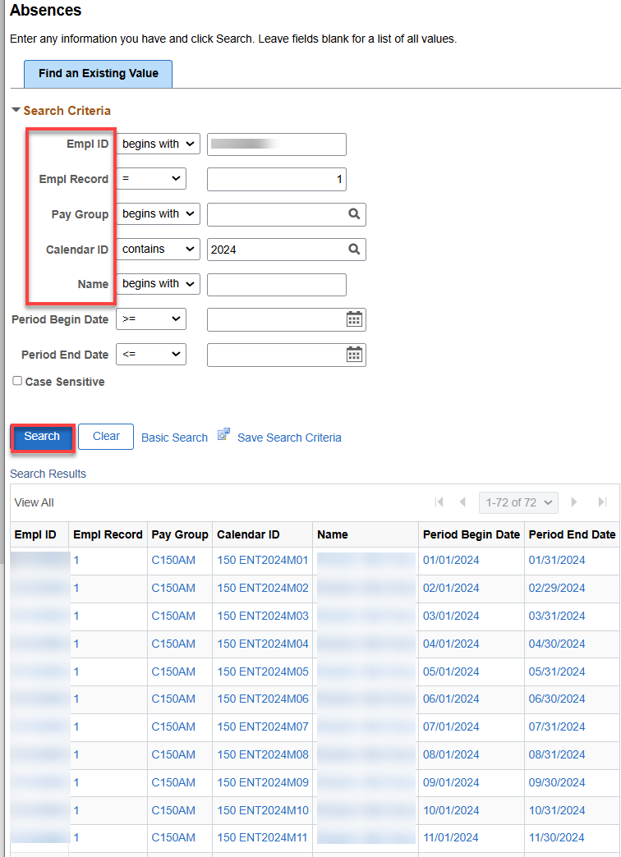

Enter the Element Name and Balance Adjustment (NOT negative in this case), Comment (optional), Save.

IF USING A TAKE CODE, DO NOT USE A MINUS OR IT WILL ADD INSTEAD OF SUBTRACT

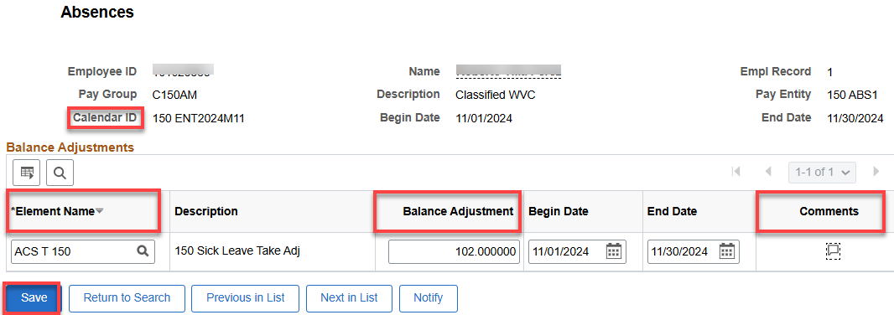

Recipient: Enter the Element Name (SBCTC SLV), Balance Adjustment (positive in this case), Save.

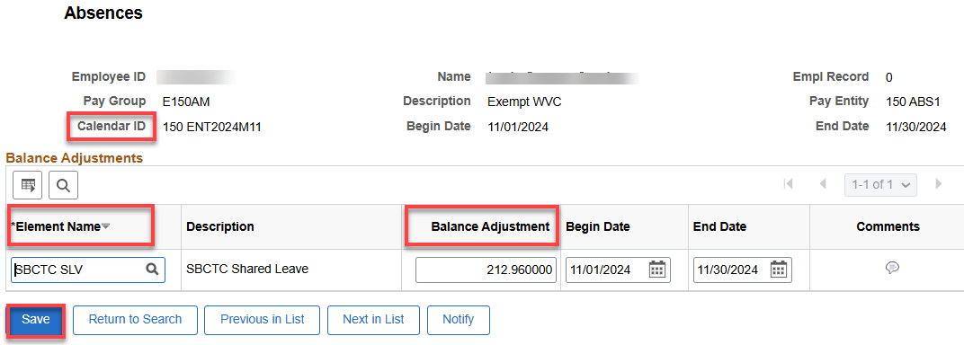

Step 3 – Running Off Cycle Process Adjustments

If you can’t let the adjustments run during the regular Entitlement run, then run an Off Cycle On Demand Process. See Absence-Run Off-Cycle On Demand Process documentation.

BEFORE PAYROLL RUNS EACH PAY PERIOD, GO INTO EACH ABSENCE EVENT AND CHANGE THE CSL (or VAC) TO “SHARED LEAVE TAKE.” A Time & Labor administrator will need do this action; it is not available to the employee.

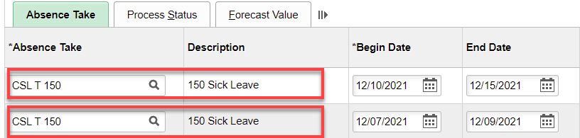

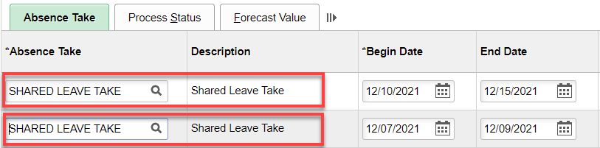

Save.

This will send what is needed to payroll.

That’s it!

Returning Shared Leave

I hope I did this right…No QRG.

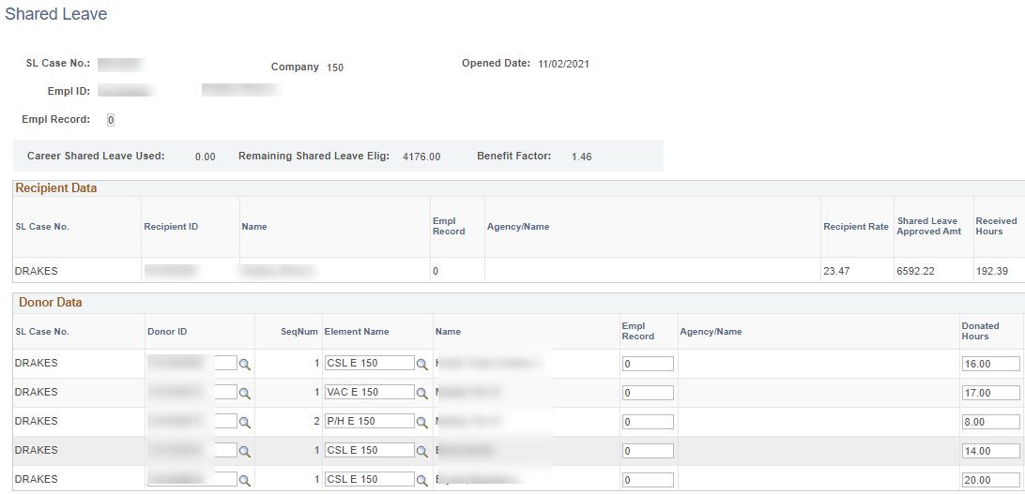

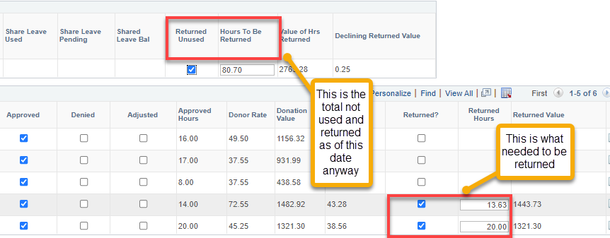

The next step is to adjust the leave balances like in Step 2 above.

Entering Absence Balance Adjustment for Donor & Recipient

Nav>Global Payroll Absence Management>Payee Data>Adjust Balances Absence

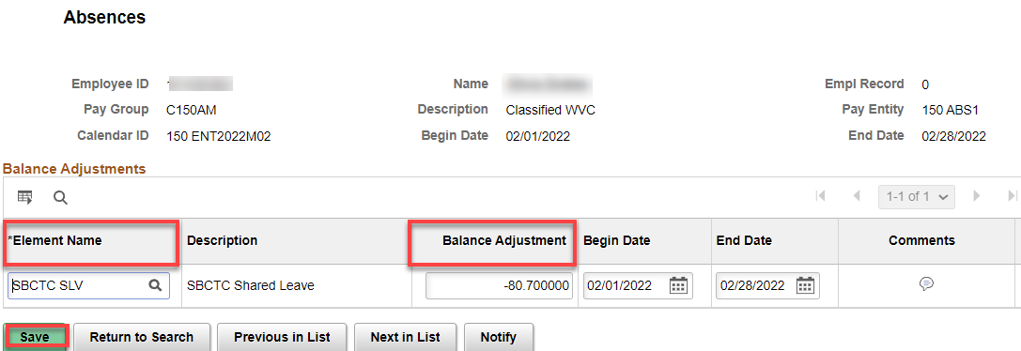

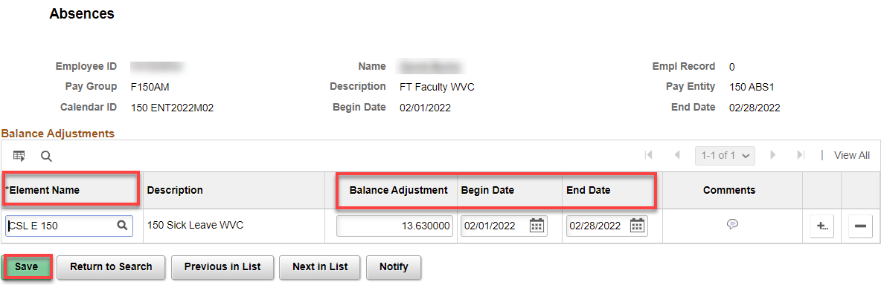

That’s it!

