Adjusting Absence Balance

Accruing P/H & PRL and Adjusting P/H, PRL, Hol & Vac for Part Time Nonpermanent

Nav>Global Payroll & Absence Management>Payee Data>Adjust Balances>Absences

Accruing P/H after four months from start date and PRL hours after the first month
1. Search for the person, select the correct Entitlement month for the balance adjustment (in this example October ENT2023M10).
2. P/H: take hours worked in the fourth month divided by working hours in month times 8 (e.g., 76.5/184=.41.6*8=3.33). Use ANP E NPEM (see below for all Leave Codes).
3. PRL: take hours worked in the first month divided by working hours in month times 24 (WPEA) (e.g., 76.5/184=.41.6*24=9.99). Use ANL E NPEM (see below for all Leave Codes).
4. Accruing hours on the previous month Entitlement before the A Take (December will not work for P/H and June will not work for PRL because they are in a previous calendar and fiscal year, respectively).

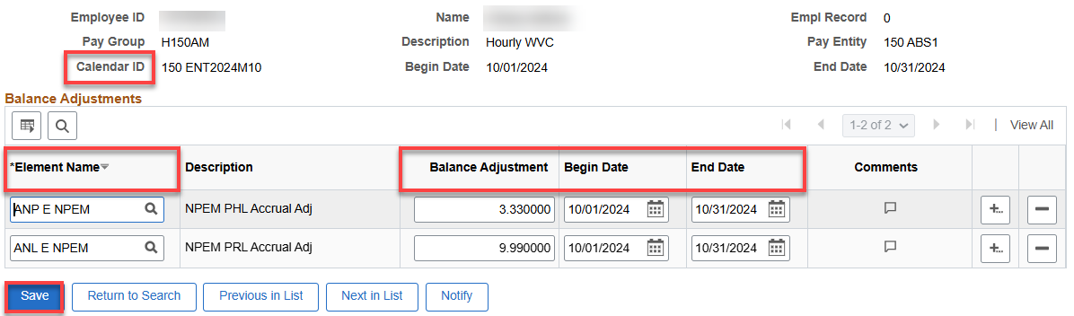

Adjusting P/H hours not used by December 31

1. If a P/H leave rule is set up like it is for WVC, the unused P/H hours will automatically be zeroed out on the 01A Take.

Adding P/H for January

1. Take hours worked in December divided by working hours in month times 8 (e.g., 69/168*8=3.29).
2. Adjust hours on the January 01A Take (this can be done on the January Entitlement, but the P/H hours won’t be available for use until February).
3. Use ANP E NPEM (see below for all Leave Codes).

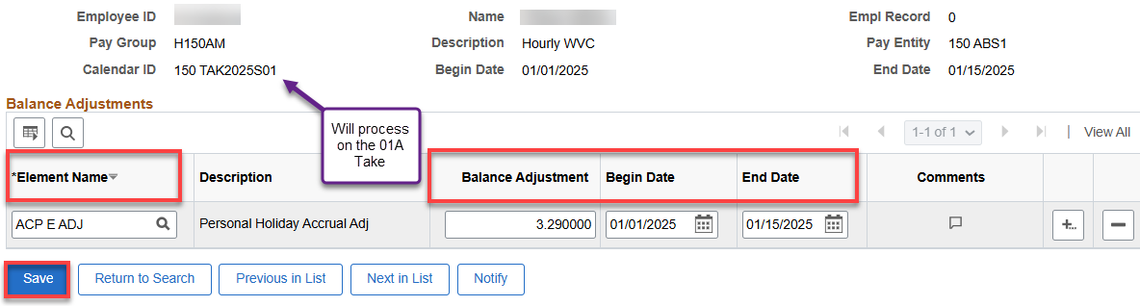

Adjusting PRL hours not used by June 30

1. If a PRL leave rule is set up like it is for WVC, the unused PRL hours will automatically be zeroed out on the 07A Take.

Adding PRL for July

1. Take hours worked in June divided by working hours in month times 24 (WPEA) (e.g., 69/168*24=9.36).
2. Use ANL E NPEM (see below for all Leave Codes)
3. Adjust hours on the July 07A Take before it runs.

Adjusting VAC and or Holiday Credit hours (and other hours if termed)

Vacation and Holiday Credit hours must be paid when a part time nonpermanent employee terminates employment (use last day worked for End Date – in other words, if term effective date is 3/16/24, last day worked is 3/15/24); Holiday Credit hours must be paid if not used by June 30 each year.

1. Check leave takes and balances in Absence Management.
2. Adjust (minus) the balance(s).
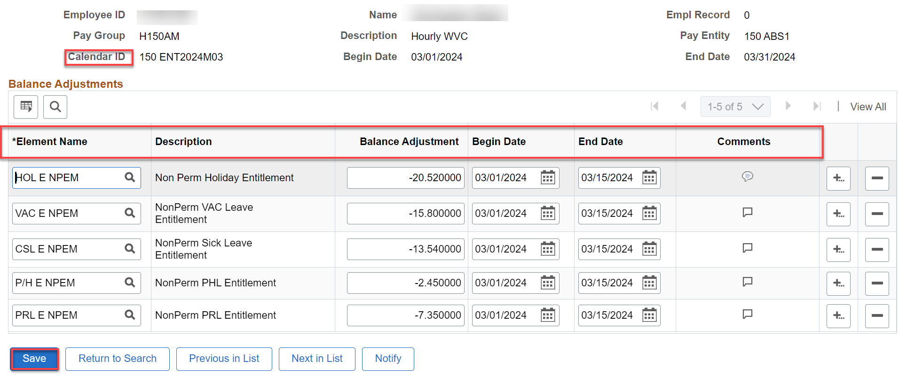

Pay employee for VAC and/or Holiday Credit hours

1. Look up the employee in Job Data for Empl ID, Combo Code and hourly pay for PSHUP file.
2. Create a PSHUP file (Nav>Payroll for North America>CTC Custom>Paysheet Holding Update).
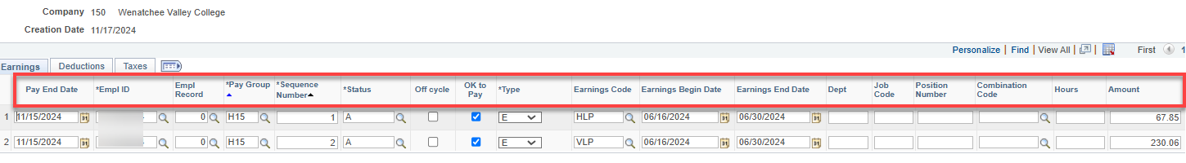

That’s it!

We still use the Entitlement Calendars*. Use the green highlighted codes for balance adjustments (transfer in/out, term, moving from one record to another, etc., orange for accrual adjustments (adding/subtracting P/H, PRL, vac, etc.), blue for adjustments to takes for Absence Balance Report, sick leave balances for sick leave buyout, shared leave donation, etc.

*The January Entitlement Calendar cannot be used for P/H (Use 01A Take); the June Entitlement Calendar cannot be used for PRL (use July 01A Take).
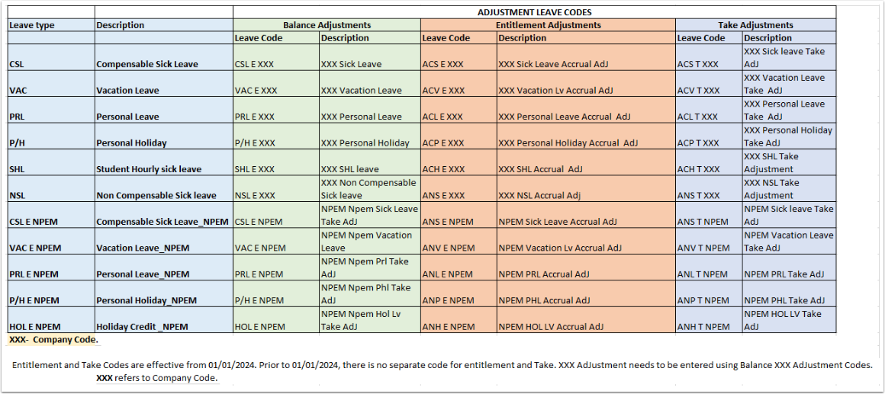

The following refers to the Absence Administration tile>Results by Calendar Group>Accumulator tab>Accumulator Results.

Using CSL, VAC, etc., will make the adjustment to the year-to-date Balance Accumulator but will not add/subtract the adjustment to the year-to-date Entitlement or Take Accumulator nor will it adjust in the Review Absence Balance page (for administrators).

Using ACS, ACV, etc., will make the adjustment to the year-to-date Balance Accumulator and the Entitlement or Take Accumulator and it will adjust the Review Absence Balance page (for administrators).

