Absence Request – HR Adding Request(s), Making Changes and their Affects

Nav>Workforce Administration>Absence Administration>Absence Event

Entering an Absence Event for an Employee

Go to Absence Event page and search for the employee.

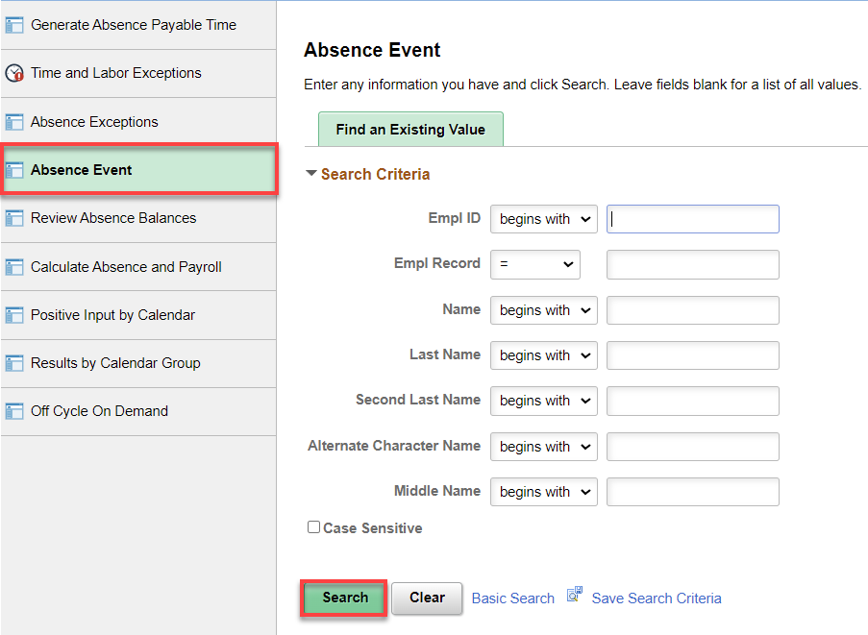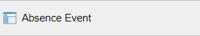

Add + a row, add the Absence Take Name, begin & End Dates, Partial Hours, if necessary, Original Begin Date, click on the Details link, choose Absence Reason, select OK, Save.

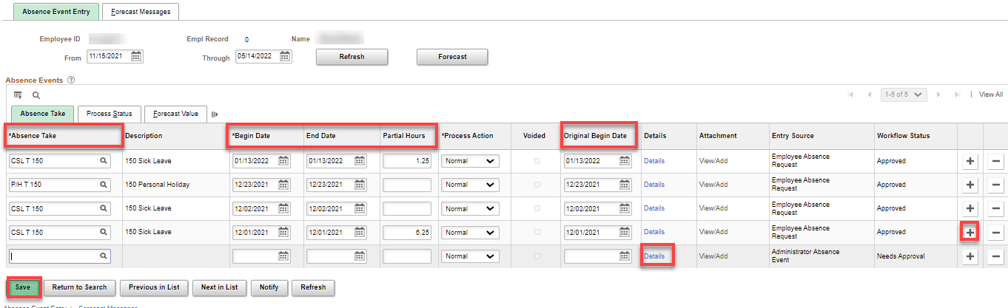
Changing a Request

HR can change an Absence Take at any time even if the take has been finalized. The change will be reversed/changed on the next leave take. To see if the take has been processed or finalized, click on the Details link. Save.

Note: if you are changing an Absence Take with Partial Hours, take note of the Partial Hours because the Partial Hours need to be added back in when making the change.

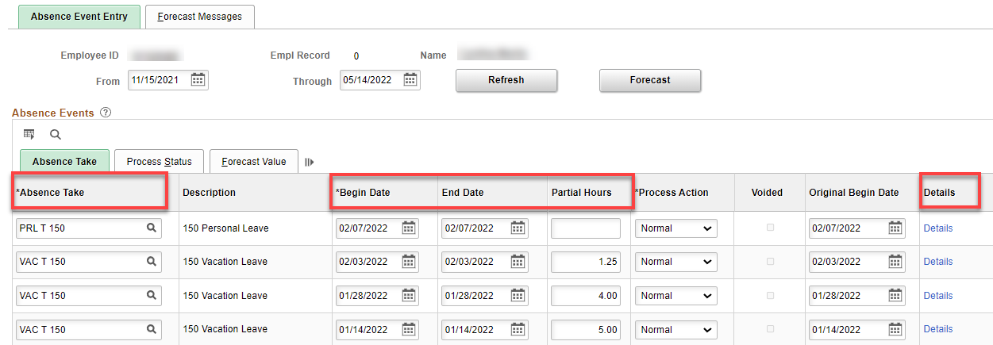

If an EE is on Shared Leave, HR must change their request (CSL/VAC or P/H) to Shared Leave prior to payroll running.

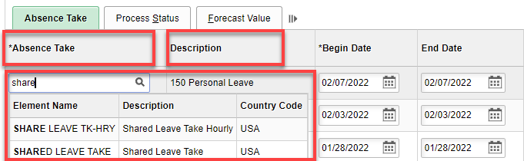

PFML
For changing leave takes to PFML Codes, see Changing Leave Takes to PFML Codes documentation.

Changing a Request with Leave Without Pay to Cyclic Leave Without Pay (or visa-versa)

Take it from me, if you change an Absence Take from one type of LWOP to another (i.e., LWO to LWC), that has already be finalized, BE SURE to tell Payroll to uncheck the LWOP on the Paysheet or it will take the LWOP again.

That’s it!

