Putting in a Leave Request (Absence Request) (good to copy and paste into an email)

Some of you have never put in a leave request (now known as an absence request), so I hope this is helpful. AND, if you have never put in a partial request (less than your scheduled shift) or you have tried to put in leave for less than a full day, you have probably felt…well…a little frustrated with ctcLink. The process IS NOT intuitive, meaning it’s difficult until you know how and then it’s still difficult. 😊

Here is the process (with pictures):

Go to Employee Self Service

Click on the Time Tile

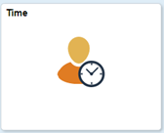

Click on Request Absence Tile

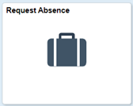

Once you are in Request Absence, select the absence name (if you don’t know what to choose, contact HR and we will help).



After choosing the leave type, choose the start and end date. You can choose multiple days only if they are regular shift hours. If the hours vary or between work weeks, put in separate requests. This is especially true for partial requests (see below).
You can put in a comment if you choose but it is not required.

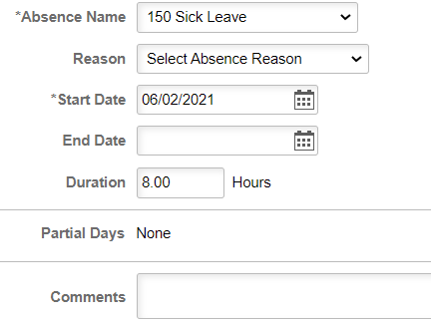

Once you are finished, click the Submit button on the top right of the screen.

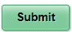

That’s it…unless you need to put in a partial day. If that’s the case then hang on and follow these 14 easy steps.

First, click on the words “Partial Days.” It’s a hot link even though it’s not underlined (actually the whole row is the link). The following box opens up:

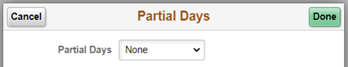

Click on “Partial days” then click on Start Day Only or All days (it doesn’t matter)

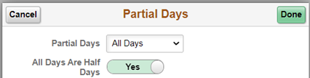

If it is a half day, then click Done and Submit. If it’s not a half day, then click the green highlighted Yes and it will change to NO and put in the number of hours. Click Done and Submit.

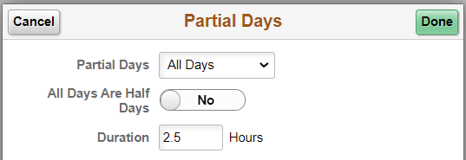

That’s it! Now wasn’t that fun?

